Functional Specification Document

FSS Payment Gateway

Version 3.1.0

All Rights Reserved
Financial Software & Systems Pvt. Ltd

Functional Specification Document

These materials are confidential and proprietary to FSS and no part of these materials should be reproduced, published in any form by any means, electronic or mechanical including photocopy or any information storage or retrieval system nor should the materials be disclosed to third parties without the express written authorization of FSS. Revision History

Revision History

S. NO | Date | Description | AUTHOR | Reviewed | Approved
1 | 05/22/19 | PG FSS NET FSD | Vinoth Selvam S

Introduction:

A Payment Gateway is a merchant service provided by an e-commerce application service provider that authorizes credit card or direct payments processing for e-businesses, online retailers .FSS Payment Gateway is a scalable, secure platform-commerce/M-commerce that supports multiple payment mechanisms across delivery channels such as internet and IVR. Powered by robust fraud and risk engine, FSS internet payment gateway ensures minimal transaction compromises and delivers a delightful experience to end users.

A payment gateway allows a connection directly between a website and a bank, meaning that payments can be placed directly on a website and deposited straight into a bank account.

A payment gateway is a server that is dedicated to linking websites and banks so that online credit card transactions can be completed in real-time.

How it works ?

Payment gateways work by providing the secure, integral link between a website (web server) and the bank. When credit card details are submitted on a website the payment gateway receives these details and sends them to the bank for verification. The bank then replies with a response; usually either accepted or declined. The payment gateway then sends this response back to the web server when the appropriate message is displayed to the user - for example "Your payment has been successful".

Requirements:

If you are looking at accepting real-time credit cards on your website then a payment gateway is required. There are three main requirements for a payment gateway to work:

1.A website that meets the security and eligibility requirements for the bank to issue a merchant account

2.A merchant account from a bank. A merchant account is a special kind of bank account that can be linked directly to a payment gateway. These bank accounts are issued only upon review of a website to ensure it meets privacy and security requirements. Requirements often include an SSL certificate and a privacy policy.

3.A payment gateway provider. Payment gateway providers offer the server that acts as the link between your website and the bank. The server has a very special configuration and a very high level of security due to the sensitive nature of the data being transferred.

Once all three requirements are met, the payment gateway then needs to be connected to the website and to the merchant account. This will then allow for real-time credit card processing.

Benefits:

By incorporating a payment gateway into your e-commerce website you can ensure you are providing the easiest and most streamlined buying experience for your customers. The easier it is to buy from your online store the more likely visitors are to purchase.

Visitors stay on site: Many websites will take advantage of third party or hosted payment processing facilities such as PayPal. These facilities do work well and can provide secure payment options, however they do have draw backs. A major advantage of using a payment gateway is that customers will not leave your website to make payment. All user information and credit card details are inputted on your website meaning fewer steps for the buyer. Further to this, re-directing users to a separate website for payment often leads to mistrust and payment abandonment.

Real time transactions and payments: Utilizing a payment gateway allows you to accept credit cards directly on your website, but also means that these credit card transactions are processed in real-time. Real-time transactions mean that you as the merchant get paid immediately and that the customers get instant feedback as to whether their payment has been accepted or declined.

Saves time and reduces administration: A payment gateway saves time with the fact that credit cards are processed in real-time and funds are deposited directly into a merchant account. A payment gateway removes the need for manual card processing or third party account consolidation.

Types of Payment Gateway:

- Hosted Transactions (3D & non-3D Transaction)
- Merchant Hosted Transaction ( 3D & non-3D Transaction) or Tranportal Transaction

Hosted Transaction (Non-3D) / Debit -pin :

Customer is prompted to enter card details on PG page(Payment Page) and then PG routes the transaction request to Base24 switch(bank switch) and in turn Switch provides response back to PG with the ISO message.

PG redirects the merchant response to the Merchant. Merchant customizes the response and sends the appropriate information to the customer.

Architecture:


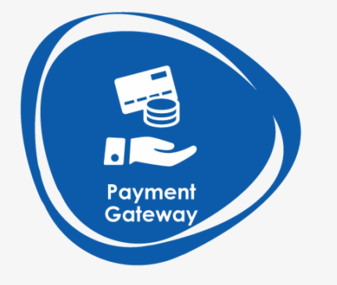

Customer
Ecommerce Merchant
Internet Gateway
1
2
3
4
8
9
10
7

Bank Host
5
6

- Customer visits the merchant site and selects the merchandise and confirms to pay using the payment gateway
- Merchants website shall already gets integrated with Payment Gateway through the secure plug-in
- Merchant redirects the customer with the transaction data to the payment gateway
- Payment Gateway verifies the transaction request from the merchant and presents the responsive hosted payment page to the customer.
- Payment Gateway supports all the standard browsers.
- The hosted page prompts the customer to enter the card holder information.
- Customer enters credit / debit card number, expiry date, ATM Pin and submits the card information.
- PG shall build the ISO message and forwards to Transaction switch for authorization
- Once Payment response arrived from Transaction switch to PG then response shall be communicated back to the Merchant Website.
- Merchant shall customize the response and shows it appropriately to their customer

Hosted Transaction 3D – Debit/Credit with CVV:

Architecture:
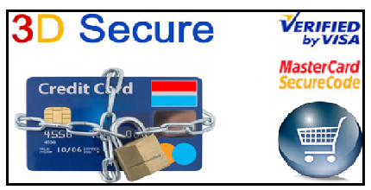
Ecommerce Merchant
Directory server/Interchange
1
2
3
4
5
6
7
10
11
12


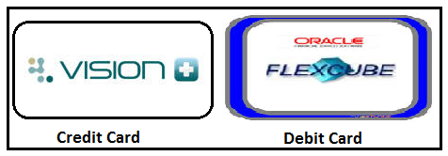

ACS
Bank Host
Customer
8
9

3 – VEREQ: Verify Enrollment Request from PG
4 – VERES: Verify Enrollment Response (Success if Enrolled).
5 – PAREQ: Payer Authentication Request (Password has to be entered).
6 – PARES: Payer Authentication Response (If password is correct, routes to Base24).

- Customer visits the merchant site and selects the merchandise and confirms to pay using the payment gateway
- Merchant redirects the customer with the transaction data to the payment gateway
- Payment Gateway verifies the transaction request from the merchant and presents the responsive hosted payment page to the customer.
- Payment Gateway supports all the standard browsers.
- The hosted page prompts the customer to enter the card holder information.
- Customer enters credit / debit card number, expiry date, cvv and submits the card information.
- Payment Gateway sends the 3D secure card holder Verification enrollment request VREQ to the Visa Directory Server (VDS) / Master Directory Server (MDS).
- VDS / MDS validates the enrollment request for the customer entered card.
- VDS / MDS sends the 3D secure enrollment status VERES (Verification Enrollment Response) and respective issuer ACS URL to the Payment Gateway.
- Payment Gateway receives the Verification enrollment response.
- Validates the enrollment status is success / failure. Proceeds / Declines the transaction based on the enrollment status.
- Payment Gateway sends the customer card holder details (PAREQ) to respective issuer ACS for authentication.
- Issuer ACS validates and authenticates the card information (PAREQ).
- Merchant Website shall send the PAREQ to ACS and customer shall see the 2FA password entry screen on the respective bank’s ACS.
- Issuer ACS sends the 3D secure authentication status to Payment Gateway (PARES).
- Payment gateway validates the 3D secure authentication status and transaction gets processed / declined based on the authentication status.
- PG builds the ISO authorization request and send to Base 24 (Switch) for authorization. It identifies the respective issuer switch and authorizes the transactions.
- Base 24 provide the authorization response to payment gateway
- Payment Gateway logs the response and PG provides the response to the customer via the merchant
- Customer knows the transaction result.
- In this approach the customer card details are captured in Bank Hosted Page on a secured network and send the Payment Gateway response to the merchant.
- Merchant displays about the transaction result.
Customer knows about the order result.

Merchant Hosted Transaction Non - 3D – Debit pin :

When customer is prompted to enter card details on Merchant Page and transaction request routes to PG and then PG routes the transaction request to Base24 switch(bank switch)


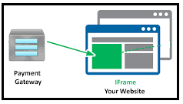
Customer
Merchant
Internet Gateway
Bank Host
1
2
3
4
5
6
7
8
9
10

- Customer shops online through Merchant Website and select payment option as Payment Gateway
- Merchants website shall already gets integrated with APM through the secure plug-in
- Merchant gets all the card credentials on their website and forwards the payment request to APM
- Payment Gateway verifies the transaction request from the merchant and presents the responsive Iframe page for customer to enter the Pin/CVV value.
- PG shall build the ISO message and forwards to Transaction switch for authorization
- Once Payment response arrived from Transaction switch to PG then response shall be communicated back to the Merchant Website.
- Merchant shall customize the response and shows it appropriately to their customer

Merchant Hosted Transaction 3D – Debit /Credit CVV :

Architecture:
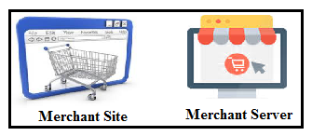
Merchant
Directory server/Interchange
1
2
3
4
5
6
7
10
11
12

ACS
Bank Host
Customer
8
9

3 – VEREQ: Verify Enrollment Request (Card details).
4 – VERES: Verify Enrollment Response (Success if Enrolled).
5 – PAREQ: Payer Authentication Request (Password has to be entered).
6 – PARES: Payer Authentication Response (If password is correct, routes to Transaction Switch).

- Customer shops online through Merchant Website and select payment option as Payment Gateway
- Merchants website shall already gets integrated with APM through the secure plug-in
- Merchant gets all the card credentials on their website and forwards the payment request to APM
- Payment Gateway sends the 3D secure card holder Verification enrollment request VREQ to the Visa Directory Server (VDS) / Master Directory Server (MDS).
- VDS / MDS validates the enrollment request for the customer entered card.
- VDS / MDS sends the 3D secure enrollment status VERES (Verification Enrollment Response) and respective issuer ACS URL to the Payment Gateway.
- Payment Gateway receives the Verification enrollment response.
- Validates the enrollment status is success / failure. Proceeds / Declines the transaction based on the enrollment status.
- Payment Gateway sends the customer card holder details (PAREQ) to respective issuer ACS for authentication.
- Issuer ACS validates and authenticates the card information (PAREQ).
- Merchant Website shall send the PAREQ to ACS and customer shall see the 2FA password entry screen on the respective bank’s ACS.
- Issuer ACS sends the 3D secure authentication status to Payment Gateway (PARES).
- Payment gateway validates the 3D secure authentication status and transaction gets processed / declined based on the authentication status.
- PG builds the ISO authorization request and send to Base 24 (Switch) for authorization. It identifies the respective issuer switch and authorizes the transactions.
- Base 24 provide the authorization response to payment gateway
- Payment Gateway logs the response and PG provides the response to the customer via the merchant
- Customer knows the transaction result.
- In this approach the customer card details are captured in Bank Hosted Page on a secured network and send the Payment Gateway response to the merchant.
- Merchant displays about the transaction result.
Customer knows about the order result.

Rupay Transaction:

RuPay, being the first domestic card scheme, is in a unique position to work together with banks and other entities including government, public sector and private sector entities to increase the cards spends as a percentage of personal consumption expenditure.
The solution will involve use of dynamic One-time-Passwordas an additional factor of authentication for e-commerce transactions on internet using RuPay Debit cards and Credit Cards. RuPay has adopted the Pay Secure solution for enabling a second factor authentication in the web based channels. The objective is to improve both Cardholder and Merchant confidence in Internet purchases and to reduce disputes and fraudulent activity related to the use of Debit cards and Credit Cards online.
Rupay has been classified into 2 types:
- Redirect Flow- Acquirer will redirect cardholder to Issuer OTP page for authentication and on submission of correct OTP by cardholder, Issuer will re-direct back to acquirer with successful response.
- iFrame Flow- Acquirer displays a modal iFrame which is hosted by the NPCI PaySecure system and PaySecure gives control to Issuing bank which loads the OTP page, sends the OTP and authenticates the customer. The authentication result is shared with NPCI. Acquirer is supplied a response form modal dialog as it closes indicating that OTP was authenticated successfully and transaction is ready for authorization
Redirect Flow:
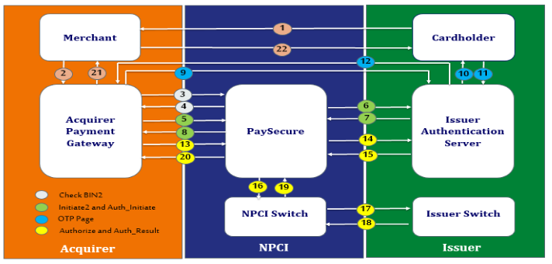

- Customer shops online through Merchant Website and select payment option as Payment Gateway. Merchants website shall already gets integrated with APM through the secure plug-in. Merchant gets all the card credentials on their website
- Merchant sends the complete payment data to Acquirer.
- Acquirer sends First 9 digits of card-number to PaySecure in Check Bin2 API call to determine if the card is eligible for eCommerce transaction.
- Based on BIN, PaySecure identifies transaction flow. If BIN not enabled for redirection flow then same will be mentioned in CheckBin2 Response, then Acquirer needs to follow Iframe Flow. Upon Successful Bin Check PaySecure Responds to Acquirer.
- Acquirer system sends Initiate2_API call to transmit the payment data to PaySecure system
- PaySecure sends Auth_Initiate API call to transmit the request for authentication to the issuer authentication server(IAS).
- PaySecure receives the response from issuer authentication server.
- PaySecure responds to Initiate2_API with transaction details along with Issuer OTP Page URL and Cardholder ID allowing the Acquirer to continue with the payment process.
- Acquirer redirects to the Issuer OTP Page URL received in Initiate2 API response for cardholder interaction with IAS. IAS System now has direct communication and control of the cardholder browser.
- The Issuer provides cardholder with available authentication options to the cardholder.
- For example: •Enter OTP
- Cardholder enters OTP on issuer OTP page.
- Issuer validates OTP as entered by cardholder on OTP page.
- **Issuer redirects cardholder browser back to Acquire system along with authentication status of cardholder
- Acquirer completes any per-authorization steps and sends Authorization_API request to PaySecure.
- PaySecure server queries IAS via Auth_Result API call to securely confirm the result of cardholder authentication.
- On Successful receipt of Auth_Result API response from IAS, PaySecure will create the ISO message with Mandatory Tag elements and will send the authorization message to the NPCI switch.
- NPCI switch sends the authorization message to the issuer switch for authorization.
- Issuer switch will validate the ISO Message and will approve/decline the transaction. Issuer will send the response back to the NPCI Switch.
- NPCI Switch will send the response to the PaySecure system.
- PaySecure system sends the response back to the acquirer.
- Acquirer sends the response to the merchant website.
- Merchant displays appropriate message to cardholder

Amex Transaction:

Transaction Flow - Hosted

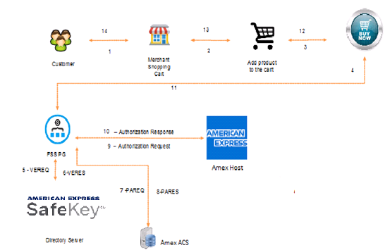

- Customer will be initiating the purchase transaction in merchant portal and merchant will send transaction details to PG.
- After validating request parameters, PG will display the payment page wherein customer has to enter the card details.
- Then PG will generate VEReq and send to the Directory Server.
- The directory Server transfers the VEReq to appropriate ACS, which verifies enrollment of the card.
- The ACS will generate VERes and returns the enrollment verification response to the DS.
- The DS will transfer the VERes to the PG.
- Card Enrollment status will be
      - Y (Card Eligible for Authentication process) or
      - N (Card not eligible for SafeKey Authentication) or
      - U (Unable to process or card not eligible for attempts)
- If PG received Y in VERes, Then PG will generate PAREQ and send to ACS url (which is received in VERes) directly otherwise appropriate error message will be sent to the merchant.
- The ACS will perform Payer Authentication and will send the PARes to PG.
- PARes Message will have Transaction status, ECI, CAVV, etc.
      - For Successful Authentication, Status is Y and ECI is 05
      - For Authentication Failed case, Status is N and ECI is not applicable.
      - For Authentication Unavailable case, Status is U and ECI is not applicable. (While authorization PG will send ECI 07 to AMEX Host.)
      - For Attempt Processing performed case, Status is A and ECI is 06
- Then PG will validate PARes and will initiate authorization request to AMEX Host for the Transaction Status Y and A with the respective ECI values.
- After getting Authorization response from AMEX, PG will send the response back to Merchant.
- If Transaction status is U, PG will initiate authorization request for credit card instrument in case of 3D secure Authentication flag is No
- If Transaction status is N, PG will send appropriate error response to the Merchant.

Transaction Flow – Merchant Hosted

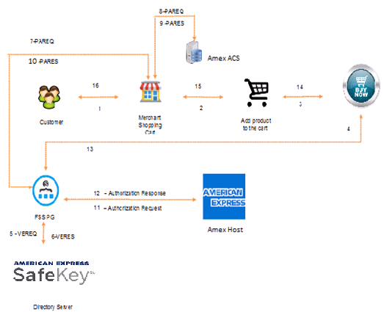

- Customer will be initiating the purchase transaction in merchant portal.
- Merchant will get card details from customer and send the transaction request to PG.
- After validating request parameters, PG will generate VEReq and send to the Directory Server.
- The Directory Server transfers the VEReq to appropriate ACS, which verifies enrollment of the card.
- The ACS will generate VERes and returns the enrollment verification response to the DS.
- The DS will transfer the VERes to the PG.
- Card Enrollment status will be
  - Y (Card Eligible for Authentication process) or
  - N (Card not eligible for SafeKey Authentication) or
  - U (Unable to process or card not eligible for attempts)
- If PG received Y in VERes, then PG will generate the PAReq and send to the merchant with ACS url (which is sent in VERes) otherwise PG will send appropriate error response to the Merchant.
- Merchant will send the PAReq to ACS url which was sent by PG.
- The ACS will perform Payer Authentication and will send the PARes to Merchant.
- Merchant will send the PARes to the PG.
- PARes contains Transaction status, ECI, CAVV, etc.
    - For Successful Authentication, status is Y and ECI is 05
    - For Authentication Failed case, status is N and ECI is not applicable.
    - For Authentication Unavailable case, status is U and ECI is not applicable.(While Authorization ,PG will send ECI 07 to AMEX host)
    - For Attempt Processing performed case, status is A and ECI is 06
- PG will validate PARes and will initiate authorization request to AMEX Host for the Transaction Status Y and A with the respective ECI values.
- After getting Authorization response from AMEX, PG will send the response back to Merchant.
- If Transaction status is U, PG will initiate authorization request for credit card instrument in case of 3D secure Authentication flag is No
- If Transaction status is N, PG will send appropriate error response to the Merchant.

Login Types:

Login screen will allow the users to login and provide access to the Payment Gateway. There are four types of login in Payment Gateway.
- Super Admin Login
- Admin Login
- Institution / Bank Login
- Merchant Login

Super Admin Login:
Steps to create a super admin:
- In super admin login page there will be a registration link to create super admin.
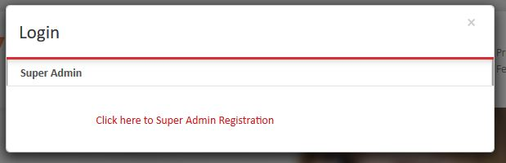
- After clicking the link, login page will redirect to user registration page.
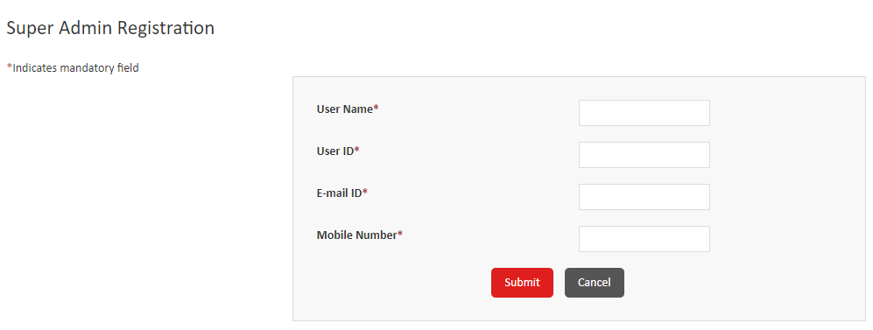
- User has to enter User ID, Password, Mobile Number and Email id in registration page.
- After successful validation, user will be created and displayed message as 'Registered Successfully'.
- After successful registration, User ID and Password will be sent through mail for respective user.
- Only registered super admin users are able to login as super admin.
- After login into super admin, schema has to be created for each bank.

Steps to Login Super Admin:
1. Enter the Super admin URL in the browser window and hit Enter.
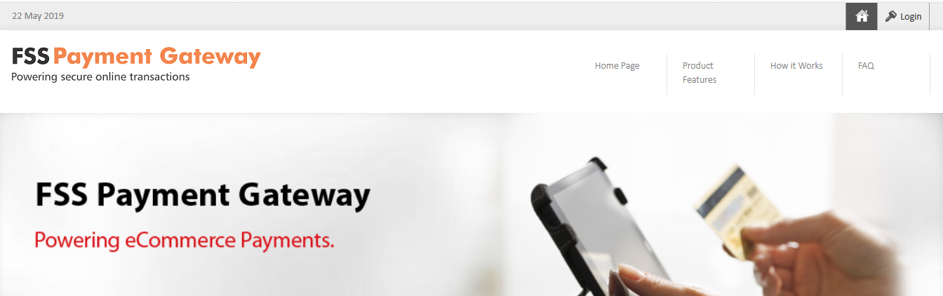
- Click on the Login button on Top right corner of the Page.
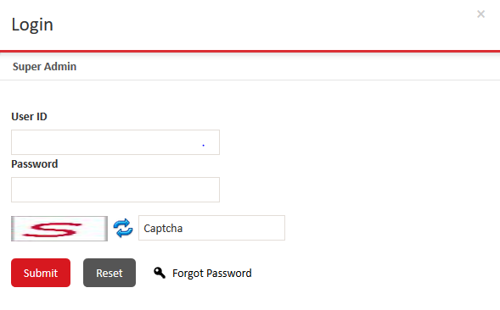
- Enter the User ID.
- Enter the Password.
- Enter the Captcha
- Click on the Submit Button.
- Login Page of the Super Admin will be displayed as below

Note:

- If you have forgotten your password, then click Forgot Password to reset your password.
- If you log on for the first time or after recovering your password, the Change Password page is displayed instead of the Home page. You must change your password, and log on again.

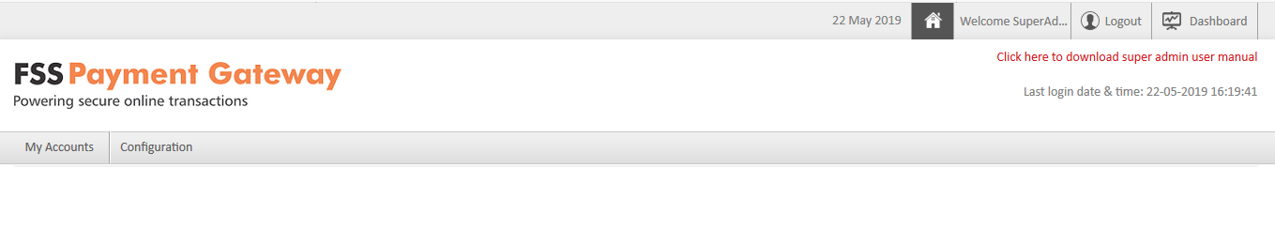
Recover a Forgotten Password:

1. On the Login screen, click Forgot Password to open the Forgot Password screen.
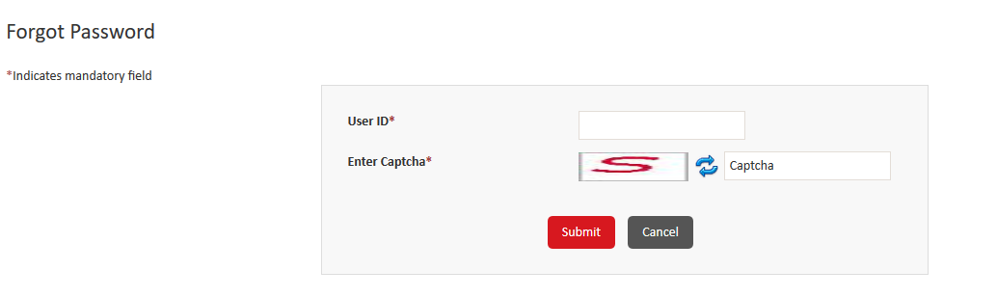

- Type your user ID.
- In the Captcha box, type the text that is displayed in the image. If you cannot read the captcha, click to load another image.
- Click Submit.
- In the Email Id box, type your registered email ID.

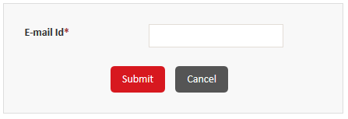
  - Click Submit.
  - After the password is reset, an email is sent to your registered email ID. The email contains a link that you can click to create your new password.

The following image displays a sample email that is sent to the user:

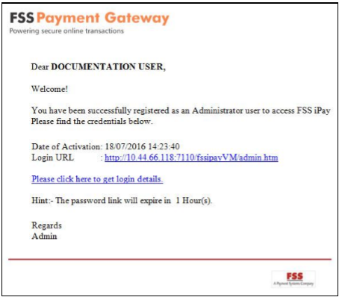
- Click Please click here to get login details to display your new password.
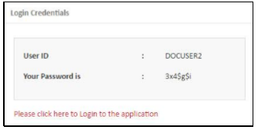
- Click Please click here to Login to the application link to log on to the application.

To Change Password:

You can change the existing password for your account. It is recommended that you change your password frequently. You must change your password at the first successful logon after your ID is created or after you have recovered your password.

Perform the following steps to change your password:

1. Point to My Accounts, and then click Change Password to open the Change Password screen.
Note: If you log on for the first time or after recovering your password, the Change Password page is displayed instead of the Home page.
- In the Old Password box, type your current password.
- In the New Password and Confirm New Password boxes, type your new password twice.
Note: Ensure that your password adheres to the acceptable password criteria that are displayed on the screen.
- Click Save to display the Login screen, where you can log on to the application using your user ID and new password.

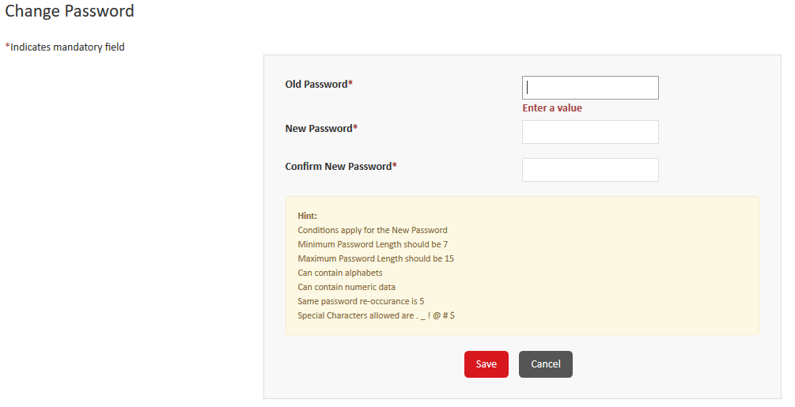

Session Monitor:

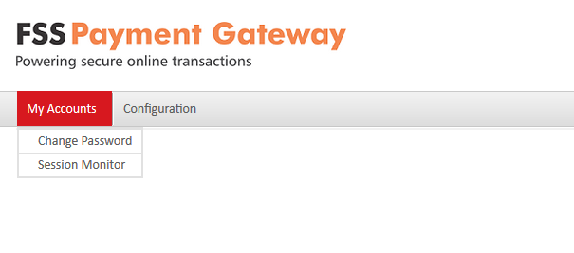
If the user is not properly logout for ex User closed the browser window instead of clicking the logout link in this case still the user session will be active in order to kill this session we can use session monitor option.
To clear the session monitor:

- click on the My Account Main menu in Super-Admin.
- Select Session Monitor.
- Click on the Remove session to close the existing session of the application.
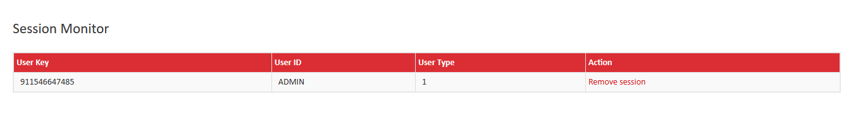
- Once the session has been removed successfully. Portal displays the success message as below
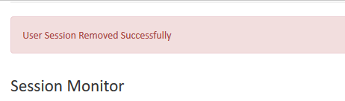

Configuration:

You can configure multiple institution schemas and create an administrator user ID for each institution.

- Create the institution schema to map an institution in FSS Payment Gateway.
- Create an administrator user ID for an institution. The institution administrator users manage the institutions.

Actions performed on Institution Schema:

- Create an institution schema
- View or modify an institution schema
- Change the status of nstitution schema

Steps to Create a Schema:

1. On the menu bar, point to Configuration, and then click Schema Creation to open the Schema List screen.
2. Click Add to open the Add Schema screen.

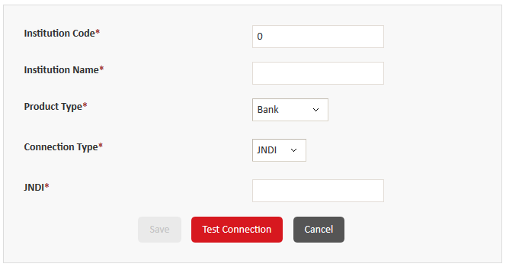
Add the following data in the field:

Field | Description
Institution Code | Type a unique three-digit identification code for the institution. This code is used to identify the institution in FSS Payment Gateway.
Institution Name | Type the name of the institution.
Connection Type | Click one of the following options to indicate the type of connection source to use for the institution:  - JNDI – Click this to use the Java Naming and Directory Interface (JNDI) connectivity. If you click this option, then the JNDI box is displayed.  - Direct – Click this option to use the Java Database Connectivity (JDBC) connectivity. If you click this option then the URL, User Id, and Password fields are displayed.
JNDI | If you selected JNDI connection type, then specify the name that contains the details to use to connect to the database.
URL | If you selected Direct connection type, then specify the URL for the direct database connection.
User Id | If you selected Direct connection type, then specify the use
Password | If you selected Direct connection type, then specify the password to use to directly connect to the database.

3. Click Test Connection to test the connection. A confirmation message is displayed if the connection is successful. If the connection is not successful, make the necessary corrections, and then click Test Connection again.

Note: You can save an institution schema only after the connection is established successfully.
4. Click Save to save the schema.

To View / Modify Schema details:

You can view or modify the details of an existing active institution schema. You cannot modify the identification code of an institution.

Perform the following steps to view or modify an institution schema:

1. On the menu bar, point to Configuration, and then click Schema Creation to open the Schema Creation screen.
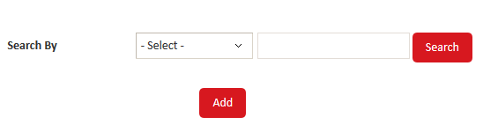

2. In the Search By list, click one of the following options:
- All – Display all institution schema.
- Institution Code – Search for a specific schema by typing the unique three-digit identification code in the box.
- Institution Name – Search for a specific schema by typing the name of the schema in the box.
- Click Search to display the filtered list.
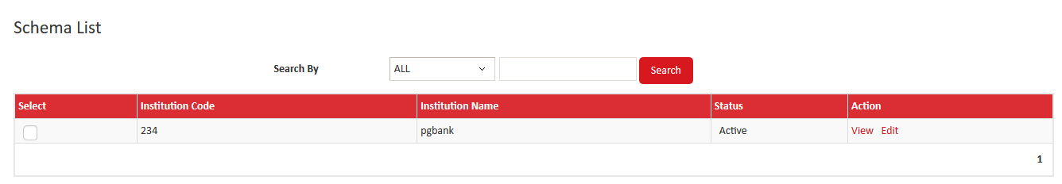
- To view the details of a schema, click View.
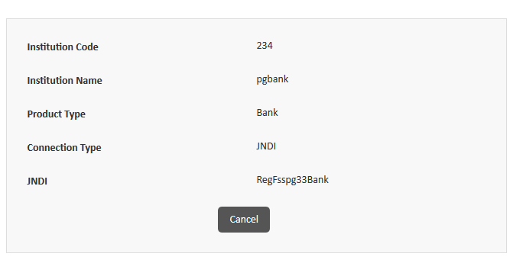

3. Alternatively, to modify the details of the schema, click Edit.
4. Modify the required details
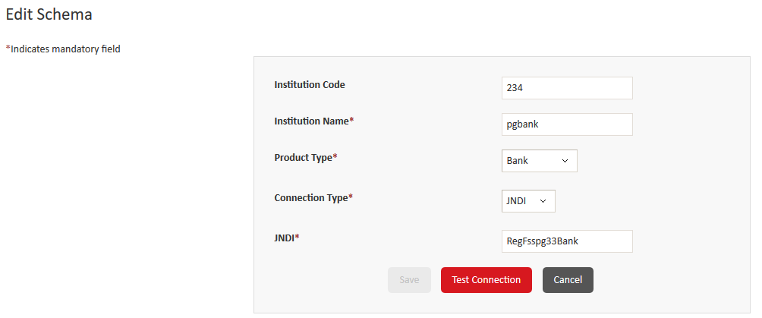
5. Click Test Connection to test the connection. A confirmation message is displayed if the connection is successful. If the connection is not successful, make the necessary corrections, and then click Test Connection again.
      - Click Save to save the changes.
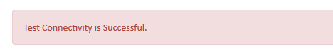
To change the Status of the Schema.

- In the Select column, select a check box to select a record.
- You can select multiple records.
- Click Change Status to open a confirmation message.
- Click OK to change the status of Active records to Inactive and Inactive records to Active.
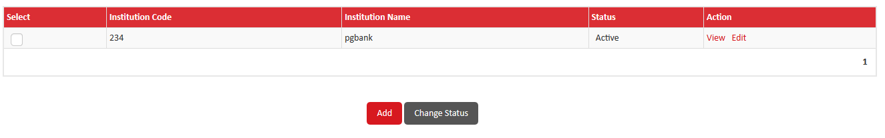

Bank Admin Registration:

- In super admin portal PG Admin registration menu will be shown under configuration Module.
- After clicking the menu, Admin user registration page will be displayed.
- Institution code will be listed in registration page to create admin user for each institution.
- User has to select institution code and enter User Name,User ID, Email id and Mobile Number in registration page.
- After successful validation, user will be created and displayed message as 'Registered successfully'.
- After successful registration User ID and Password will be sent through mail for respective user.
- Only Registered admin users are able to login using User ID and Password.
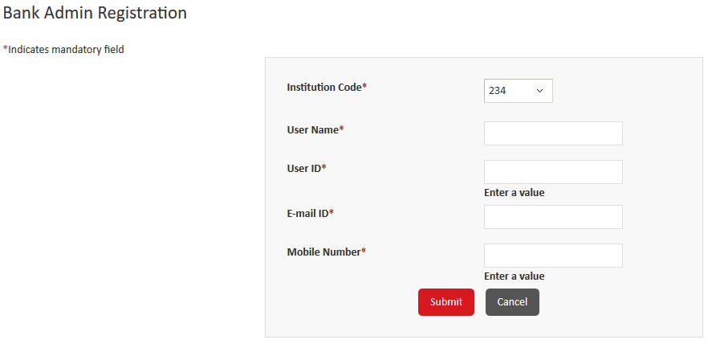

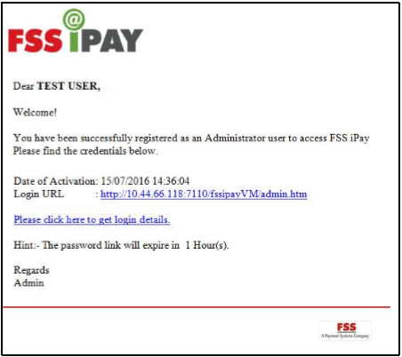

Thread Monitor:
A thread indicates a single batch process that is running in FSS Payment Gateway. You can view the list of active and inactive threads for institutions. Additionally, you can start a thread or stop a running thread.
Steps to Monitor Batch Transaction Threads:
- On the menu bar, point to Configuration and then click Thread Monitor.
- Depending on your requirement, perform one of the following steps:
  - To start a thread that is not running, click Start.
  - To stop a thread processing, click Stop.
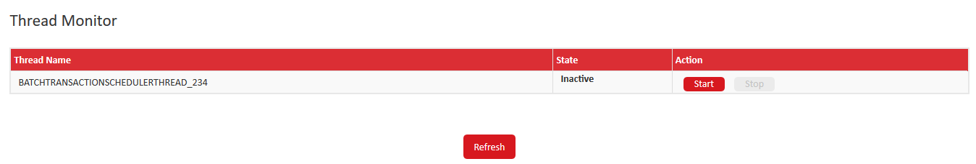
  - To refresh the list of threads, at the bottom of the screen, click Refresh.
Admin Login:
Steps to Login to the application:

- Open a browser window, type the URL for FSS Payment Gateway in the address bar, and then click Go to or press Enter. The Pre-Login page appears.
- In the right top corner, click Login or at the bottom of the page, click Process to Login to open the Login screen.
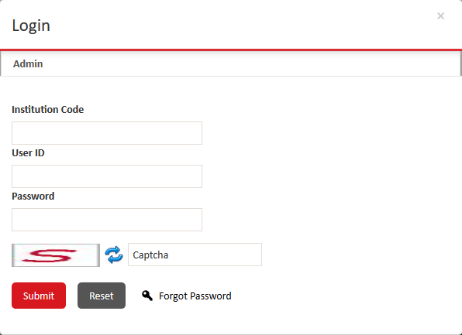
- In the Institution Code box, type the unique three-digit identification code for your institution.
- Type your user ID and password.

Note: If you have forgotten your password, then click Forgot Password to reset your password.

- In the Captcha box, type the captcha text that is displayed in the image. If you cannot read the captcha, click to load another image.
- Click Submit to log on to FSS Payment Gateway and display the Home page.

Note: If you log on for the first time or after recovering your password, the Change Password page is displayed instead of the Home page. You must change your password, and log on again.
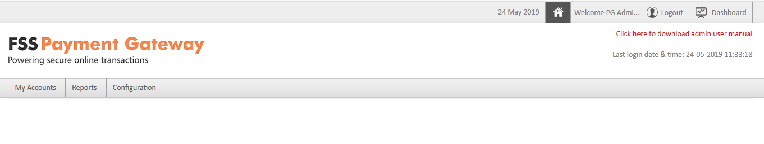
Menus and Sub - Menus of Admin Login:

My Accounts – User Menu

It allows you to customize the application for each user type as per your requirement, thereby making FSS Payment Gateway more user-friendly.

Note: You cannot modify the menu ID and menu type for a menu or sub menu.


- Select User Menu from My Account Main menu.

- Specify the search criteria to display the predefined menus and sub menus by performing the following steps:

- In the Search By list, click one of the following options:
▪ ALL – Display the list of all of the menus and sub menus.
▪ Menu ID – Search for a specific menu or sub menu using its menu ID.
▪ Menu Name – Search for a specific menu or sub menu using its name.

- If you select Menu ID or Menu Name in the Search By list, perform the following steps:
i. In the Search Conditions list, click Exact, Starts With, Ends With, or Contains to indicate the search conditions to use.
ii. In the Menu ID/Name box, type the ID or name of the menu or sub menu to search for.
iii. Click Search.

- In the list of menu and sub menus that are displayed, click Edit to open the Edit User Menu screen.
Alternatively, you can click View to open the View User Menu screen, where you can view the details of a menu or sub menu.

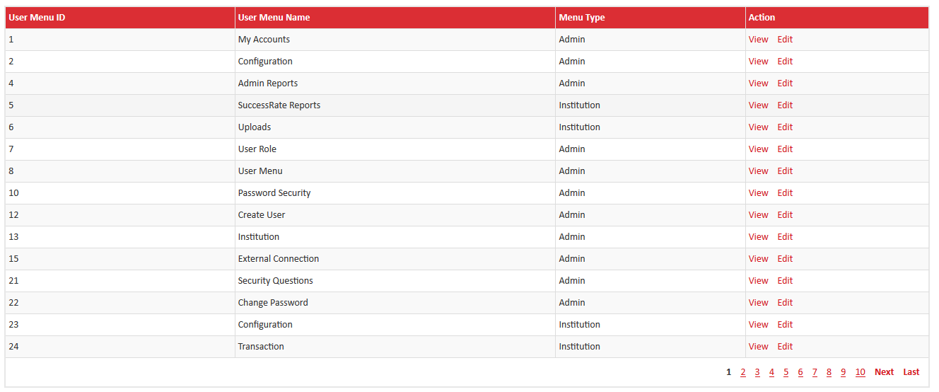

Edit User Menu:

- In the User Menu Name box, modify the name of the menu or sub menu.
- In the User Menu Key box, modify the key for the menu or sub menu.
- In the Menu URL box, modify the URL for the menu or sub menu.

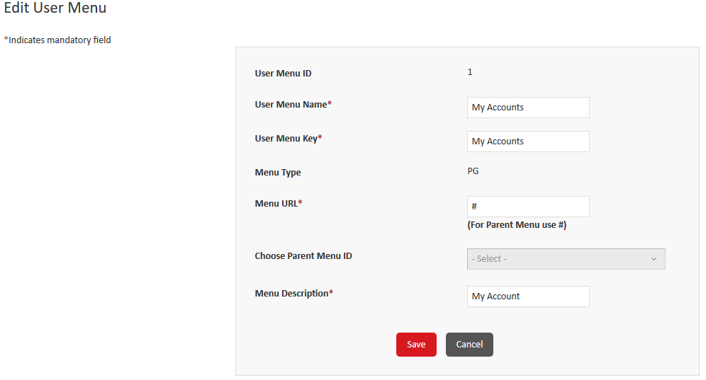

4. If you are customizing a sub menu, then in the Choose Parent Menu ID list, click the parent menu for the sub menu. This field is not available for parent menus.
5. In the Menu Description box, modify the description for the menu or sub menu.
6. Click Save to save the changes.

Note: You must specify # as the menu URL for all parent menus.

User Role:

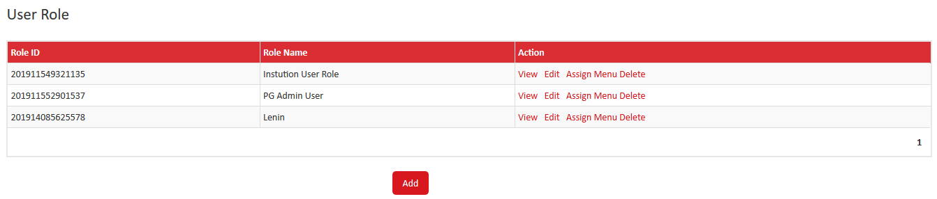
Steps to Create a User role:

- Point to My Accounts, and then click User Role to open the User Role screen.
- Click Add to open the Add User Role screen.
- In the Role Name box, type the name of the role to create.
- In the Role Type list, click the type of role to create.
- In the Description box, type the description of the user role.
- Click Save to create the user role. An identification code is generated and assigned to the role and the role is added to the list on the User Role screen.
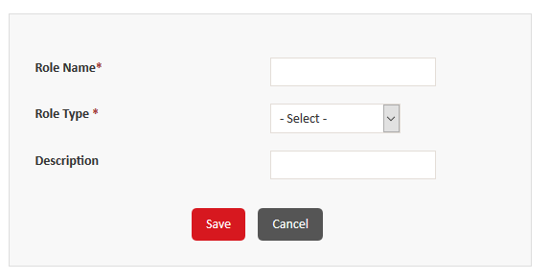

Notes:
- Click Cancel to get routed to the “User Role” screen.
- To sort the records, click on the respective column head of the table. This activity completes the task of adding a user role.
Assign/Remove Privileges:
You can assign access to menus and sub menus to the user role. Alternatively, you can remove access to menus and sub menus from existing roles. This allows restricting access of the users who belong to a selected role.
- On the menu bar, point to My Accounts, and then click User Role to open the User Role screen.
- In the list of roles that are displayed, click Assign Menu to open the Assign Menu screen, where you can assign or remove access for the user role.
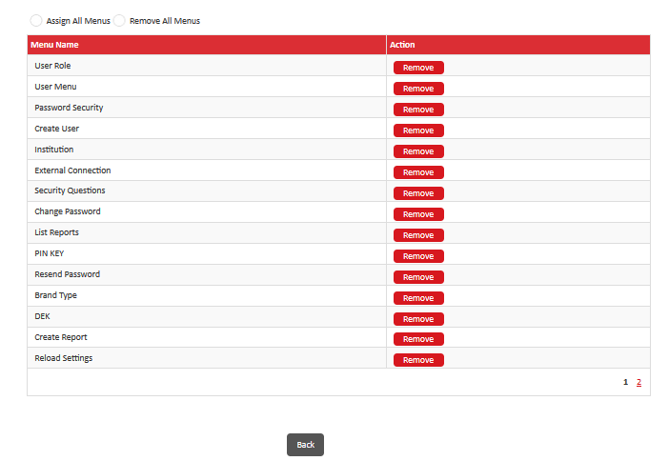
  - Depending on the menus or sub menus to assign, perform one of the following steps:
To assign all of the menus and sub menus - On the top of the screen, click Assign All Menus.
To remove all of the menus and sub menus - On the top of the screen, click Remove All Menus.
To assign access to specific menus and sub menus - In the Action column, click Assign for the menus or sub menus to remove.
To remove access for specific menus and sub menus - In the Action column, click Remove for the menus or sub menus to remove.
  - Click Back to save the changes.
View / Edit User Role:
1. Select the target record and click View (located under the ‘Action’ column). The application displays the following screen:
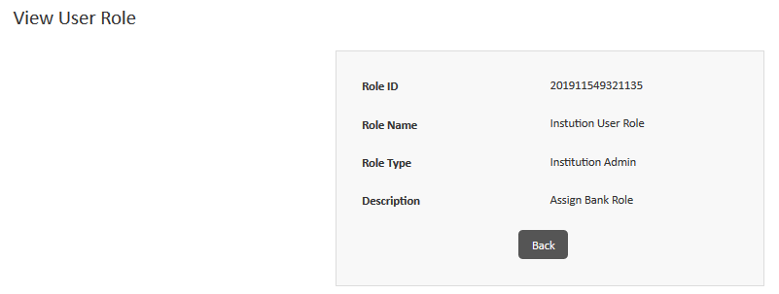
2. Click Back to get routed to the “User Menu” list screen.
3. Select the target record and click Edit (located under the ‘Action’ column). The application displays the following screen:

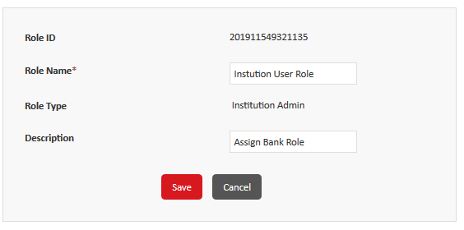
4.Make the required changes and click Save. The application will display a success message:
5. Click Cancel to get routed to the “User Menu” screen
6. To sort the records, click on the respective column head of the table.
Password security:
You can specify the length, recurrence, expiration, lockout, allowed characters, and inactivity details for passwords.
Perform the following steps to view or modify the parameters:
- Point to My Accounts, and then click Password Security to open the Password Security screen.
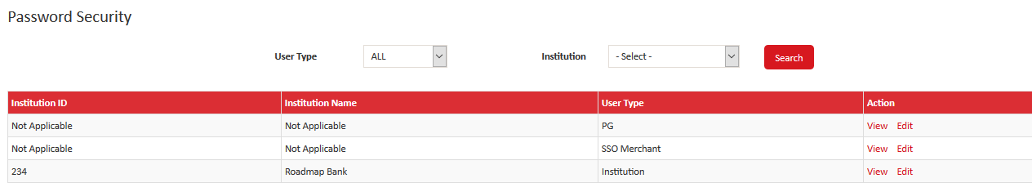
- In the list of parameters that are displayed, click Edit to open the Edit Password Security screen.
- Alternatively, you can click View to open the View Password Security screen, where you can view the parameters.
To Edit Password Security:
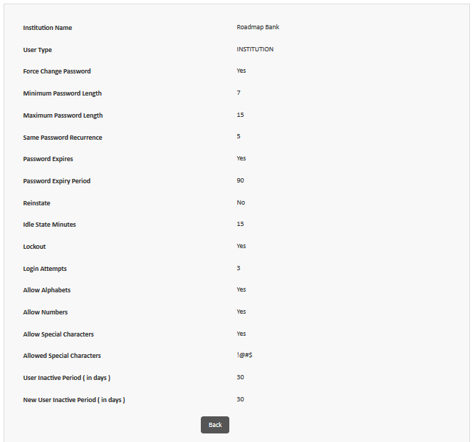
Purpose: The menu is used to configure the security details associated for password creation based on the user type.

To edit the password security details, follow the steps below:
1. Select the target record and click Edit (located under the ‘Action’ column).
2. By default, the application displays the Institution Name details in read-only format.
3. By default, the application displays the User Type details in read-only format.
4. By default, the application displays the Force Change Password details in read-only format.
5. Select the target Minimum Password Length from the available drop-down options.
6. Select the target Maximum Password Length from the available drop-down options.
7. Select the target Enable Password Expires option (Yes/No):
- If Yes is selected, then password expire period will be applicable for the PG user's or Institution user's.
- If No is selected, then password expire period is not applicable. Select the target Enable Reinstate option (Yes/No):
8. If Yes is selected, then terminal in-active due to risk will be validated.
9. If No is selected, then terminal in-active due to risk shall not be validated.
10. Enter Idle State Minutes (ex: 10).
11. Enter Same Password Re-Occurance (ex: 3).
12. Select the target Enable Lockout option (Yes/No):
13. If Yes is selected, then if password failed attempts reached the limit the user account has been locked out.
14. If No is selected, then user account lock out not applicable.
15. Select the target Allow Alphabets option (Yes/No):
16. If Yes is selected, then in auto generated password or user entered password shall allow alphabets
17. If No is selected, then in auto generated password or user entered password shall not allow alphabets
18. Select the target Allow Numbers option (Yes/No):
19. If Yes is selected, then in auto generated password or user entered password shall allow Numbers
20. If No is selected, then in auto generated password or user entered password shall not allow alphabets
21. Select the target Allow Special Characters option (Yes/No):
22. If Yes is selected, then the application displays the following field:
23. If No is selected, then it won’t display to enter the special characters
24. Enter User Inactive Period (ex: 10).
25. Enter New User Inactive Period (ex: 10).
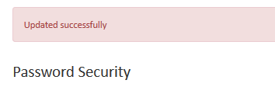
26. Click Save. User will receive the success message

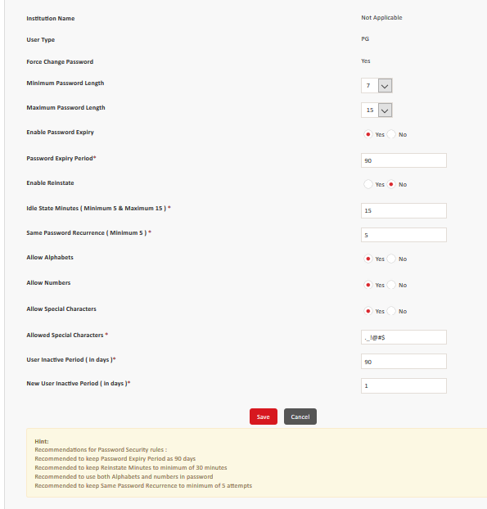
Create User:
Search A User:
- Click My Accounts > Create User in the “Home” screen.
- Select All from the available Search By drop-down option.
- To search for a particular user using the ‘User Name’, follow the steps below:
  - Select User Name in the available Search By drop-down list
  - Enter the User Name (in the field located beside the Search By drop-down list)
  - Click Search.
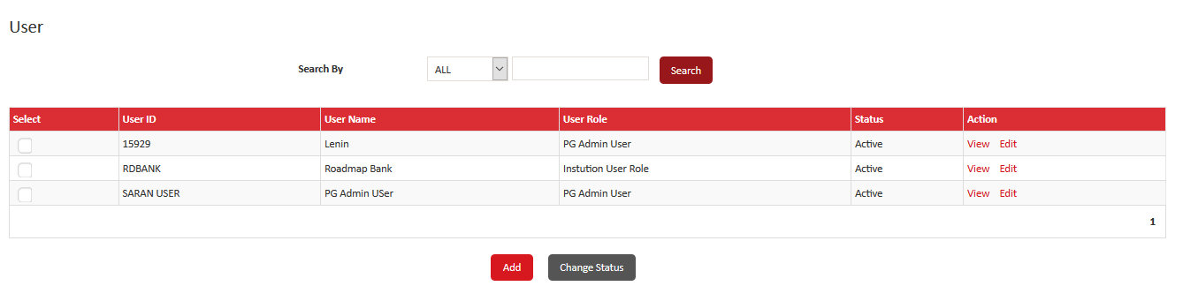

- To search for a particular user using the ‘User Role’, follow the steps below:
  - Select User Role in the available Search By drop-down list
  - Select the User Role (from the drop-down list located beside the Search By drop-down list)
  - Click Search.

Add User:
Steps to add a new user:
1. Navigate to My Accounts > Create User in the “Home Page”.

2. Click Add. The application displays the following screen:
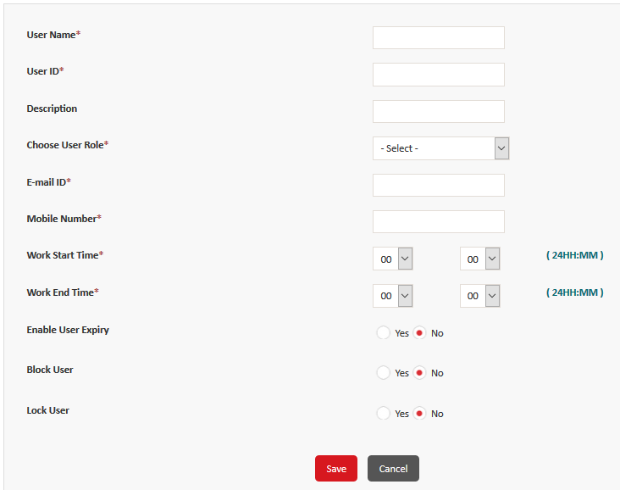
Specify values in the following fields:
- User Name - Type the name of the user.
- User ID - Type a unique alphanumeric user ID for the user. The user ID cannot contain special characters and spaces.
- Description - Type the description of the user.
- Choose User Role - Click the role to assign to the user. The access for the user is restricted based on the role. E-mail ID - Type the email ID of the user.
- Mobile Number -Type the 10 digit mobile number of the user.
- Work Start - Time Click the hour and minute to indicate the beginning of work time for the user.
- Work End Time - Click the hour and minute to indicate the ending of work time for the user.
- Enable User Expiry - Click Yes or No to enable or disable user expiration after the expiry period elapses.
- User Inactive Period ( in days ) - Type the number of inactive days after which the user ID is blocked. Note: This box is available only if you select Yes in the Enable User Expiry field group.
- Block User - Click Yes or No to block or unblock the user ID.
Once clicked on Save the User will be created with the success message.
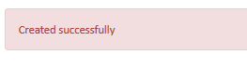
Email will be triggered for the registered email ID as below when the new user is created.
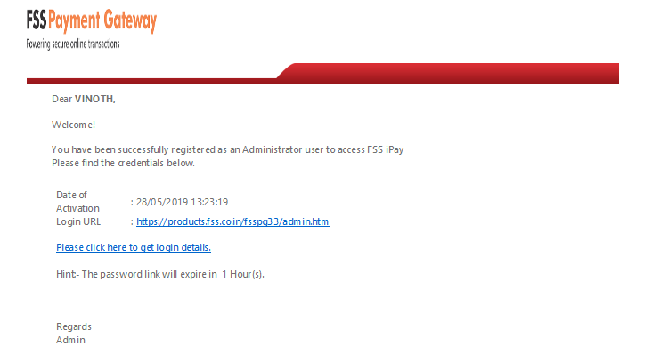

When user clicks on the hyper link to get the login details, the screen will be displayed as below
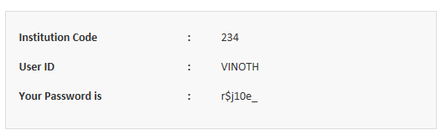
User login to the application with the given url and password.
Security Questions:
The security questions are used to authenticate your user ID in case you forget your password. You can add or update answers for the security questions for your profile.
- Navigate to My Accounts > Security Questions in the “Home Page”.
- Enter the answers to the Security Question and click Save (answer provided in the purpose). The application displays the following success message:
Note: Click Cancel to get routed to the “Home Page”.
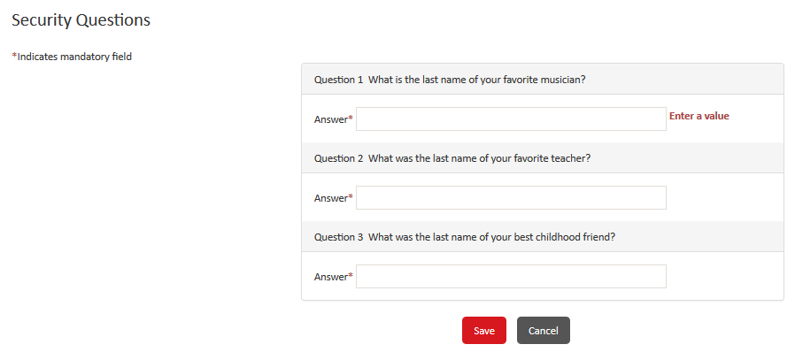

Change Password:
You can change the existing password for your account. It is recommended that you change your password frequently. You must change your password at the first successful logon after your ID is created or after you have recovered your password.
Steps to change the Password:
- Navigate to My Accounts > Change Password in the “Home Page”.
- Enter the Old Password
- Enter the New Password
- Enter the new password again in the Confirm New Password field to confirm it.
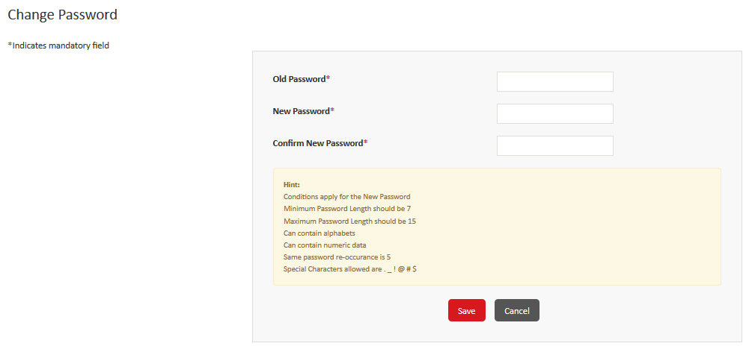
- Click Save.
- Note: Click Cancel to get routed to the “Home Page”.

Resend Password:
You can regenerate the default password for a user and send it to their registered email ID. Additionally, you can send a test email to validate a user’s email ID.
Steps to Resend the password:
- Navigate to My Accounts > Resend Password in the Home Page.
- Select the target User from the available drop-down options.
- Select the target user record checkbox and click Send Mail. The application will display the success message.
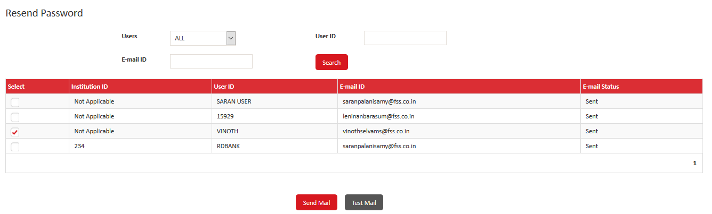
Note: To sort the records, click on the respective column head of the table.
Test Mail:
User can send the Test mail to validate whether the Email ID is appropriate or not.
- To send a test email to an email address, click Test Mail.
- The Test Email dialog box is displayed, type the email address to send the test email to and click OK to send the test email.

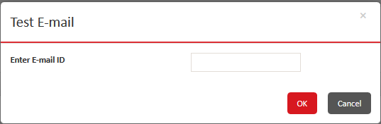

- Click Cancel to get routed to the “Resend Password” screen.
Configurations:
Below are the list of configurations to be setup in-order to securely initiate a transaction.
- Brand Type
- External connection
- Institution/ Institution configuration
- KEK
- DEK
- Pin Key
- Key Store Password
- Risk Alert Configuration
Brand Type:
Brand type is used to configure the Brand details of different cards – Visa/ Master/ Maestro/Dinners/Amex.
Steps to Add a Brand Type:
- Navigate to Configuration, and then click Brand Type to open the Brand Type screen.
- Click Add to open the Add Brand Type screen.
- Enter the Brand Type
- Enter the Description
5. Click on Save
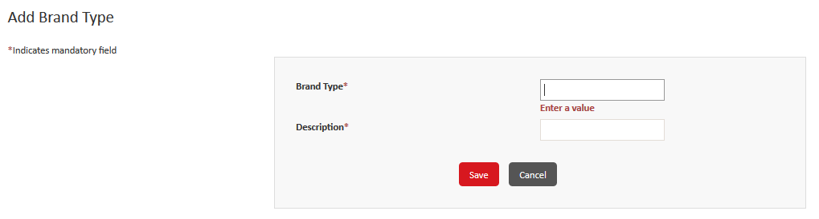
Note: Click on Cancel to return to the Brand Type home screen.
View/ Edit the Brand Type:
You can view the details of a brand type or modify the description of a brand type.
You cannot delete a brand type, but you can change the status of the brand type.
- Navigate to Configuration, and then click Brand Type to open the Brand Type screen.
- Depending on the action to take, perform one of the following steps:
- To view the details of a brand type, click View. Click Back to return to the Brand Type screen.
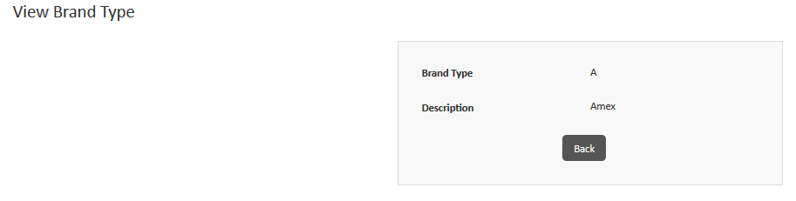

- To modify the description of a brand type, click Edit, and then modify the description. Click Save.
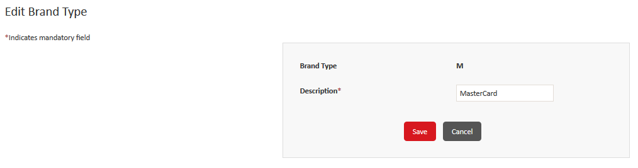
- To change the status of a brand type, in the Select column, select a check box or multiple check boxes to select records, and then at the bottom of the screen, click Change Status.
If a confirmation message is displayed, then click OK.
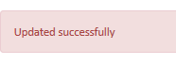
External Connection:
User can configure the FSS Payment Gateway to an external entity such as transaction switch, Visa directory, or MasterCard directory using External connection.
External connection can be created with Transmission Control Protocol/Internet Protocol (TCP/IP) protocol for socket connection or Hyper Text Transfer Protocol Secure (HTTPs) protocol for web URL connectivity.
The TCP/IP connection can be created for Base 24, Aggregator, or Aggregator Echo Application Programming Interface (API) connection types. A connection can be created for each application instance.
Note: You must configure all three types of API Connections (Base24, Aggregator, or Aggregator Echo).

Steps to Create External Connection for HTTPS:
- Navigate to Configuration, and then click External Connection to open the External Connection screen.
- Click Add to open the Add External Connection screen.
- Enter the External connection ID.
- Enter the External connection description
- Choose the Protocol as HTTPS.
- In the Formatter Type field , choose any one of the following radio button
  - Bank Based
  - Default
7. Enter the name of the Formatter
8. Choose Connectivity Mode list, click a connectivity mode to use for the external connection. Based on the value that you select, the remaining fields on this screen may vary.
9. Specify values in the following fields for the HTTP s connection:
Source - Type the source URL to use for the external connection.
Note: This field is displayed only if you select Nodejs in the Choose Connectivity mode list.
Destination - Type the destination URL to use for the external connection.
Note: This field is displayed only if you select Nodejs in the Choose Connectivity mode list.
Choose Connectivity Type - Click Primary or Alternate to indicate the type of connection. If you click Alternate, then the Choose Primary External Connection ID list is displayed.
Choose Primary External Connection ID - Click the connection to use as the primary connection.
Note: This list is displayed only if you select Alternate in the Choose Connectivity Type list.
Enable BICI Flag - Click Yes to enable the payment gateway to connect directly to BICI switch.
Alternatively, click No to connect through an intermediate switch.
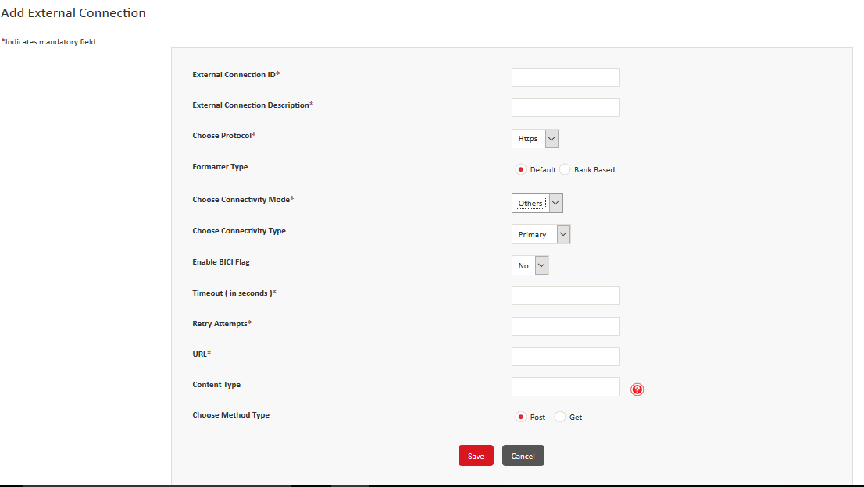
Authorization Entity - Click Switch or Interchange or HSM to indicate the authorization entity for the key.
Timeout (in seconds ) - Type the time in seconds after which an idle connection is timed out.
Retry Attempts - Type the number of retry attempts for the connection.
URL - Type the URL to connect to.
Content Type - Type the type of content or file that is sent to the external system. For example, application/XML or application/TXT.
Choose Method Type - Click Post or Get to indicate the type of method to use for the connection.

Steps to Create External Connection for TCPIP:
- Navigate to Configuration, and then click External Connection to open the External Connection screen.
- Click Add to open the Add External Connection screen.
- Enter the External connection ID.
- Enter the External connection description
- Choose the Protocol as HTTPS.
- In the Formatter Type field , choose any one of the following radio button
  - Bank Based
  - Default
- Enter the name of the Formatter
- Choose Connectivity Mode list, click a connectivity mode to use for the external connection. Based on the value that you select, the remaining fields on this screen may vary.
- Specify values in the following fields for the TCPIP connection
- In the Authorization Entity list, click one of the following options to indicate the authorization entity for the key:
- Switch
- Interchange
- HSM
In the Authorization Type list, click Visa or Master to indicate the interchange that will authorize the key.
Note: This list is displayed only if you selected Interchange in the Authorization Entity list.
11. In the API Connection Type list, click one of the following options to indicate the API connection type:
o Base 24 o Aggregator o Aggregator Echo
The remaining fields on this screen are displayed depending on the API connection type.
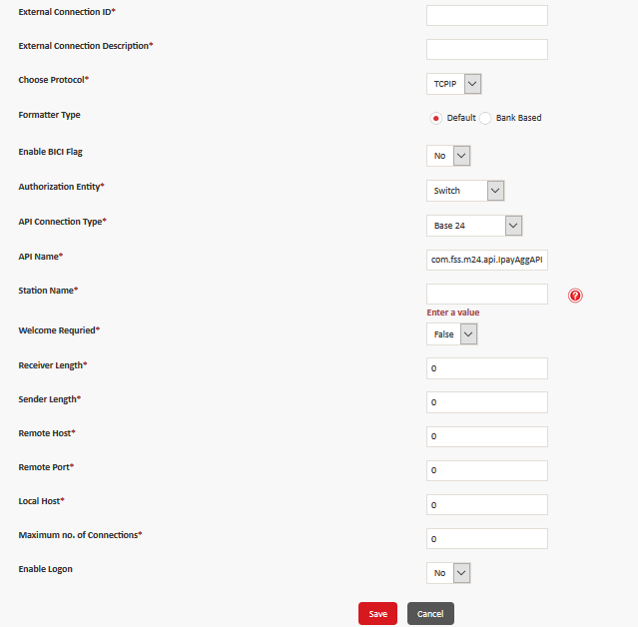
API Name - Displays the URL where the APIs are available for the connection. The value in this box depends on the authorization
Station Name - Type com.fss.m24.api.IpayAggAPI as the name of the station. Welcome Required Click True or False to enable or disable logon for Base 24, Visa, and MasterCard.
Receiver Length - Depending on the type of connection, type one of the following values:
• For Base24 API connection, type 2
• For Aggregator API connection, type 2
• For Aggregator Echo API connection, type 4
Sender Length - Depending on the type of connection, type one of the following values:
• For Base24 API connection, type 2
• For Aggregator API connection, type 2
• For Aggregator Echo API connection, type 4
Remote Host - Type the Base 24 host address for the connection.
Note: This field is available only for Base 24 API connection type.
Remote Port - Type the Base 24 port number for the connection.
Note: This field is available only for Base 24 API connection type. Local Host Type the manager server IP address for the connection.
Local Port - If you clicked Aggregator or Aggregator Echo in the API Connection Type list, then type the manager server port number.
Note: This field is not available for Base 24 API connection type.
Timeout ( in seconds ) - If you clicked Aggregator or Aggregator Echo in the API Connection Type list, then type the time in seconds after which a connection request is timed out.
Note: This field is not available for Base 24 API connection type.
Retry Attempts - If you clicked Aggregator or Aggregator Echo in the API Connection Type list, then type number of times a connection should be retried.
Maximum no. of Connections - Depending on the type of connection, type one of the following values:
• For Base24 API connection, type 1 for each manager server
• For Aggregator API connection, type 50 or more each manager server
• For Aggregator Echo API connection, type 1 or more for each manager server
Host Event - Click Yes or No to indicate that host event is triggered or not triggered by the connection.
Event Interval ( in seconds ) - If you clicked Yes in the Host Event list, then type the time period interval between host events, in seconds.
Target Host - Type the URL of the target host.
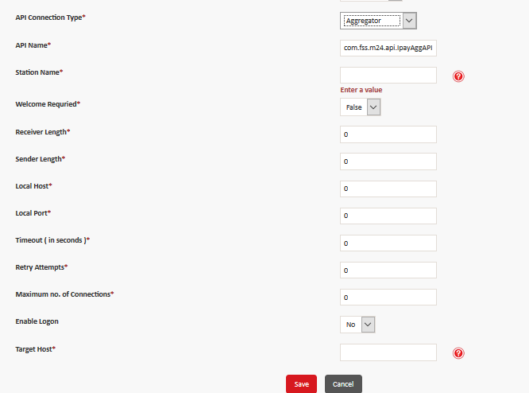
Note: This field is available only for Aggregator API connection type.

Institution:
- To Search an Institution:
- Click Configuration > Institution in the “Home Page”.
- Select All from the ‘Search By’ drop-down options.
Search for a particular institution using the Institution ID/Institution Name/ All, follow the steps below:
- Select Institution ID / Institution Name/ All from the available ‘Search By’ drop-down options.
- Enter Institution ID / Name (in the field located beside the ‘Search By’ drop-down).
- Click Search. The application displays the following screen:

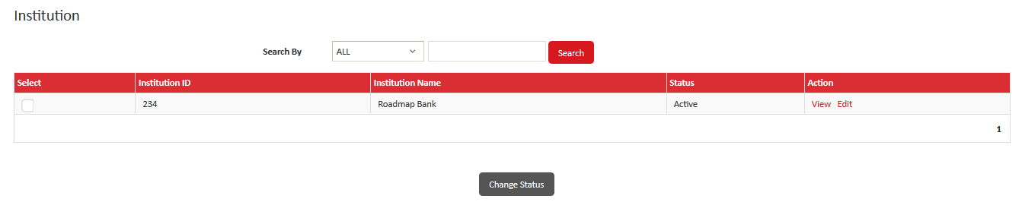
To View the Institution:
- Click Configuration > Institution Password in the “Home Page”.
- Select the target record and click View (located in the ‘Action’ column). The application displays the following screen:
Click the respective tabs to view the Institution, Address, Contact, and Configuration details.
Note: To sort the records, click on the respective column head of the table.

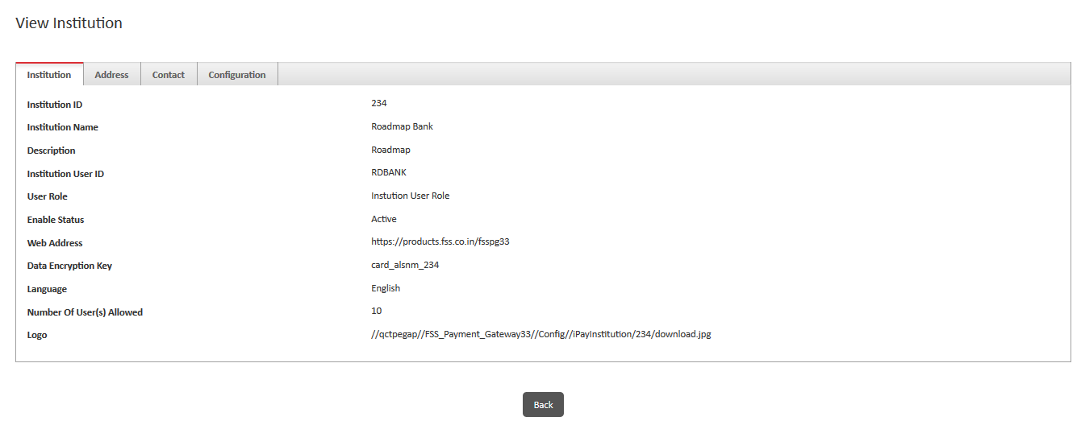
To Edit the Institution:
Pre-requisite: The ‘Edit’ link is displayed under the ‘Action’ column only if the status of the institution is ‘Active’.
- To edit the selected institution details, follow the steps below:
- Click Configuration > Institution Password in the “Home Page”.
- Select the target Search By from the available drop-down options .
- Select the target record and click Edit (located in the ‘Action’ column).
- Click the respective tabs to view and edit the Institution, Address, Contact, and Configuration details.
- Make the required changes and click Save.
- Click Cancel to get you routed to the “Institution Search” screen.

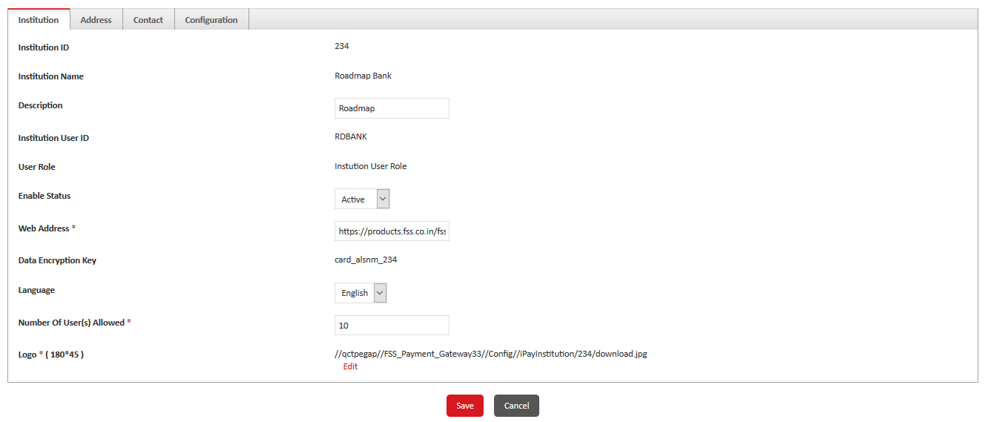
Institution ID - Enter the Unique ID for the Institution
Institution Name - Enter the Name of the Institution.
User role: Displays the role that the administrator user belongs to. You cannot modify this value.
Enable Status: Displays the Status of the Institution Created.
Web Address: Enter the Web Address of the Institution
Data Encryption Key: Displays the data encryption key for the institution. You cannot modify this value.
Language: Choose the Language as English
Number of Users Allowed: Enter the total number of user allowed for the Insitution
Logo (180*45) : Click Edit to modify the logo of the institution. The Logo box and Browse button are displayed. Click Browse to select and upload a different logo.
Address: Enter the Address details of the Institution.

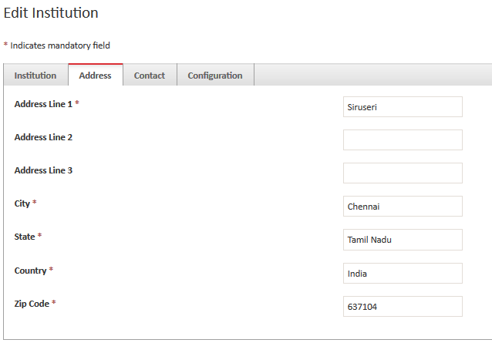
Contact : Enter the contact details of the Institution
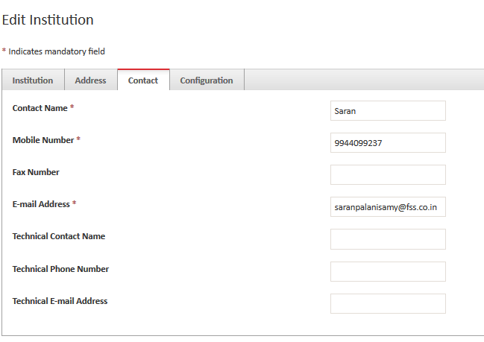
Configuration Tab in Institution:
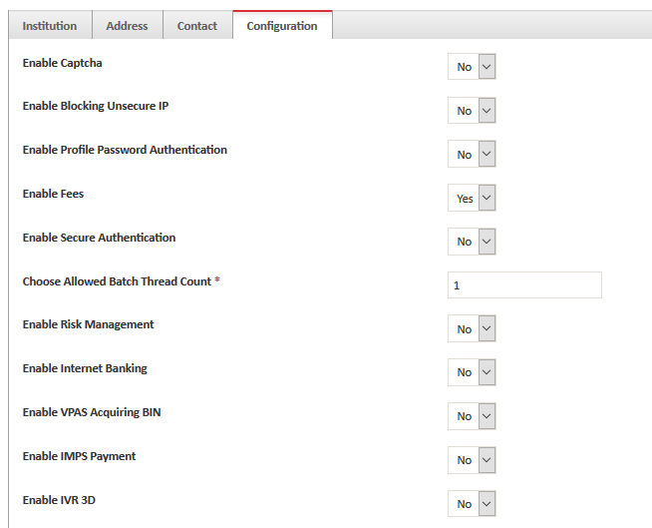
Enable captcha: Enabling this flag, will display captcha at payment page.
Enable Blocking Unsecure IP: Enable or Disable to block unsecure IP during transaction.
Enable Profile Password Authentication: Click Yes or No to enable or disable profile password authentication for the bank and merchant users of the institution. If you click Yes, then the bank and merchant users must specify the profile password to access transaction and configuration modules.
Enable Fees: Enable or Disable fees on Transactions
Enable Secure Authentication: Enable or Disable secure Authentication.
Choose Allowed Batch Thread count: Allows user to run the no of Batch transaction threads for the Institution. Eg: 1 – Single thread runs single batch process.
Enable Risk Management – Enable or disable risk management for the institution.
Enable Internet Banking - Enable or disable payments through internet banking.
If Enabled following field will appear.
• Internet Banking prefix– Type the prefix to use for internet banking.
• Internet Banking URL – Type the URL for internet banking.
• Internet Banking Inquiry URL – Type the inquiry URL for internet banking.
• Internet Banking Connection Timeout – Type the time in seconds after which an inactive internet banking session is timed out.
• Internet Banking Read Timeout – Type the time in seconds after which inactive internet banking read request is timed out.
Enable VPAS Acquiring Bin -
VPOS/VPAS – Visa Pont of Sale / Authentication server
Enable or disable Visa Pont of Sale (POS) Authentication Server (VPAS) acquiring BIN for multi currency transactions. If you click Yes, then one VPAS acquiring BIN for each currency will be used for 3D secure authentication.
Enable IMPS Payment : To Enable or disable IMPS Transaction.
Enable IVR 3D: To Enable or Disable IVR (Interactive Voice Response) for 3D Transactions.
Choose Cryptographic Method: Enabling or disabling the cryptographic method will allow bank to create merchants with different cryptographic method such as Plain text, Encryption & Hashing.
Choose Authorization Level: You cannot modify this value. If this field displays the values Only Verification Required or Verification and Authorization Required, then maker, checker, and authorizer functionality is enabled for the institution.
Enable OTP: Enable or Disable usage of OTP authentication for transactions.

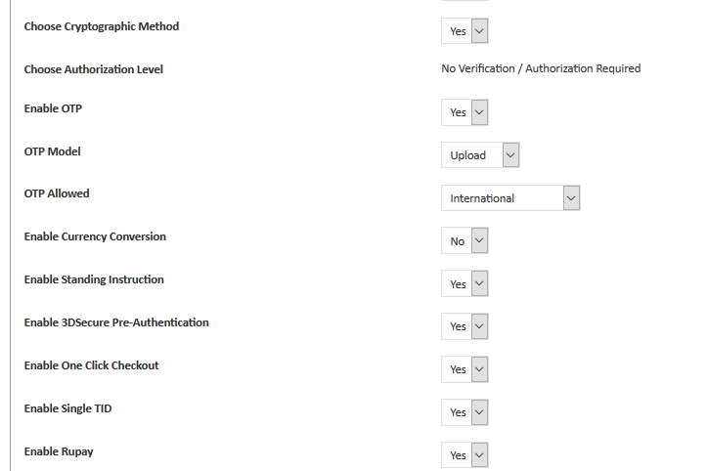
Enable Currency conversion: Enable or Disable currency conversion for transactions
Enable Standing Instructions: Enable or Disable SI for the Institution
Enable 3D Secure Pre-Authentication - Enable or Disable 3D secure pre-authentication flag for transactions for which authentication is to be done by 3D secure and authorization is to be done by FSS Payment Gateway.
Enable One- Click Checkout- Enable or disable one click checkout for Merchants allowing users to save and use the faster payment option.
Enable Single TID- Click Yes to manage multiple merchants on a single terminal ID. Alternatively, click No.
Enable Rupay: Enable or disable for Rupay Transactions.
• Caller ID – Type the identification code of the caller to use for RuPay transactions.
• Token – Type the token to use for RuPay transactions.
• User ID – Type the user ID to use for RuPay transactions.
• Password – Type the password to use for RuPay transactions.
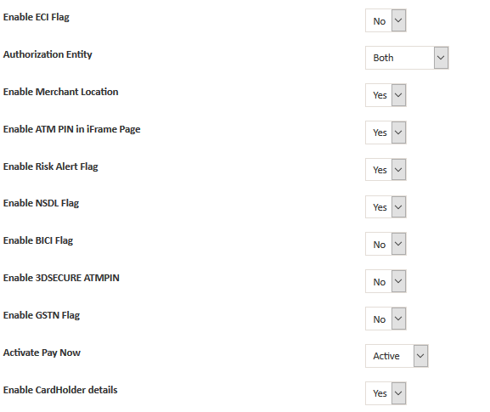
Enable ECI Flag: Click Yes or No to enable or disable the 3-D Secure authentication for debit card transactions.
Authorization Entity - Click one of the following options to indicate the authorization entity to use for the institution: • Switch • Interchange • BOTH
Enable Merchant Location - Display the first two characters of the ISO defined merchant location code. Alternatively, click No to display the all three characters.
Enable ATM PIN in iFrame Page - Click Yes or No to enable or disable ATM PIN in the iFrame screen.
Enable Risk Alert Flag - Click Yes or No to enable or disable risk alerts for the institution.
Enable BICI Flag - Click Yes to enable the payment gateway to connect directly to BICI switch. Alternatively, click No to connect through an intermediate switch.
Enable GSTN: Enable or disable this flag to collect tax from the customers through bank.
Enable Activate Pay Now: Enable or disable this flag to activate pay now features for the small scale merchants
Enable Cardholder details – Cardholder information such as name, address, email id, phone number will be acquired by the customers if the flag has been enabled.
Click Save to save the changes.
Institution Configuration :
User can configure institution level parameters in FSS Payment Gateway.
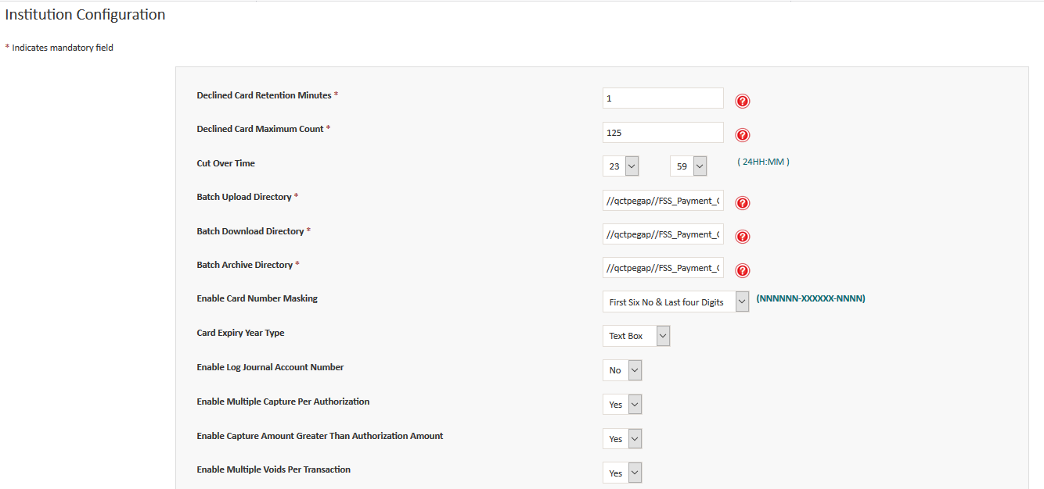
Declined Card Retention Minutes: To set the maximum number of retention minutes for the maximum transaction counts.
Declined Card Maximum Count: maximum number of transactions allowed in the time specified in the Declined Card Retention Minutes . Any transaction above the maximum count is declined until the retention duration has elapsed or the count for the retention period duration is less than or equal to the limit.
Cut Over Time: Daily Cut over time for the institution.
Batch Upload Directory: Directory path where the batch processed file is upload.
Batch Download Directory: Directory path from where the batch processed file is downloaded.
Batch Archive Directory : Type or modify the path and name of the batch processes archive directory.
Enable Card Masking:
• Show All – Display all the digits of the card numbers.
• Last Four Digits – Display only the last four digits of the card numbers. The first 12 digits are masked.
• First Six No & Last four Digits – Display the first six and last four digits of the card numbers. The remaining six digits are masked.
Card Expiry Type: Depending upon the option selected, card expiry type will be displayed in the payment page.
• Text Box
• Select box - If you click this, then the Card Expiry Year list is displayed.
Enable Multiple Capture Per Authorization - Enable or disable multiple captures for each authorization. Enable Capture Amount Greater Than Authorization Amount - Enable or disable capturing an amount greater than authorization amount for transactions.
Enable Multiple Voids Per Transaction - Enable or disable multiple void transactions for each transaction. Enable Void Amount Greater Than Original Amount - Enable or disable creating a void transaction for an amount greater than the original amount.
Enable Multiple Credits Per Debit - Allow or block multiple credits for a single debit transaction.
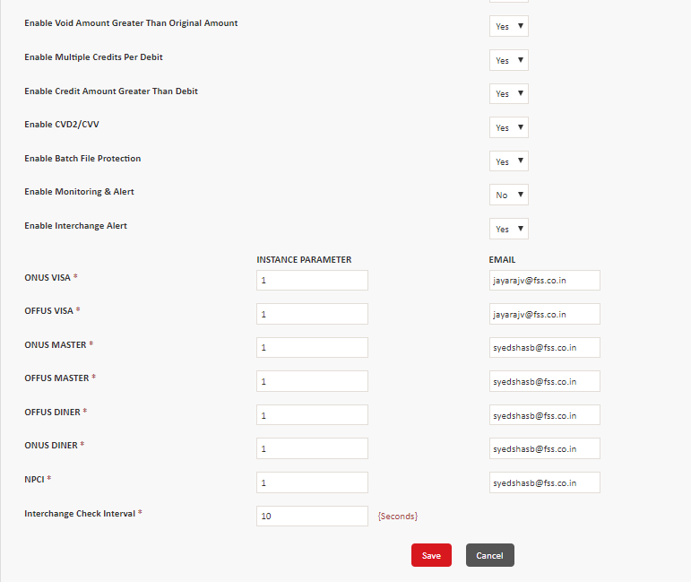
Enable Credit Amount Greater Than Debit - enable or disable crediting an amount greater than debit amount.
Enable CVD2/CVV - Enable or Disable Card Verification Data 2 (CVD2) or Card Verification Value (CVV) for authenticating transactions.
Enable Batch File Protection – Enable or disable to protect batch files.
Enable Monitoring Alert - Enable or disable monitoring and alerts. Email ID should be entered if enabled.
Enable Interchange Alert - Enable or disable the interchange alerts
If Enabled, then the type of transaction, Instance Parameter, and E-mail columns, and Interchange Check Interval box are displayed.
Perform the following steps:
- For each transaction type, in the Instance Parameter column, specify the number of transactions declined due to risk after which an alert is sent. The maximum value can be 99.
- For each transaction type, in the Email column, type the email ID to send the email alerts to.
- In the Interchange Check Interval box, type the time interval in seconds to send interchange alerts.
Encryption Types:
There are 4 Types of encryption available in FSS Payment Gateway
- DEK – The DEK is used to encrypt the sensitive data, such as card numbers.
- KEK – The KEK is used to encrypt the DEK.
- PIN encryption key – The PIN encryption key is used to encrypt the PINs of users.
- KeyStore passwords – The DEK and KEK are stored in a KeyStore that is protected using two KeyStore passwords.
KEK- Key encryption Key:
KEK is a single key for iPay application but DEK will be maintain as separate key for every institution.
Purpose of the KEK is to securely encrypt the DEK and store in the keystore file.
Note: KEK can be rotated but not DEK. It means over a period of time KEK will be changed and during that process all the encrypted DEK will be decrypted and re-encrypt by the new KEK and store it in the keystore.
KEK will be added to the Institution by default, If not available the card alias name will be displayed as NO Card Key. Alternatively you can rotate the KEK and remove the old KEK and replace with the new KEK.
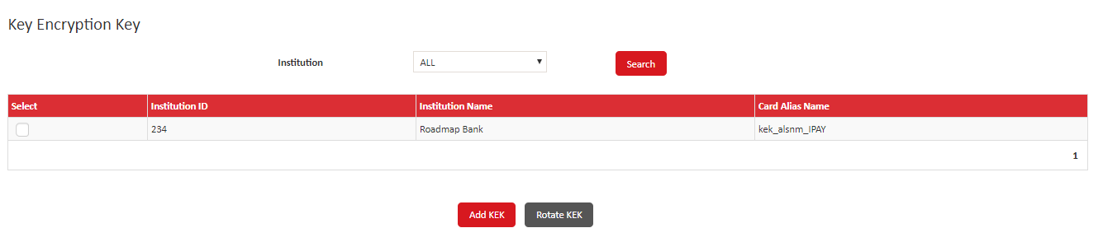
Steps to reset the KEK:
- Navigate to Configuration > KEK in the “Home Page”. The “Key Generation” screen is displayed as shown above.
- Select the target Institution from the available drop-down options.
- Click Search.
- Click Rotate KEK. It displays screen above and enter your old key store password click the validate button.
- Enter your new key store password and click the save button the application displays the following success message.
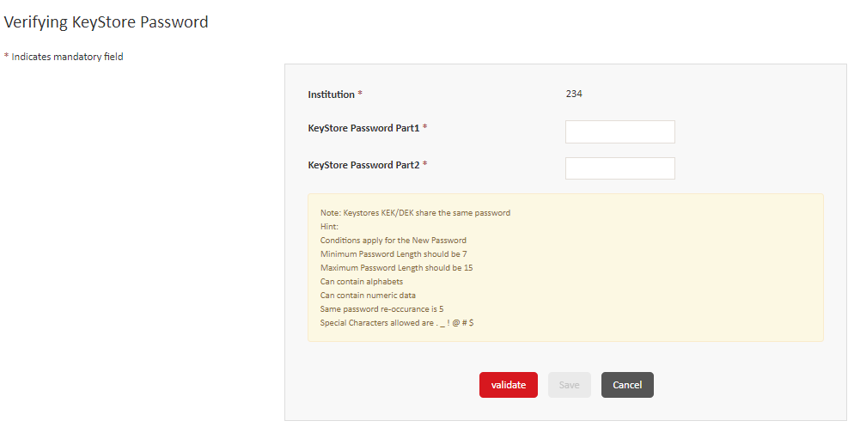
- The KEK file is not present in the directory to click the add KEK button the KEK is successfully added and displays the success message
DEK – Data Encryption Key :
The DEK is generated and added to the institution when the institution is created. You can add a DEK in case when the DEK was not generated. The Card Alias Name column is updated as No Card Key for the institutions for which DEK is not added.
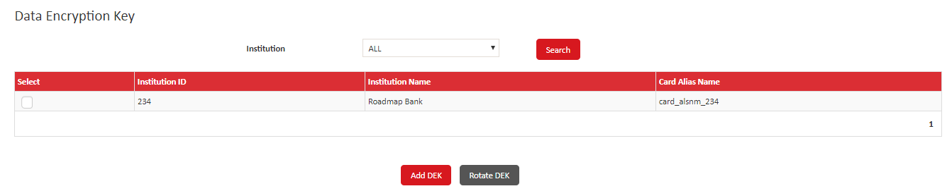
Steps to reset the DEK:
1. Navigate to Configuration, and then click DEK to open the Data Encryption Key screen. .
2. In the Institution list, click an institution and click Search.
- Select the target Institution record.
- Click DEK. System should display the success message.
You can add the DEK for institutions for which DEK has not been generated. The Card Alias Name column for such institutions is updated as No Card Key
- In the Verifying KeyStore Password screen, in the KeyStore Password Part1 and KeyStore Password Part2 boxes, type the two KeyStore passwords, and then click Validate to validate.
- If a confirmation message is displayed, then select the user to change the passwords for, and then click OK.
- iii. The Change KeyStore Password screen is displayed. You must change the KeyStore password in order to complete the DEK rotation. To do so, in the New KeyStore Password Part1 and New KeyStore Password Part2 boxes, type the new KeyStore passwords, and then click Save to rotate the DEK.
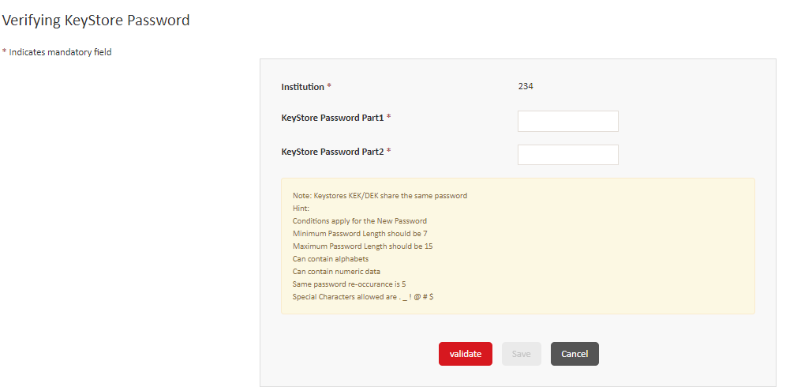
PIN Encryption Key:
You can add a software or hardware security module (HSM) PIN encryption key.
Steps to configure Pin Key
1. Navigate to Configuration, and then click PIN Encryption Key to open the PIN Encryption Key screen.
2. In the Institution ID list, type the numeric identification code of the institution to create the PIN encryption key for.
3. In the Encryption Mode list, click one of the following modes to use:
o CBC – Cipher block chaining
o EBC – Electronic Codebook
- In the Padding type list, click a type of padding.
- In the PIN Block Format list, click one of the following options:
o ANSI
o PINPAD –If you click this option, then the PIN Pad Character box is displayed, type any alphabet to use as the PIN pad character.
6. In the Key Type list, click one of the following options:
o Software – Click this option to add a software key.
7. Authorization Entity - Click one of the following options to indicate the authorization entity for the key:
  - Switch
  - Interchange
- Pin Key Value: Enter the Key Value (ex: C83BFE868A3BDF83) It can contain digits from 0 to 9 and characters from a to f
- Algorithm - Click Data Encryption Standard (DES) or TripleDES as the encryption algorithm
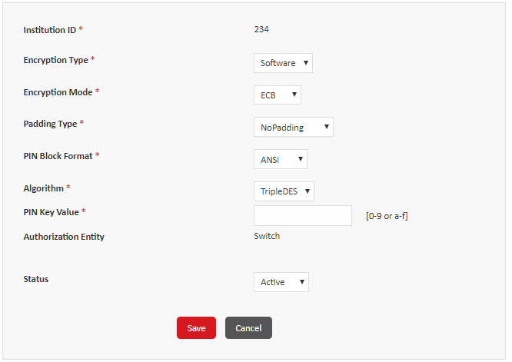
HSM- Click this option to add a HSM Key
- HSM Type - Click RACKAL or ERACOM to indicate the type of HSM.
- IP Address - Type the Internet Protocol (IP) address for the HSM key.
- Port Number - Type the port number for the HSM key.
  - Click Save to save the PIN encryption key.
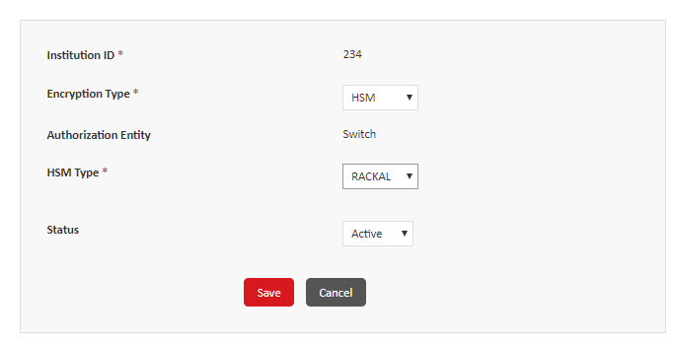
Change Keystore Password:
Steps to change the Keystore Password:
1. navigate to Configuration ->Change Key Store Password in the “Home Page”.
- In the Institution list, click the institution to change the KeyStore Passwords for.
- In the KeyStore Password Part1 and KeyStore Password Part2 boxes, type the two KeyStore passwords.
- Click Validate, and then click OK in the Confirm Password Change dialog box.
- The Change KeyStore Password screen is displayed, type the new KeyStore passwords one by one in both the boxes.
- Click Save to save the new passwords.
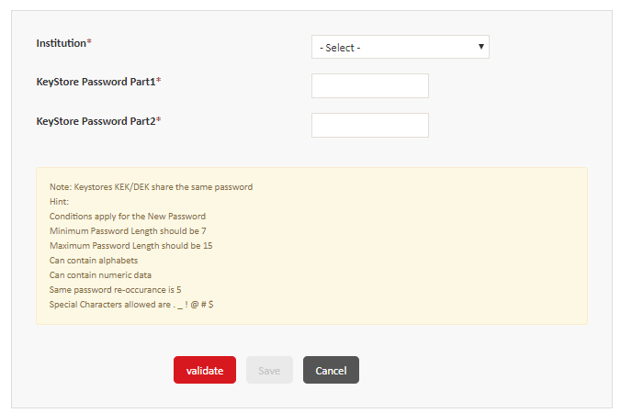
Listener Configuration:
FSSPG can be deployed in many manage server. However the listener servlet should be configured in only one manage server. You can modify/view the listener configuration in this screen. These configuration details are running from the backend.
- Navigate to Configuration, and then click Listener Configuration to open the Listener Configuration screen.
- You can view or modify the listener configuration.
- Status of all the listener config should be in active state. You can modify the status by clicking on Edit and change the status to Inactive.
- In the Run On list, click an option to indicate the number of managed servers to run the listener on. The listener for Payment Gateway 3.1.0 must be run only one managed server, therefore click Single. The Managed Server Name box is displayed.
- Modify the name of the Manage server and click Save.
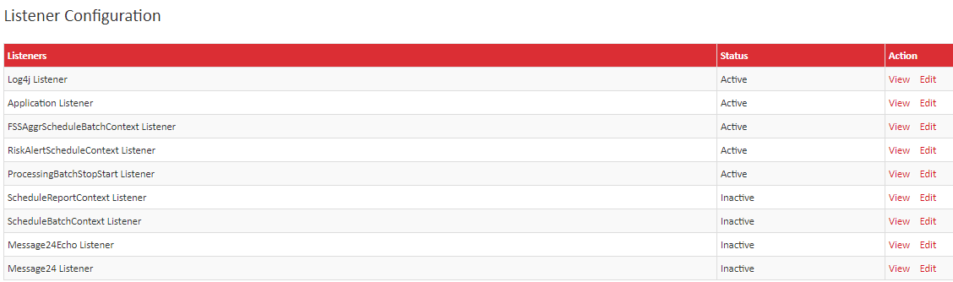
Edit a Listener configuration:
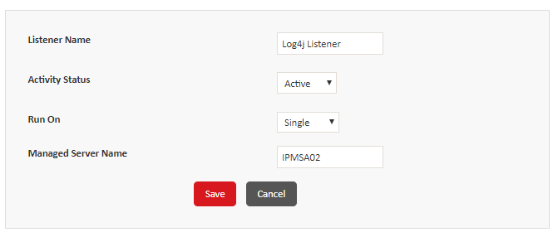
View a Listener configuration:
Reload Settings:
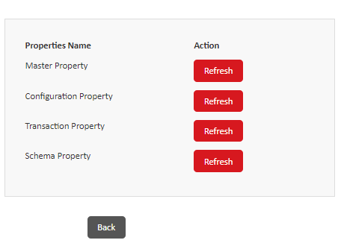
This option helps to refresh the server to update all of the configuration information on the server. This is required only if the property file has been updated by the administrator.
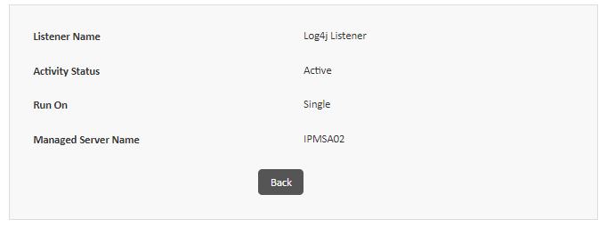

- Navigate to Configuration > Reload Settings in the “Home Page”.
- Select the target Property Name and click Refresh.
- The application displays the following success message:
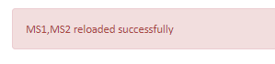
Risk Alert Configuration:
Alert Messages shall be sent via email and SMS if any of the risk validation fails. This configuration can be set up for the following items
- Risk Alert
- Interchange Alert
- One- Click checkout

Risk Alert configuration:
Alert message such as Email and SMS will be sent to the corresponding user through the configuration setup under this screen.
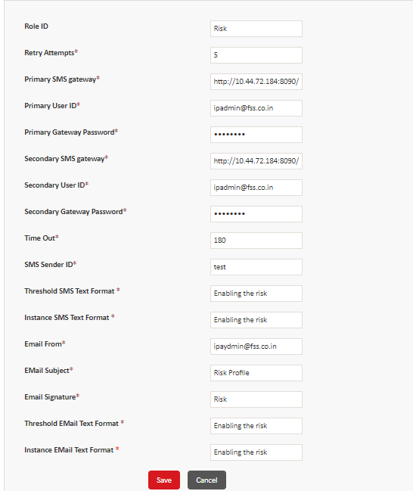
- Point to Configuration, and then click Risk Alert Configuration to open the Risk Alert Configuration screen.
- Click Add to open the Risk Alert Configuration screen.
- Enter all the configuration details for that particular institution.
- Click Save to configure the risk parameters.

Reports:
Admin can Create and download the institution base transaction reports.
Reports can be created using static URL or dynamic parameters, such as table, query, etc. Also the created reports can also the modified.
To Create a Report:
- Navigate to Reports, and then click Create Report to open the Create Report screen.
- Click Add to open the Report Builder screen.
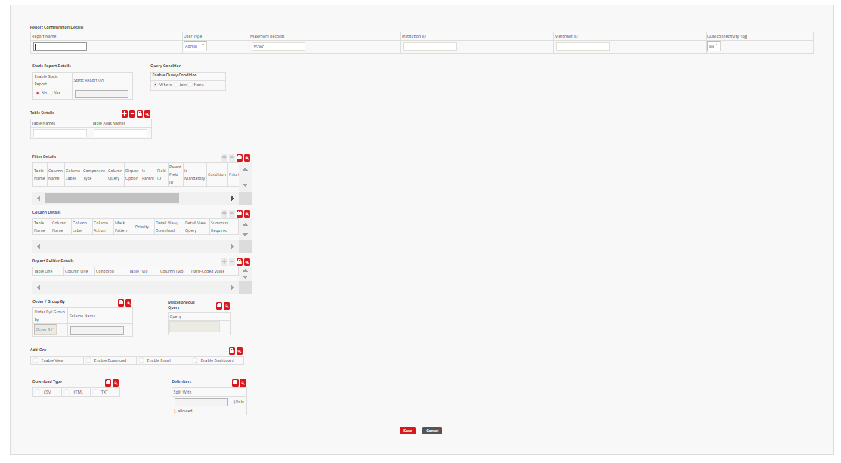
- Enter Report Name (ex: Merchant summary report)
- Select the target User Type from the available drop-down options.
- Enter Maximum Records (ex: 1000).
- Enter Institution ID (ex: 1234)
- Enter Merchant ID (ex: 123456)
- Under Static Report Details section:
- If Yes is selected, then the application enables the ‘Static Report URL’ field and disables the ‘Query Condition’ and ‘Table Details’.
- If No is selected, then the application enables the ‘Query Condition’ and ‘Table Details’.
- Under Query Condition section:
- Select the target Query Condition.
- If Join is selected, the application displays ‘Join Types’ table
- Enter Table Name (ex: traninfo)
- Enter Table Alias Names (ex: tran)
- Under Join Types section:
- Select the target Join Type from the available drop-down options.
- Under Filter Details section:
- By clicking unlock button we can add the filter details
- Under Column Details section:
- Only person who knows the column details they can create the reports
- Under Report Builder Details section:
- If reports required multiple table combination,report builder is required.
- Under Order/Group By section:
- To add new Order/Group By details, click lock.
- Select Order/Group By.
- Enter Column Name.
- Under Miscellaneous Query section:
- Direct query can fetch the report.
- Under Add-Ons section:
- To enable the fields, click lock.
- Select the target Add-On by selecting the respective check box.
- Under Email Details section:
- To enable the fields, click lock.
- Enter E-mail ID.
- Enter E-mail Host IP.
- Under Download Type section:
- To enable the fields, click lock.
- Select the target Download Type by selecting the respective check box.
- Under Delimiters section:
- To enable the fields, click lock.
- Enter Split With delimiter
- Click Save. It will display the following success message.
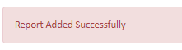
- Click Cancel to get routed to the “Create Report” screen.
To Edit a Report:
Click Reports > Create Report in the “Home Page”.
Click Edit (located in the ‘Action’ column). The application displays the following screen:
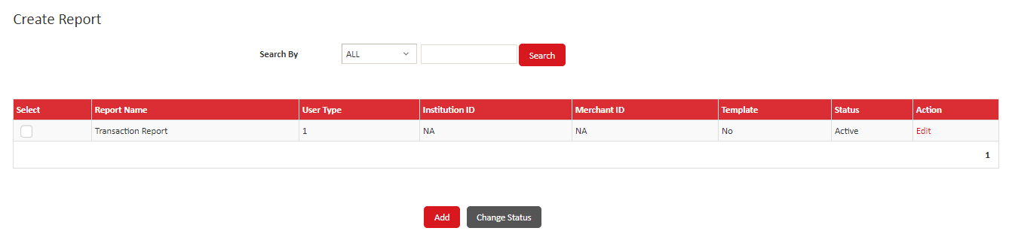
Modify the required details and click Save.
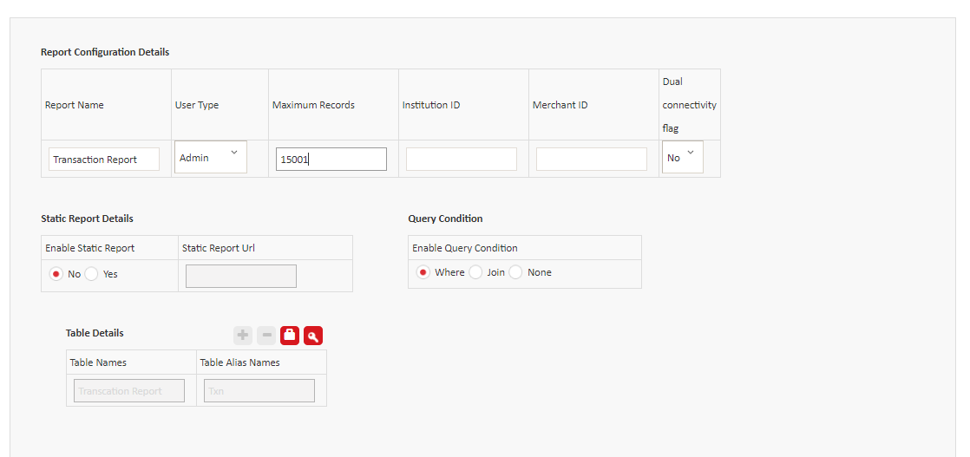
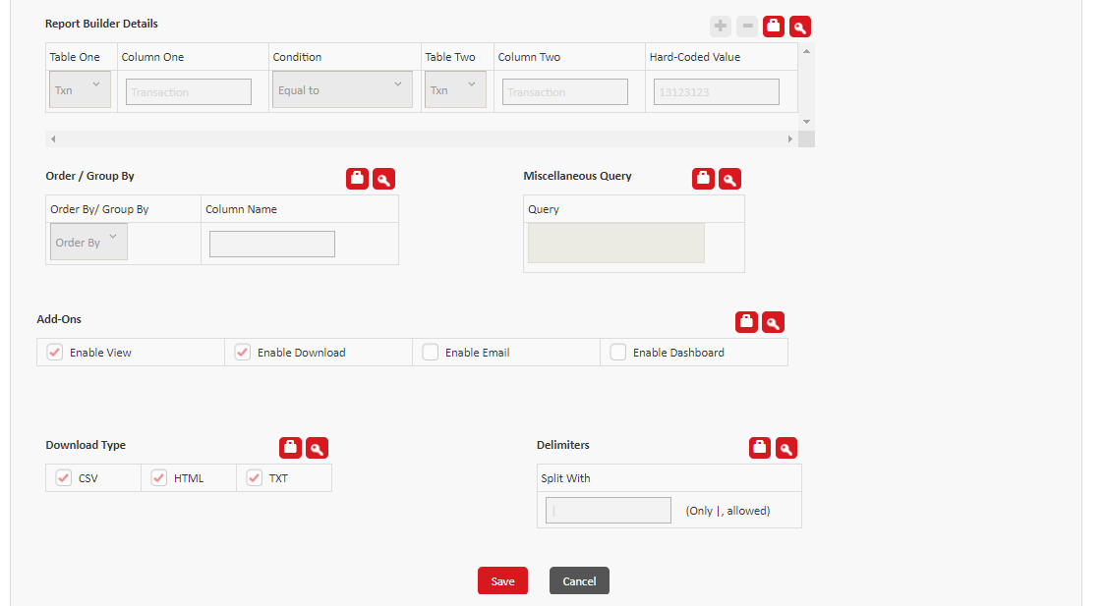
The application displays the following success message:
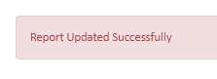
List Report:
It List all the reports created.
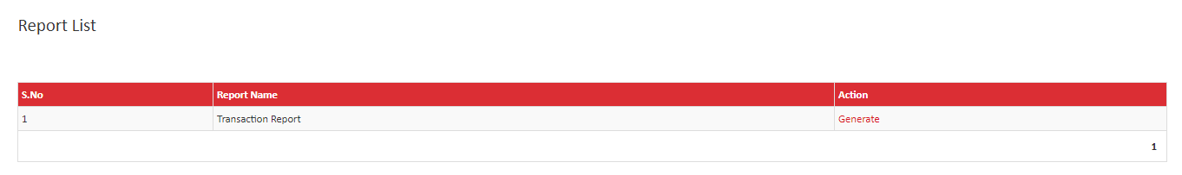
User can able to View/ download the report using CSV, HTML and TXT format when clicked on generate.
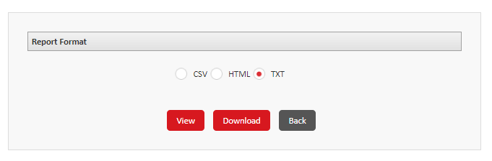

Bank Login:
All the functionality remains the same as per the admin login for the below:
- User role
- Create User
- Password Security
- Security Questions
- Change passwords
- Resend password
MCA Group (Maker, Checker, and Authorizer):
The MCA group and information is used if the authorization level for the institution is configured as Only Verification Required or Verification and Authorization Required by the bank administrator user.
User can view or modify MCA groups. You can change the status of a user group from Active to Inactive or Inactive to Active but cannot delete MCA groups.
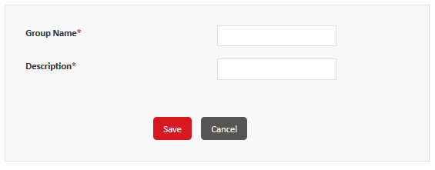
Create an MCA group:
- Navigate to My Accounts, and then click MCA Group to open the MCA Group screen.
- Click Add to open the Add MCA Group screen.
- In the Group Name box, type the name of the group to create.
- In the Description box, type the description of the group.
- Click Save
Edit/View the MCA group:
Navigate to My Accounts, and then click MCA Group to open the MCA Group screen.
In the Search By list, click one of the following options:
- ALL – Select this option to display the list of all records.
- Group Name – Select this option to search using the name of a group, and then in the box, type the name of the group to search for.
- Click Search.
In the list of groups, depending on the action to take, perform one of the following steps:
- To view the details of a record, click View. Click Back to return to the MCA Group screen.
- To modify the description of a group, click Edit, and then modify the description. Click Save.
- To change the status of a group, in the Select column, select a check box or multiple check boxes to select records, and then at the bottom of the screen, click Change Status.
If a confirmation message is displayed, then click OK.
Institution Branding:
Branding details to be displayed under payment page can be configured under this feature. User can also view or modify the already added branding details.
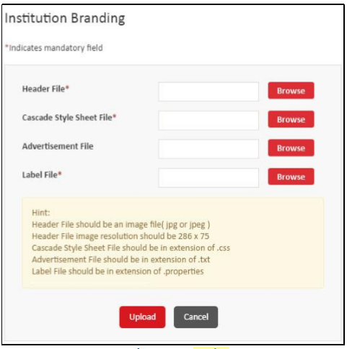
- Navigate to Configuration >Institution Branding to open the Institution Branding screen.
To Upload the branding files:
- Click Browse to open the File Upload dialog box.
- Depending on the section, select a file to upload.
The following table contains the information about the format of the file to upload:
- Header file – JPG or JPEG
- Cascade Style Sheet File - CSS
- Advertisement File - TXT
- Label file - PROPERTIES
After you have selected all of the files, click Upload to validate and upload the branding details.
You can click Preview on the Institution Branding screen to preview the institution branding on the payment page.
Currency:
Currency with currency code can be created or modified with this feature. User can change the status of a currency from Active to Inactive or Inactive to Active but cannot delete a currency.
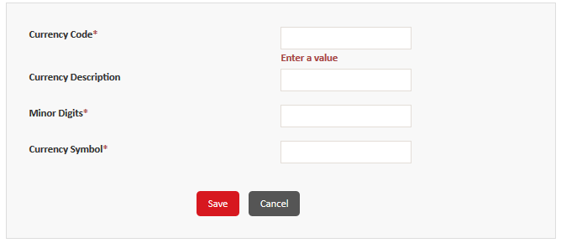
- Currency Code - Three-digit International Organization for Standardization (ISO) code.
- Currency Description - Description of the currency.
- Minor Digits - Number to indicate the decimal places to be used for the currency.
- Currency Symbol - Character symbol to be used for the currency.
- Click Save to add the currency.
View/Edit the Currency:
User can view the details of a currency or modify its description, minor digits, and symbol. You cannot modify the code for a currency.
Note: You can modify only an active record.
You cannot delete a currency, but you can change its status.
- Navigate to Configuration, and then click Currency
- To view the details of a record, click View. Click Back to return to the Currency screen.
- To modify the description of a currency, click Edit, and then modify the details. Click Save.
- To change the status of a currency, in the Select column, select a check box or multiple check boxes to select records, and then at the bottom of the screen, click Change Status.
- If a confirmation message is displayed, then click OK.

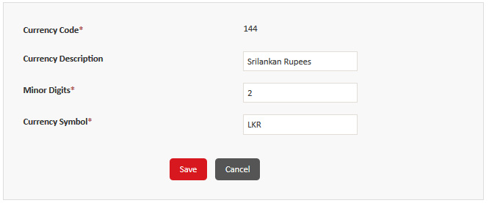
Brand:
A brand indicates a combination of payment instruments, brand type, and BIN ranges that are configured to be processed similarly at terminals.
Brand types should be configured before you can create a brand. Brand type cannot be modified in the existing brand.
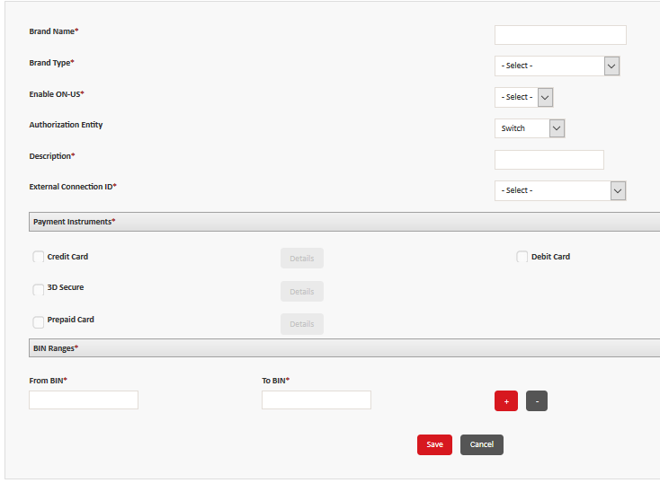

Steps to Create a brand:
- Brand Name - type the name of the brand.
- Brand type list - type of brand to add.
- Enable ON-US - click Yes or No to enable or disable on-us transactions for the brand.
- Authorization Entity - click one of the following options to indicate the authorization entity to use for the institution:
o Switch o Interchange
- Description box - type the description of the brand.
- External Connection ID - click an external connection to use for the brand.
- In the Payment Instruments section, select a check box to add a payment instrument, and then click Details to open the dialog box.
- Specify the type of authentication and verification to use for the payment instrument, and then click OK to return to the Add Brand screen.
- On the Add Brand screen, in the BIN Ranges section, in the From BIN and To BIN boxes, specify the starting and ending value of the BIN range to use for the brand.
- If required, click to add another row. Click Save
View /Edit a Brand:
User can view or edit a brand but cannot delete it.
Navigate to Configuration > Brand.
In the Search By list, click one of the following search criteria:
- ALL – Select this option to display the list of all records.
- Brand Name – Select this option to search using the name of a brand
- Description – Select this option to search using the description
Depending on the action to take, perform one of the following steps:
- To view the details of a record, click View. Click Back to return to the Brand screen.
- To modify the description of a brand, click Edit, and then modify the details. Click Save.
- To change the status of a brand, in the Select column, select a check box or multiple check boxes to select records, and then at the bottom of the screen, click Change Status.
If a confirmation message is displayed, then click OK.
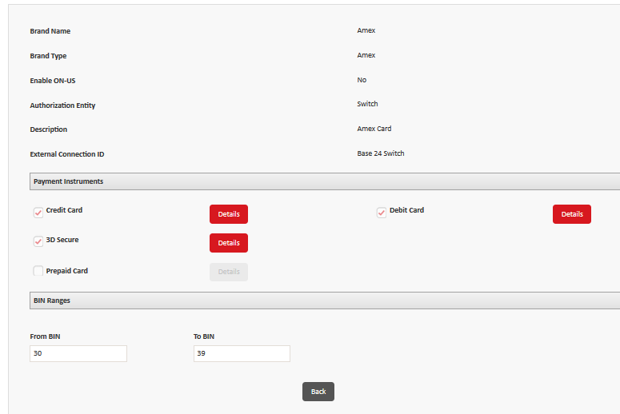
Merchant Category:
Merchant Category is used to group the similar merchant under one code. Merchant category code should be created before creating a merchant. User cannot delete a merchant category code but he can either move to active or inactive state. Multiple merchants can also be grouped under one code.
Create a Merchant Category code:
- Navigate to Configuration > Merchant Category.
- Click Add.
- In the Merchant Category Code - type a numeric identification code for the category.
- In the Description - type the description of the merchant category.
- Click Save.

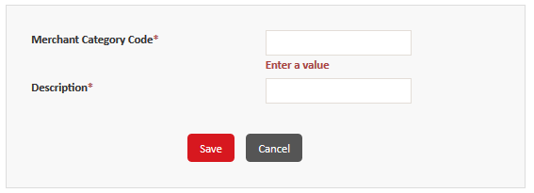
View/Edit the Merchant Category:
- To view the details of a record, click View in the Merchant Category screen. Click Back to return to back.
- To modify the description of a category, click Edit, and then modify the description.
- Click Save.
- To change the status of a merchant category, in the Select column, select a check box or multiple check boxes to select records, and then at the bottom of the screen, click Change Status. If a confirmation message is displayed, then click OK.
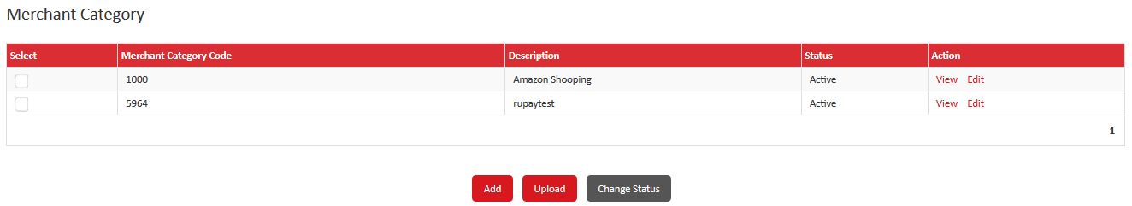
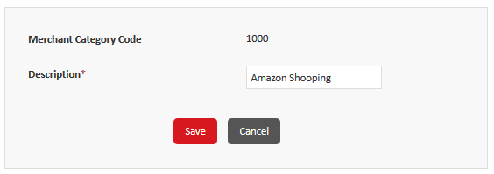

Upload Merchant Category:
- User can create a merchant category through Upload file.
- Navigate to Configuration > Merchant Category.
- Click Upload.
- Click Sample Format to display the Merchant Upload Sample Format screen.
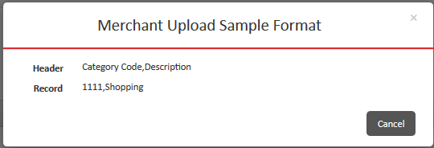
- Click Cancel to close and return to the Merchant Category Code Upload screen.
- Click Browse to locate the merchant category file to upload.
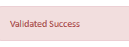
- Click Validate to validate the file and display the confirmation message.
- Click Download Log to open or save the log file that contains the errors encountered during the validation. Rectify the errors in the batch file, and then upload the file again.
- After successful validation, click Upload to upload the file.
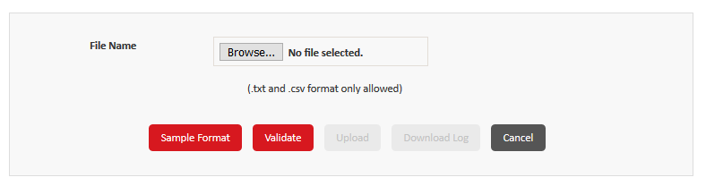
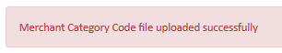
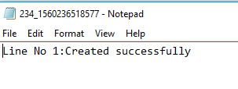

Merchant Branding:
Modifying the payment page as per the Merchants requirement is handled under Merchant Branding.
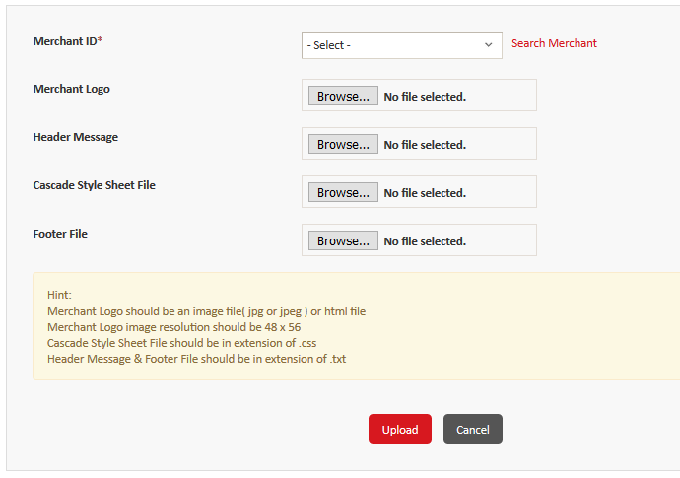
Navigate to Configuration > Merchant Branding.
In the Merchant ID list, click the merchant to configure the branding for.
1. Click Browse to open the File Upload dialog box.
2. Depending on the section, select a file to upload.
The following table contains the information about the format of the file to upload:
- Header File - JPG or JPEG
- Cascade Style Sheet File – CSS
- Advertisement File - TXT
- Label file - PROPERTIES
3. Click Open to return to the Institution Branding screen.
4. The name of the file that you opened is updated in the box.
5. After you have selected all of the files, click Upload to validate and upload the branding details.
6. You can click Preview to view the preview of the merchant branding on the payment page.

Merchant:
An e-commerce merchant or an online merchant is someone who sells products or services exclusively over the Internet. An e-commerce merchant is not only in charge of his store’s inventory but also of the financial process, promotion of his products and even building the brand identity.
Multiple merchants can be configured for a single institution. Multiple terminals can be configured for each merchant.
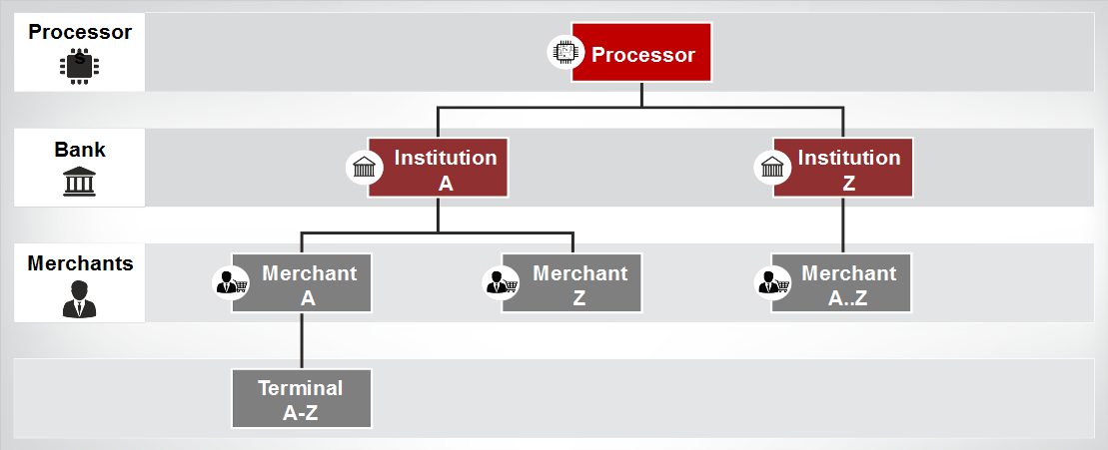

Requirements to Onboard a Merchant :
- Create a merchant category code
- Create a merchant administrator user role and assign privileges to the role
- Create a merchant record
- Configure risk parameters
- Create brands
- Create merchant terminals
- Configure merchant branding
- Generate the resource file
- Register a merchant for 3D Secure, if required
- Rotating the terminal keys, if required

Steps to Create a Merchant:
- Navigate to Configuration > Merchant.
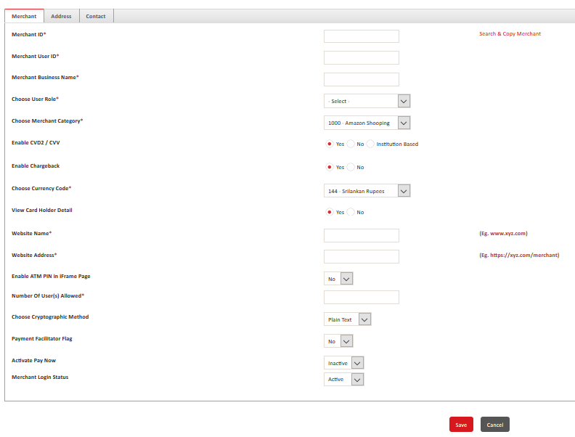
- Click Add.
Merchant ID – Unique Identification code for the merchant.
Search and Copy – Existing data of the created merchant will be used to create a Merchant with New ID.
Merchant User ID – Administrative user ID of the Merchant.
Merchant Business Name – Business name of the merchant.
User Role – Select the User role for the particular merchant.
Merchant Category – Category that the merchant belongs to.
Enable CVD2/CVV – Enable the flag for Authenticating the CVV/CVD2 value.
Disable the flag for not Authenticating the CVV/CVD2 value.
Institution Based works as per the configuration of the Institution.
Enable Chargeback – Enable/Disable chargeback for the transaction of that particular merchant.
Currency Code – Select the currency code of that Merchant.
View Card Holder Detail – Enable / Disable a card numbers for inquiring transaction while using Enter trans action.
Website Name- Name of the Merchant Website.
Website Address- URL of the particular Merchant.
Enter ATM Pin in Iframe page – Enable or disable to accept ATM Pin in Iframe page for Tranportal txns.
Number of Users allowed- Total number of users that can be created for that merchant.
Choose Cryptographic Method - select one of the following to decide the encry process of the merchant.
- Plain Text / Hashing/encryption
Payment Facilitator Flag - Enable or Disable payment facilitator for the merchant. If you click Yes, then the Payment Facilitator Id, Payment Facilitator Name, Independent Sales Organization Id, and Sub Merchant Id fields are displayed.
Activate Pay Now – Enable or Disable Pay Now feature for the small scale merchant .
Merchant Login Status- Status of the merchant.
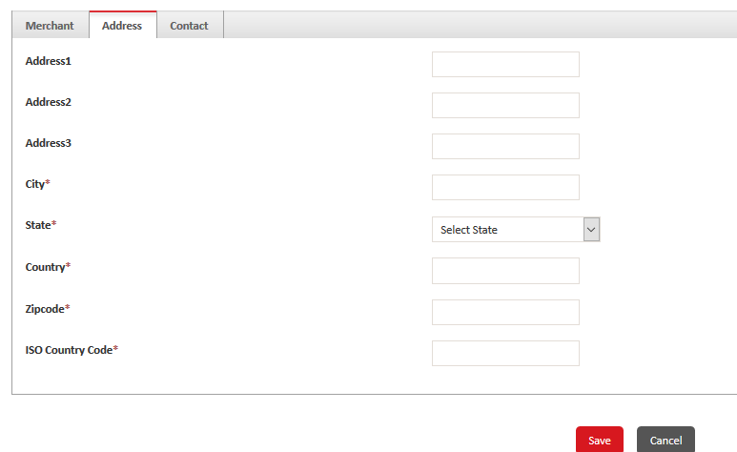
Merchant Screen – 2
Specify the address, city, state, country, pin code, and the ISO country code for the merchant.
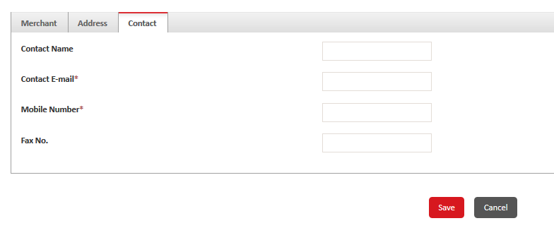
Specify the contact information for the merchant’s contact person, such as name, email address, mobile number, and fax number.
Click Save to create the merchant.
welcome email is sent to the contact person’s email address. The email contains a link to view the user ID that you created on the Merchant tab and an automatically generated password.
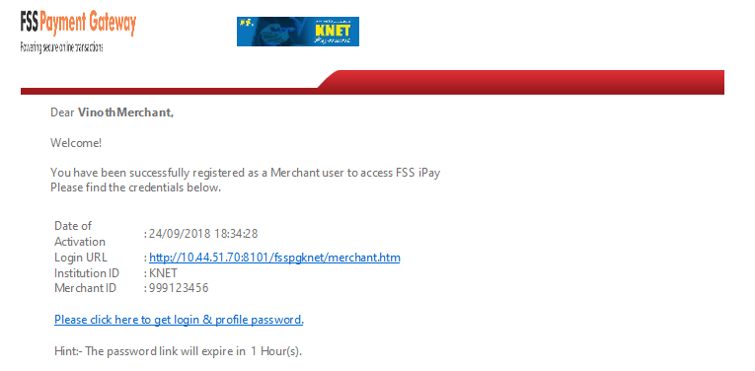
View/Edit a Merchant:
User can View or edit a Merchant but cannot delete a Merchant.

- To view the details of a record, click View. Click Back to return to the Merchant screen.
- To modify the details of a merchant, click Edit, and then modify the details. Click Save.
- To change the status of a merchant, in the Select column, select a check box or multiple check boxes to select records, and then at the bottom of the screen, click Change Status.
- If a confirmation message is displayed, then click OK.

Terminal:
A Terminal can be Virtual entity through which merchant an process the transaction. Each merchant must have at least one terminal and can have multiple terminals.
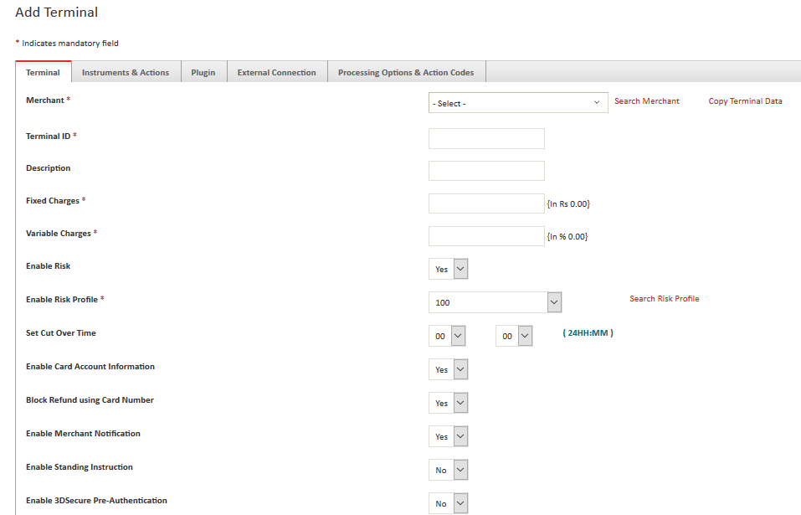
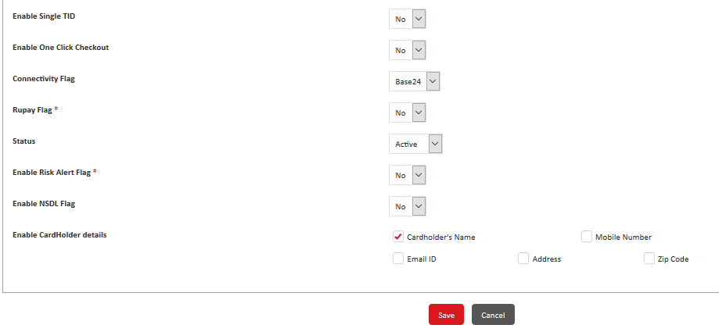

Merchant – Select the merchant for which the terminal has to be created for. (Search merchant helps you to refine the search)
Copy Terminal Data- To copy the details of an existing merchant terminal.
Terminal ID- Enter the Unique ID for the Terminal.
Description- Enter the Description of the Terminal
Enable Risk - Enable or Disable to add risk profile for the terminal.
Enable Risk Profile – Select the risk profile created from the drop down for the terminal.
Set Cut over time - Set the cut over time in 24 hour format for the transactions happening in the terminal.
Enable Card Account Information – Enable or Disable card account information at the terminal.
Block Refund using Card Number - Enable or Disable to restrict refund using card number.
Enable Merchant Notification – Enable or Disable Merchant Notification for the Terminal.
Enable Standing Instruction – Enable or Disable Standing instruction for the Terminal.
Enable Faster Checkout- Enable or Disable faster checkout to be displayed in Payment page for the terminal.
Enable Single TID – Enable or Disable Single Terminal ID flag where Merchant info will be passed in ISO.
Enable Grips - Government support for Receipt Portal System (GRIPS) to enable or disable.
Enable Radio Button Flag – Enable or disable to filter the credit and debit cards based on the banks. Alternatively, click No to display all cards without any filtering.
Connectivity Flag- Connect to Base 24 or Test path with this flag. Test path acts as a simulator to provide positive response. Choosing Base 24 connects to real switch during the transaction processing.
Rupay flag- Enable or Disable the Rupay flag for Rupay based transactions.
Partner ID and Merchant Password will be inputted for Rupay transactions if the flag is enabled.
Enable Risk Alert flag – Enable or Disable to send the Risk alert messages to the users.
Users shall receive the risk through Email, SMS or Both with the alert type selected.
Enable NSDL flag – Enable or Disable the flag to send the merchant information in the ISO.
Enable Card Holder Details – Enable or Disable the card holder information to be added to the Payment page during the transaction. Select the check boxes for Cardholder name, Mobile No, Email id, zip code,address.
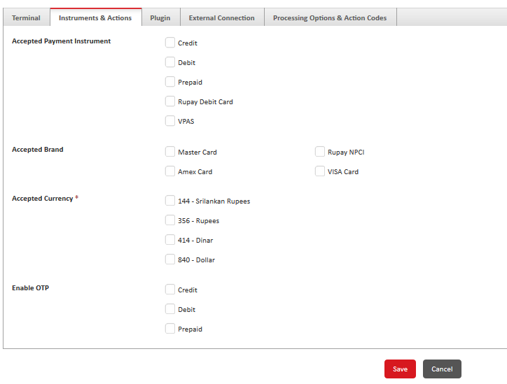
Terminal – Screen 2
Accepted payment Instrument – Mark the check boxes to indicate the acceptable payment instrument such as credit / Debit/Prepaid/ VPAS.
Accepted Brand - Mark the check boxes to indicate the acceptable brand such as Master Card/Amex Card/ Rupay NPCI/ Visa Card.
Accepted Currency - Mark the check boxed to indicate the acceptable currency such as rupees, dollar etc.
Enable OTP – Mark the check boxes to indicate the OTP for Credit , Debit and Prepaid cards.

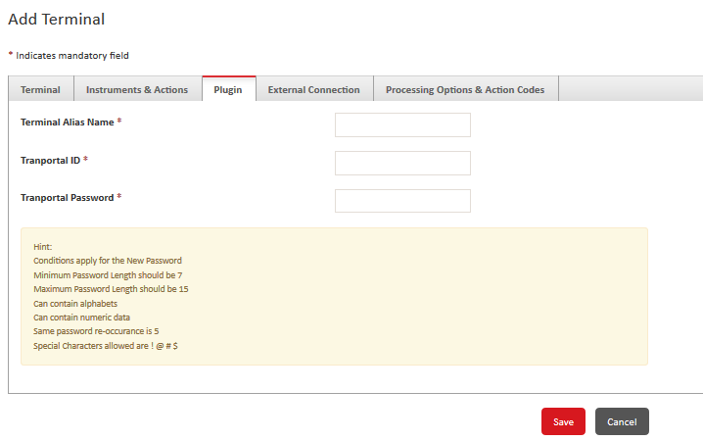
Terminal – Screen 3
Terminal Alias Name - Type the alias name for the terminal.
Tranportal ID - type the tranportal identification code for the terminal.
Tranportal Password - type the tranportal password for the terminal.
In the Key field group, click Generate Key to generate the key and update it in the Key box. The key is masked.
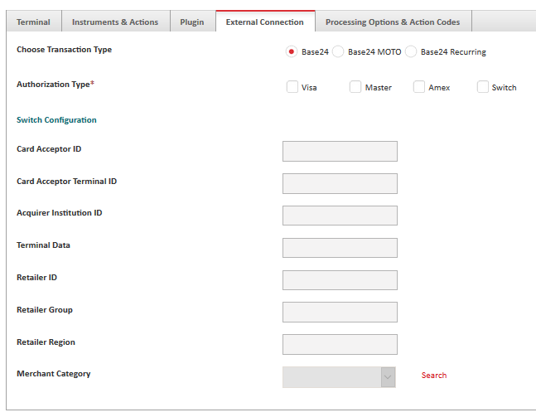
Choose Authorization Type - Select the radio corresponding radio button for the authorization entity such as BASE 24, BASE24 MOTO, BASE24 Recurring.
Authorization Type - Mark the check boxes to select any of the authorization type listed.
Visa / Master/ Switch – When the check box is enabled it display the corresponding external connection entities such as Visa / Master /Switch where the details are specified for the Authorization.
Switch Configuration - Corresponding Switch configuration details should be specified for the below
- Card Acceptor ID
- Card Acceptor Terminal ID
- Acquirer Institution ID
- Terminal Data
- Retailer ID
- Retailer Group
- Retailer Region
- Merchant Category
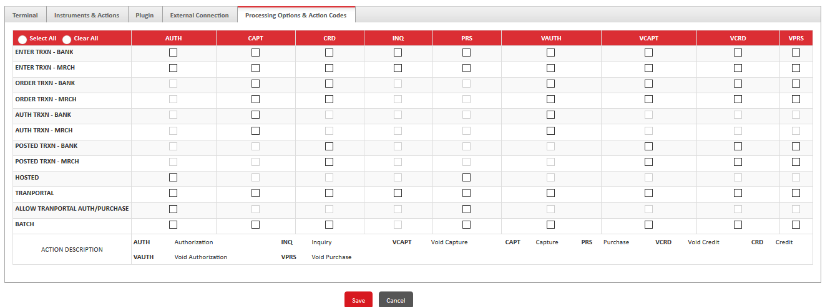
In the matrix, select the check boxes to select the transactions and their processing options.
Alternatively, you can click Select All or ; to select or clear all of the transaction types and their processing options.
Click Save to add the terminal.
VPAS Merchant:
User can configure a merchant to be VPAS Merchant if it is to enable 3D secure transaction or VPAS via VbyV (Verified by Visa) or Master Card Secure code.
Added record cannot be deleted however it can be change from Active to Inactive State.
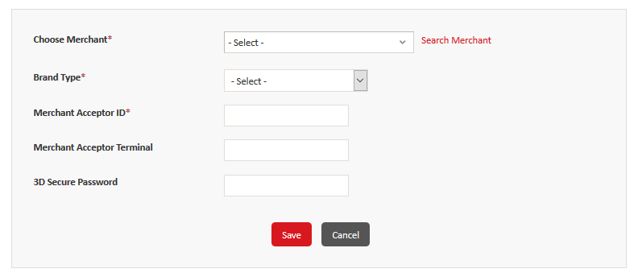
Steps to Create a VPAS Merchant:
Navigate to Configuration > VPAS Merchant. Click on Add to open the Create VPAS Merchant Screen.
Choose Merchant – Select the Merchant that you want to configure the VPAS for.
Brand Type – Select the Brand Type for VPAS to be enabled like VISA, MASTER, AMEX, Diners.
Merchant Acceptor ID – Enter the identification code of the merchant acceptor.
Merchant Acceptror Terminal – Enter the identification code of the acceptor terminal.
3D Secure Password – Enter the 3D secure password for the VPAS transactions – accepts alphanumeric.
Click Save.
Click Cancel to return to the VPAS Search page.

Terminal Key Rotation -
Terminal keys are used to encrypt and decrypt the merchant request and response at a terminal . If key has been rotated Merchant has to regenerate a new resource file and download it.
If the merchant does not download the new resource file, old keys only be used to encrypt and decrypt the req and response. New Keys will be activated only after merchant download the resource file.
The Key will be rotated if the Merchant is changing the cryptographic method from plain text to hashing /encryption or vise versa.
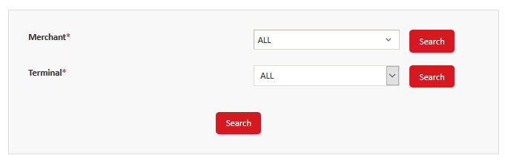
- Merchant and Terminal will be selected to rotate the Key.
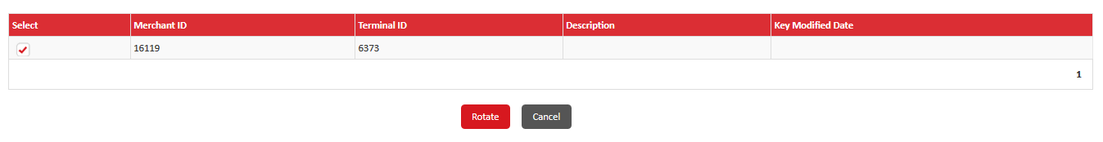
- In the Select column, select a check box to select a terminal.
- Click Rotate to rotate to open the Key Rotation - Key Generation screen.
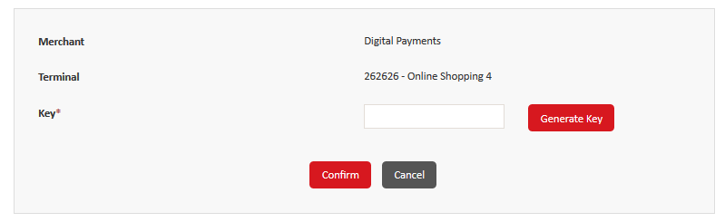

- Click generate Key button to generate a New Key and click on confirm to remove old &update with new keys.
- User will be receiving a success message after key rotation.
- Last Key modified date will be updated in the Grid.

Generate Resource File:
Once the Merchant is created , User can generate the resource file from the bank portal and download the resource file from the Merchant portal. The terminal uses the resource file and the credential configured during terminal creation to connect with the FSS Payment Gateway and acquire customer transactions.
The Resource file contains the tranportal ID, tranportal password, web address of the FSS Payment Gateway, and the terminal resource keys.
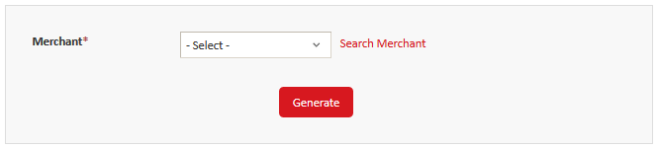
The terminals acquire customer transactions in the following manner:
- When a merchant sends a request for a transaction to FSS Payment Gateway, the merchant reads the resource file, and then posts and connects to the Payment Gateway.
- The FSS Payment Gateway validates the request by validating with database and then processes the transaction.
- Navigate to Configuration > Generate Resource File.
- Select the Merchant from the Search Merchant Hyperlink.
- Click on Generate.
- Once the resource file is generated, success message will be displayed.

OTP Configuration:
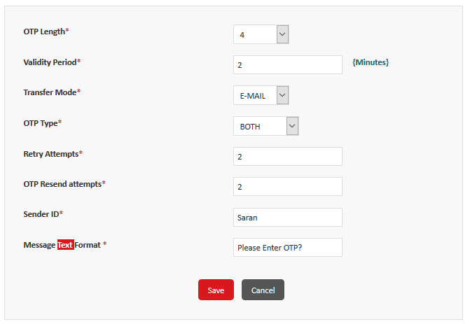
OTP is sent to E-mail or SMS only if the configuration parameter is set appropriate. Customer receives the OTP during the transaction via this configuration. OTP will be triggered only if the Enable OTP option is enabled at institution and bank level.
OTP Length – Length of the OTP
Validity Period – Maximum time frame of the OTP to be valid. Beyond this limit the OTP expires.
Transfer Mode – Can set to Email or SMS or Both.
Select any of the transfer mode for the customer to receive the OTP.
OTP Type - To set the character type of the OTP , it can be either Numeric, Alphabets or Both.
Retry Attempts- Number of times the user is allowed to enter the incorrect OTP during the transaction.
OTP Resend Attempts – Maximum number of the times customer can request for the OTP.
Sender ID - unique identification code of the SMS sender.
Message Text format – Text format of the OTP to be sent.
Primary SMS gateway - Type the primary gateway to send and receive Short Message Service (SMS) transmissions.
Primary User ID -Type the user ID to use for the primary SMS gateway.
Primary Gateway Password -Type the password to use for the primary SMS gateway
Secondary SMS gateway -Type an alternate gateway to send and receive Short Message Service (SMS) transmissions.
Secondary User ID - Type the user ID to use for the alternate SMS gateway.
Secondary Gateway Password -Type the password to use for the alternate SMS gateway
Time Out - Type the time in seconds after which an idle connection is timed out.
Click save to activate the changes.
OTP Registration :
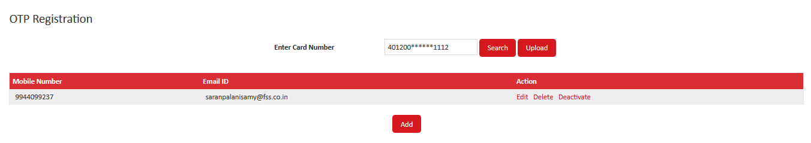
OTP will be sent to the corresponding mobile number only if it has been registered. User can register, deregister, edit the mobile number or email address, deactivate or delete.

Steps to Register the OTP:
- Navigate to Configuration> OTP registration
- Click on Add
- Enter the following details.
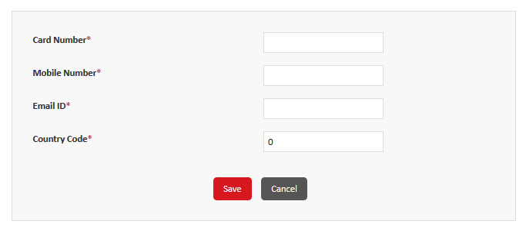
It can either be uploaded by single GUI or batch.

Faster Checkout DeRegistration:
Existing faster checkout enabled customer can deactivate the faster checkout service under this configuration. User can reactivate or delete the faster checkout service.
View Information:
User can view the already created features under this information.
- View Terminal
- View Merchant
- View Risk
- View Merchant Categories
- View Currency code
- View Brand
- View Merchant User

Transaction:
Supporting Transactions initiated through either bank or merchant portal are called Offline transactions.
Offline Transaction includes the below:
- Authorization
- Posted Transaction
- Order List
- Enter Transaction
- Batch Upload
- Batch Process
Authorization Transaction:
Capture or Void the authorization transaction can be initiated under this module.
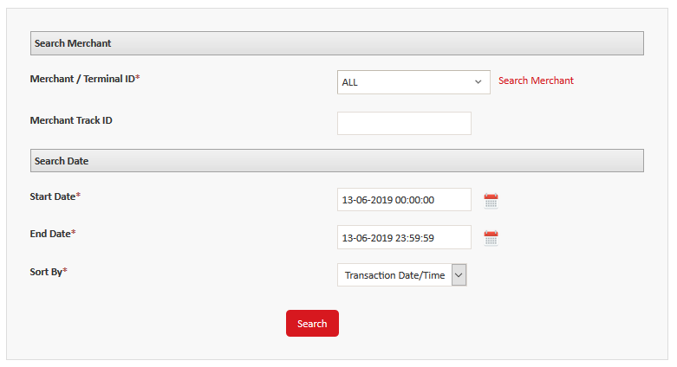
Navigate to Transactions> Authorization
Select the Merchant / Terminal ID
For precise filtration enter the Merchant Track ID.
Select the Start Date, End Date and Sort By
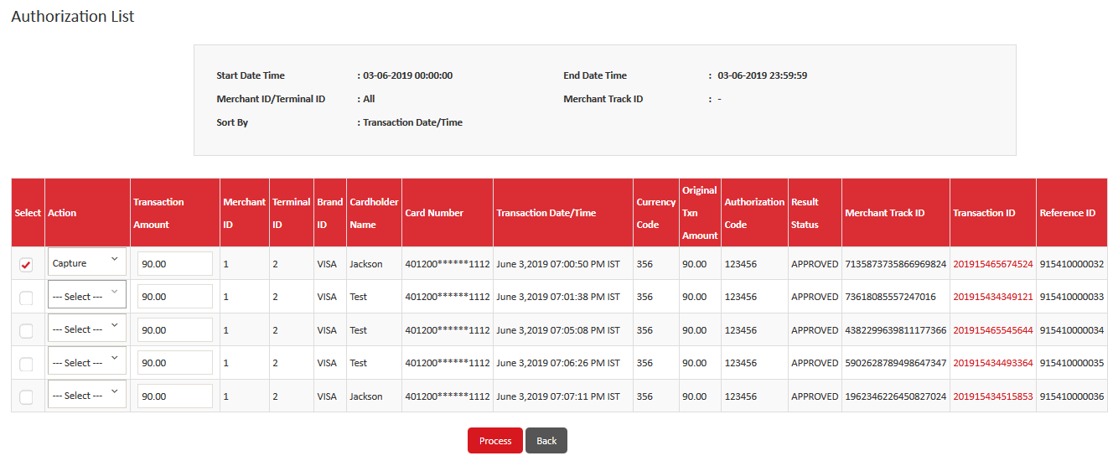
Select the record to Capture or void the Authorization transaction. If required, in the Transaction Amount box, modify the amount to process.
Click on Process.
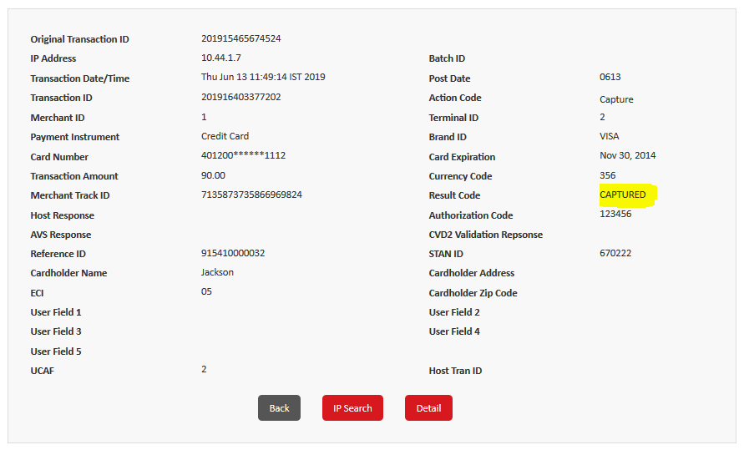

Posted Transaction:
User can Credit or Void a posted transaction under this module.
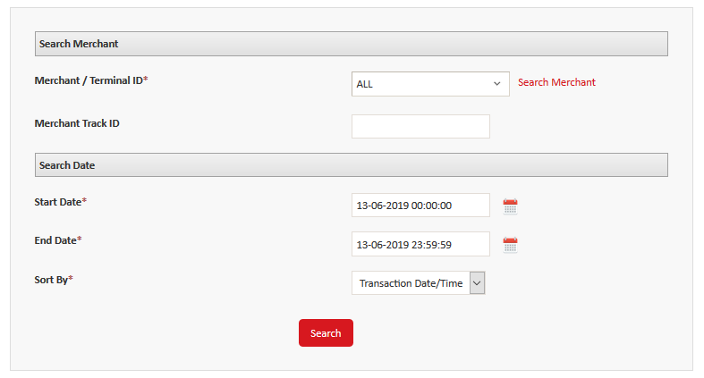
Navigate to Transactions> Posted Transaction
Select the Merchant / Terminal ID
For precise filtration enter the Merchant Track ID.
Select the Start Date, End Date and Sort By
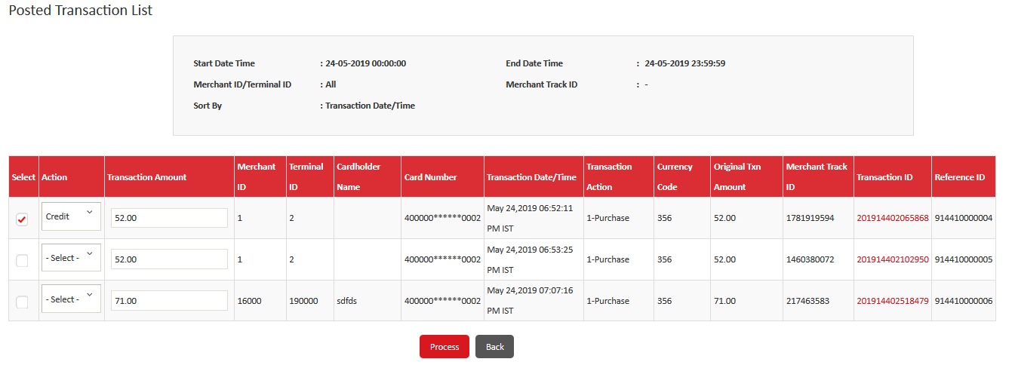
Select the record to void or credit the Posted transaction. If required, in the Transaction Amount box, modify the amount to process.
Click on Process.
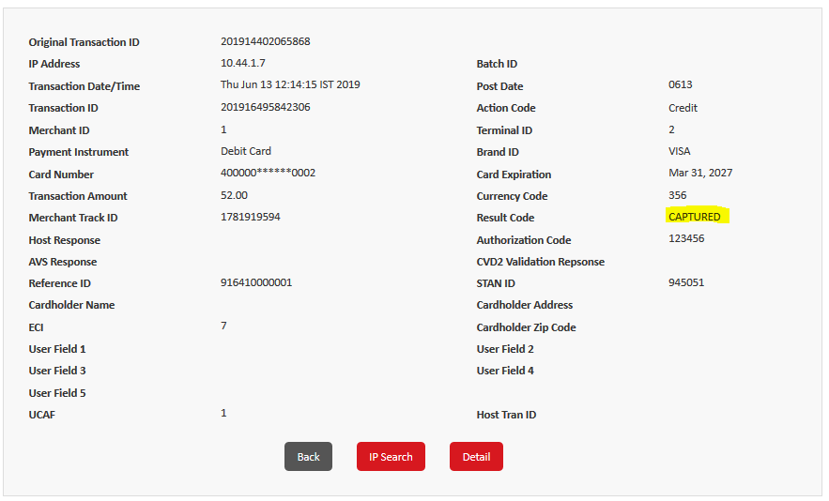

Order List:
Order List contains list of all transactions that are ordered at that terminal.
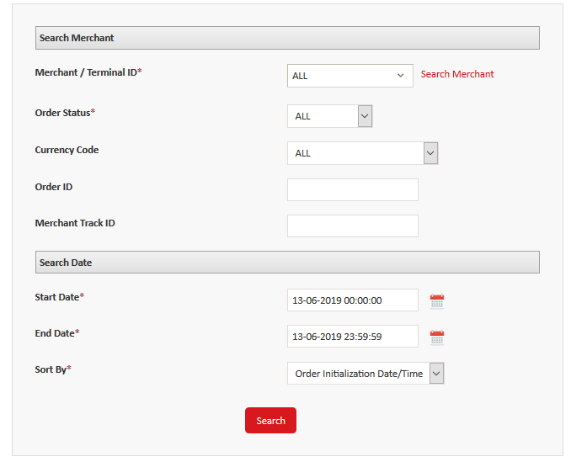
- You can filter the list using the merchant and terminal ID, order status, currency, order ID, track ID, and time period.
- Navigate to Transactions> Order List
- Select the Merchant / Terminal ID
- For precise filtration enter the Merchant Track ID/ order status/currency code/Order ID
- Select the Start Date, End Date and Sort By
Transactions can be listed under all the 4 categories such as
- Presented
- Processed
- Auth Error
- Canceled

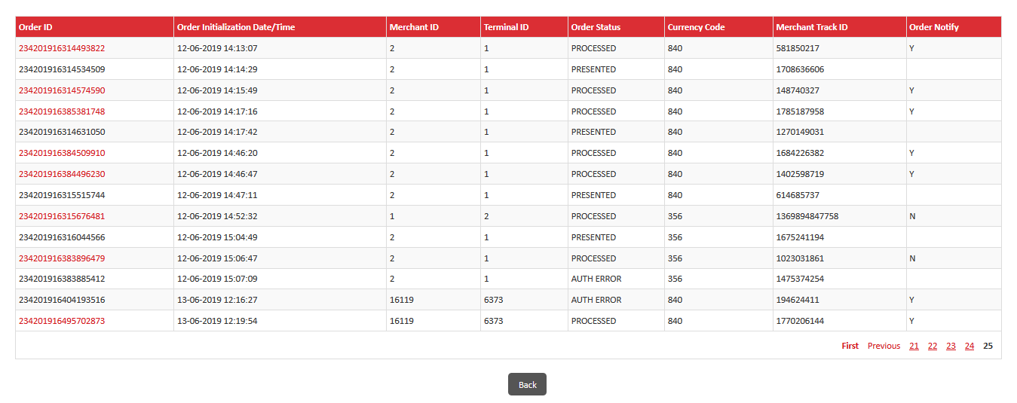
Processed transactions alone will be marked with hyperlink in the order ID.
User can click on the hyper link to credit, capture or void the transaction.
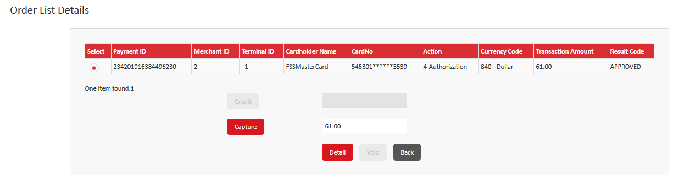
Select the transaction and click on capture/ void or credit to process.
User can navigate back to the search grid by using back button.
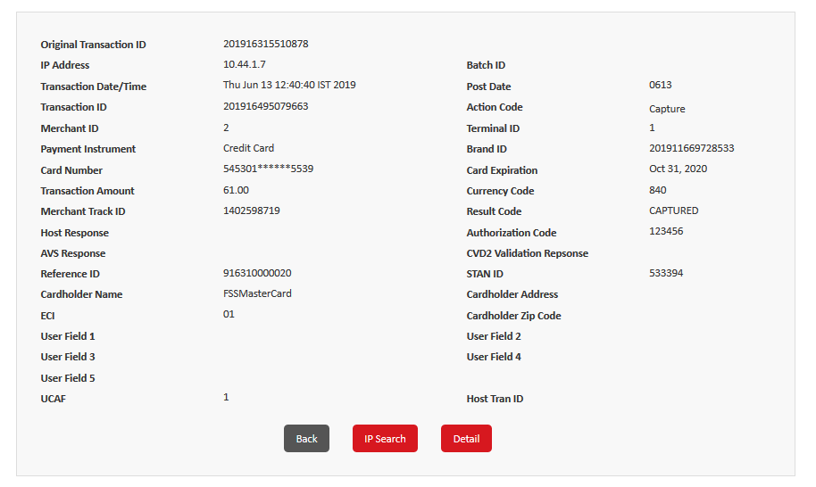
Enter Transaction:
User can initiate the main and supporting transaction with enter transaction.
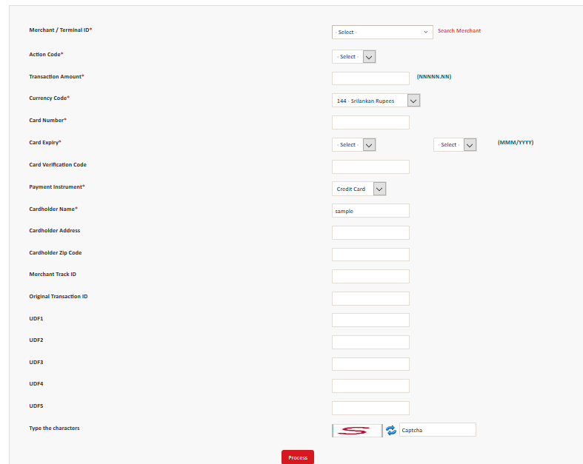
Merchant ID / Terminal ID – Choose the merchant and the terminal to initiate the main or supporting transaction.
Action Code - choose Auth, Capture, Credit, Inquiry, Purchase, Void Auth, Void Capture, Void Credit, or Void Purchase to indicate the type of action to create the transaction for.
Note: The remaining fields on this screen may be mandatory or not mandatory depending on the action code that you select.
Transaction Amount - type the transaction amount in the NNNNN.NN format, where N indicates a digit.
Currency Code - click the currency for the transaction.
Card Number - type the card number.
Card Expiry - click the month and year of card expiration.
Card Verification Code - type the CVD2 or CVV of the card.
Payment Instrument - click Credit, Debit, or Prepaid to indicate the type of payment.
Cardholder Name - type the name of the card holder.
Cardholder Address and Cardholder Zip Code - type cardholder’s address and pin code.
Merchant Track ID - type the merchant track ID for the transaction.
Original Transaction ID - type the identification code of the original transaction.
If required, in the remaining UDFs, type the required values.
Click Process to initiate transaction processing.

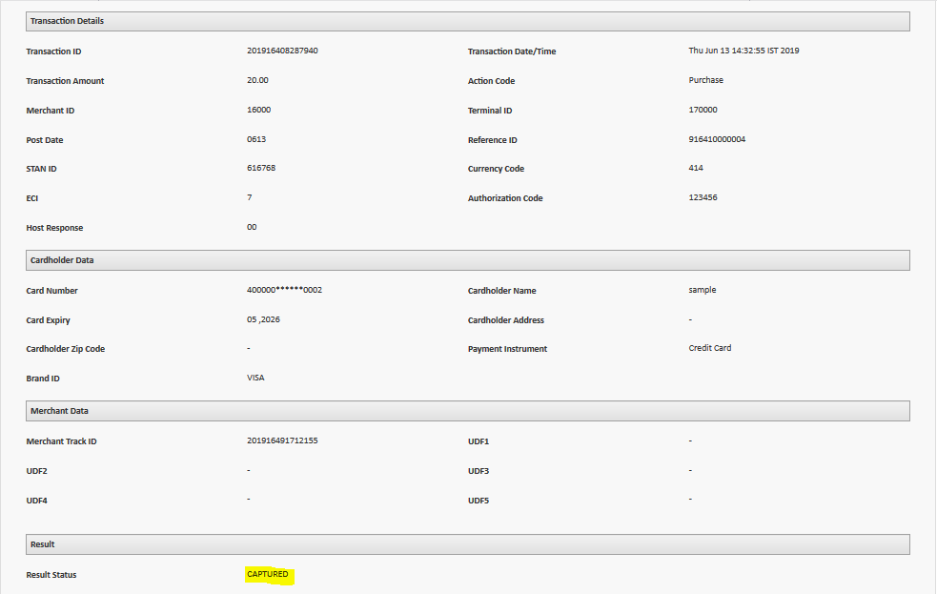
Batch Process:
Processing the transactions such as void or refund or purchase in bulk. It can either be done manually or by schedule. Once Batch process is started it can be paused, resumed, removed or canceled.

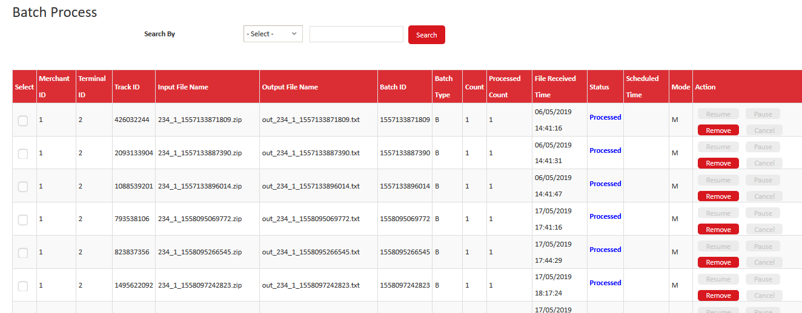
- Before the batch process is started the file upload will be listed under Input file name.
- Once it is is processed, the process transaction file will be listed under Output file name. You can either run a batch report to download the file or verify the file in the batch download directory.
- For every batch unique ID is generated called Batch ID which is generated while uploading a batch file.
- Batch Type – Indicates B for batch
- Count/ Processed count – count sets out the total number of transaction in the batch file.
- Processed count sets out the total number of processed transaction from the batch file.
- Status – Before running a batch the status will be not processed after successful batch process it is changed to processed. Stopped, canceled and error are different kind of status for actions during processing.
- Mode- M- indicates a manual batch process were as S – indicates a Schedule batch process.
Schedule a Batch:
In-order to Schedule a batch, select a Not processed batch record and click schedule.
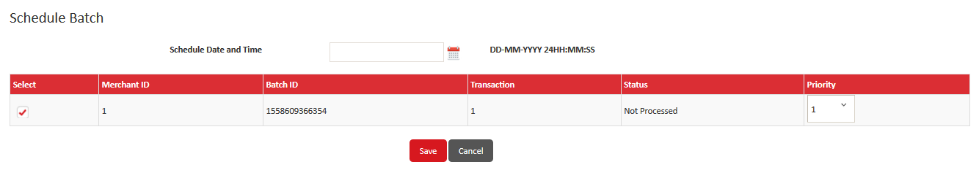
If multiple batch records have been scheduled simultaneously, user can set the priority accordingly.
Schedule date and time will be selected and click on Save.
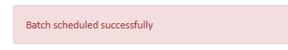
The batch will automatically process the transaction at the scheduled time.

Risk Configuration:
Transactions happening at the particular terminal can be allowed or denied by Risk profile. Bank can set up the risk profile for the Merchants Terminal depending upon the requirement. If the transaction reaches the threshold limit of the risk it will be denied upon the configuration. Denied response will be sent to the merchant along with the description.
Below are the risk parameters that can be configured for the terminal.
- Declined Card
- Negative Card
- IP Block
- Negative Bin
- Risk Profile
Negative Card:
Negative Cards are cards which can be blocked permanently as Fraudlent or Invalid cards. Transactions performed using these cards numbers are declined by the application.
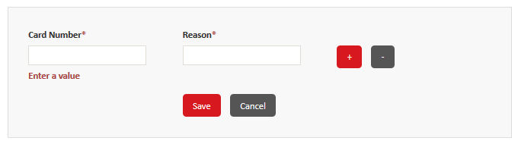
Navigate to Risk Configuration > Negative Card
Click on Add button.
Enter the Card number to be added to the Negative card list.
Enter the Reason for blocking the card. User can add multiple cards by inserting a row with '+' symbol.
Click on Save.
User can deactivate or activate the card by changing the status of it. Once it is inactive the transaction will be processed without any risk.
Upload a Negative Card:
User can upload the negative card via batch file.
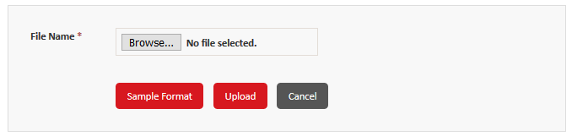
Sample format – illustrates sample file to be uploaded for the negative card.
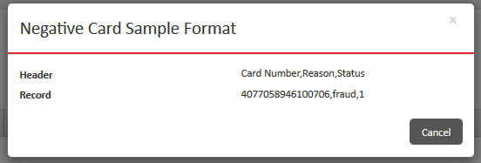
Click Browse to open the dialog box, search for and select the file to upload. Click Open.
Click Upload to upload the file and display a confirmation message.
If required, you can click To See Log Click Here to view the log file.
Negative Bin:
Negative Bins are Bins which can be blocked permanently as Fraudlent or Invalid bins. Transactions performed using these Bin numbers are declined or Blocked by the application.
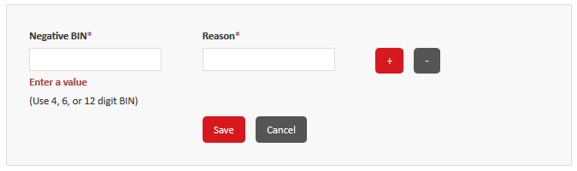
Navigate to Risk Configuration > Negative Bin
Click on Add button.
Enter the BIN to be added to the Negative BIN list.
Enter the Reason for blocking the BIN. User can add multiple cards by inserting a row with '+' symbol.
Click on Save.
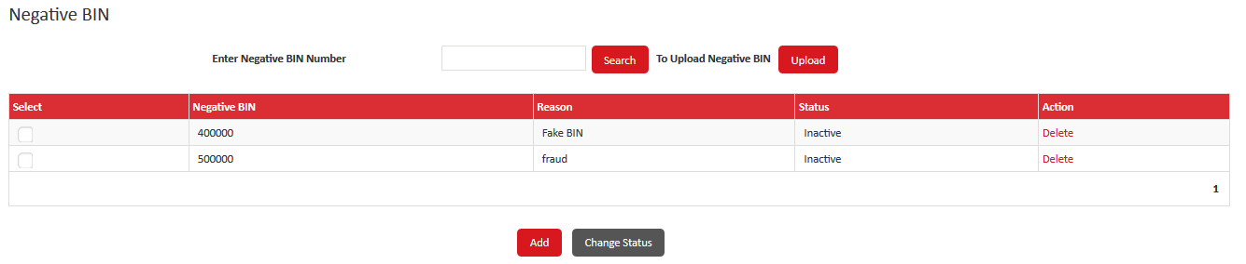
Upload a Negative Bin File :
User can upload a Negative Bin via Batch file.
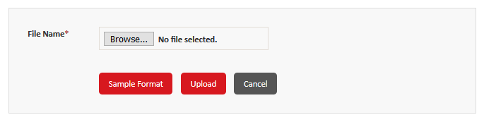
Sample format – illustrates sample file to be uploaded for the negative Bin.
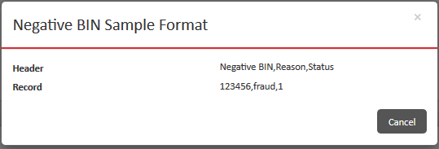
Click Browse to open the dialog box, search for and select the file to upload. Click Open.
Click Upload to upload the file and display a confirmation message.
If required, you can click To See Log Click Here to view the log file.
IP Address Block:
Fraudulent transactions initiated from the specific IP can be blocked using this IP address block. Alternatively, you can unblock a blocked IP address by changing its status to Inactive.
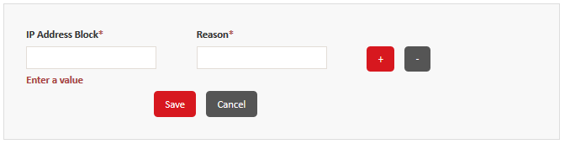
Navigate to Risk Configuration > IP Block
Click on Add button.
Enter the IP Address to be added to the IP Address Block
Enter the Reason for blocking the IP. User can add multiple cards by inserting a row with '+' symbol.
Click on Save.
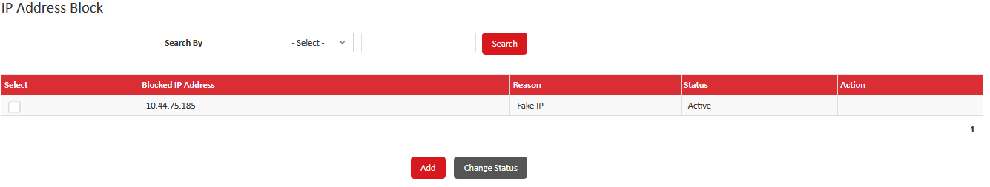
Risk Profile:
Transactions are diagonized and alerts have been set out to merchants if risk criteria has been crossed.
User can create a risk profile with terminal-specific, card-specific, and IP-specific risk parameters and three level escalation criteria. Additionally, the negative cards, negative BIN ranges, and blocked IPs can be added to a risk profile. Risk profiles are associated with the Merchant's and Terminals created. Hence transactions initiated from corresponding terminal will under go risk check and be declined if crosses the limit.
EMAIL and SMS will be triggered depending up on the 3 levels of risk parameters.
- If a risk parameter value or count is equal to or greater than level 1 threshold percentage and is less than the level 2 percentage, then escalation alerts are sent to the level 1 mobile numbers and email addresses.
- If a risk parameter value or count is equal to or greater than level 2 threshold percentage and is less than 100%, then escalation alerts are sent to the level 1 and 2 mobile numbers and email addresses.
- If a risk parameter value or count is equal to or greater than 100%, then the transaction is declined. If the number of level 3 violations from a terminal exceed the number specified in the Instance box, then escalation alerts are sent to the level 3 mobile numbers and email addresses.
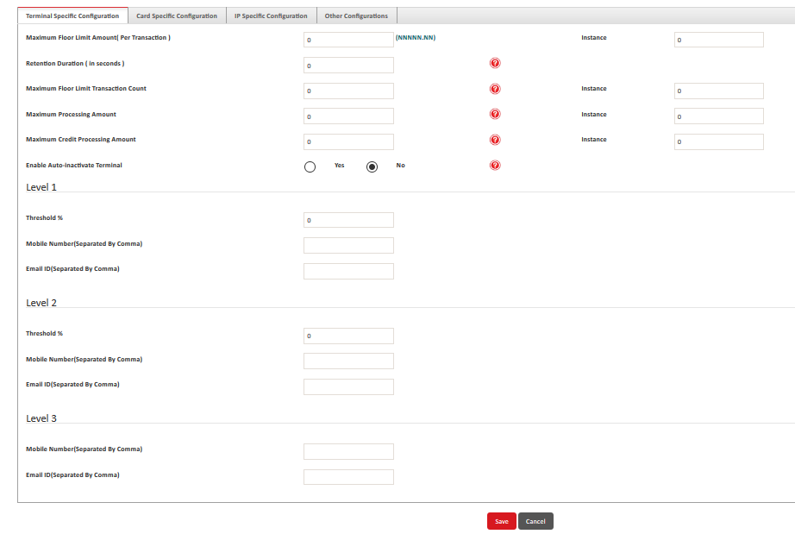
- Navigate to Risk Configuration > Risk Profile.
- Click Add.
- Risk Profile ID - type the identification code for the risk profile.
- Currency Code - click the currency code for the risk profile.
- A dialog box is displayed, click OK. After you select the currency code, the remaining fields are displayed
Terminal Specific Configuration:
Maximum Floor Limit Amount – It indicates that “single” purchase, credit, authorization, or capture transaction amounts cannot exceed the specified Limit. Transactions exceeding the specified limit will be denied by FSS. Note: If the Limit amount is set to zero, this risk rule will not be considered and transactions will be allowed with any amount.
Maximum Floor Limit Transaction Count – It indicates that the “maximum number of transactions” allowed from the terminal in a rolling 24-hour period cannot exceed the specified Limit number. Once the transaction count from the terminal reaches the maximum, transactions will be denied until the rolling 24-hour count is again less than or equal to the limit number. The count includes all processed financial transactions (purchases, credits, authorizations, capture transactions, and void transactions).
Retention Duration – It indicates the duration (in seconds) after which the transaction is not allowed from a Terminal. After this time limit the transaction can take place for the same duration. Note: Example: Duration has been configured with 1 hour (3600 seconds). This will be considered from the transaction initiation time to past 1 hour. This should not be set with the value 0.
Maximum Processing Amount – It indicates that the “maximum net monetary amount” allowed from the terminal in a rolling 24-hour period cannot exceed the specified Limit. Once the net monetary amount of transactions from the terminal reaches the maximum, transactions will be denied until the rolling 24-hour net amount is again less than or equal to the limit amount. The net amount is calculated by totaling all non-voided financial transactions (purchases, authorizations, and capture transactions, minus credits).
Maximum Credit Processing Amount – It indicates that the “maximum total credit amount” allowed from the terminal in a rolling 24-hour period cannot exceed the specified Limit. Once the credit amount of transactions from the terminal reaches the maximum, transactions will be denied until the rolling 24-hour credit amount is less than or equal to the limit amount. The total credit amount is calculated by totaling all processed credits.
Auto-inactivate this terminal when in violation? – “Yes” indicates that the terminal status be set to "inactive" when only Max daily processing amount is exceeded.
Note - Terminals marked as inactive, based on this field setting, are listed on the Violated Terminals Report, where they continue to appear until an operator manually resets the status to active.
Card specific Configuration:
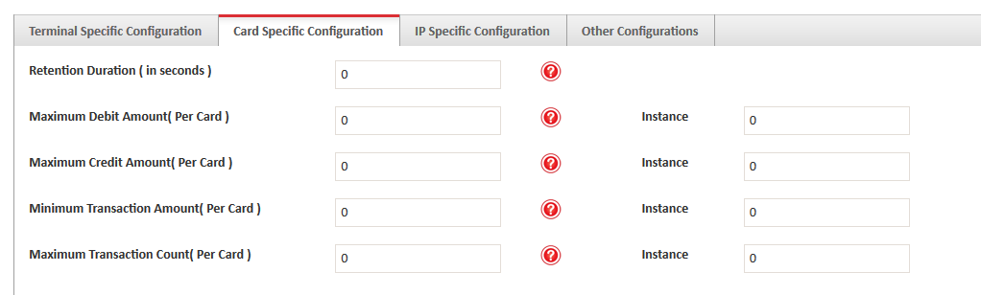
Retention Duration – It indicates the duration (in seconds) after which the transaction is not allowed from a Card. After this time limit the transaction can take place for the same duration. Note: Example: Duration has been configured with 1 hour (3600 seconds). This will be considered from the transaction initiation time to past 1 hour. This should not be set with the value 0.
Maximum 24 Hour Debit Amount – It indicates that the “maximum total debit amount allowed for a single card number (PAN)” in a rolling 24-hour period cannot exceed the specified Limit. Once a card number reaches the specified maximum debit amount, transactions will be denied for the card number until the rolling 24-hour debit amount for the card is again less than or equal to the limit amount. The total debit amount is calculated by totaling all of the card number’s purchase and capture transactions.
Maximum 24-Hour Credit Amount – It indicates that the “maximum total credit amount allowed for a card number (PAN)” in a rolling 24-hour period cannot exceed the specified Limit. Once a card number reaches the specified maximum credit amount, transactions will be denied for the card number until the rolling 24-hour credit amount for the card is again less than or equal to the limit amount.
Minimum Transaction Amount – It indicates that “single” purchase, credit, authorization, or capture transaction amounts cannot lesser than the specified Limit. Transactions lesser than the specified limit will be denied by FSS. Note: If the Limit amount is set to zero, this risk rule will not be considered and transactions will be allowed with any amount.
Maximum Transaction Count – It indicates that the “maximum number of transactions allowed for a single card number (PAN)” in a rolling 24-hour period cannot exceed the specified Limit. Once a card number reaches the specified maximum transaction count, transactions will be denied for the card number until the rolling 24-hour count for the card is again less than or equal to the limit number. The count includes purchases, credits, authorizations, or capture transactions.

IP Specific Configuration:
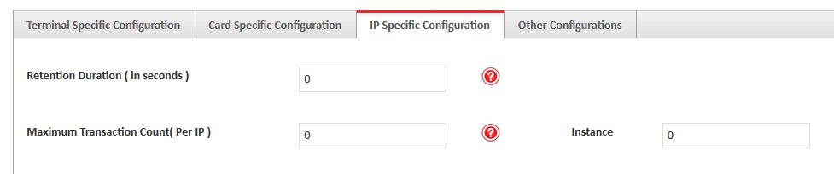
Maximum Transaction Count – It indicates that the maximum number of transactions allowed for an IP address in a rolling 24-hour period cannot exceed the specified Limit. Once the transactions from the IP address reaches the specified maximum transaction count, transactions will be denied for the IP address until the rolling 24-hour count for the card is again less than or equal to the limit number. The count includes purchases, credits, authorizations, or capture transactions.
Other Configurations:

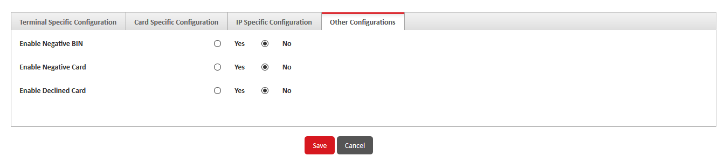
Enable Negative BIN – "Yes" indicates that transactions are to be validated against the FSS PG Negative BIN database (a list of known invalid card prefixes). In this case, if the card used in a transaction has a BIN that matches an entry in the Negative BIN database, the transaction will be denied. Negative BINs are managed using the Negative BIN page.
"No" indicates that transactions are not to be validated against the FSS iPay Negative BIN database.
Enable Negative Card – "Yes" indicates that transactions are to be validated against the FSS PG Negative Card database (a list of cards known to be permanently declined). In this case, if the card number used in a transaction matches an entry in the Negative Card database, the transaction will be denied. Negative cards are managed using the Negative Card page. "No" indicates that transactions are not to be validated against the FSS iPay Negative Card database.
Enable Declined Card – "Yes" indicates that transactions are to be validated against The FSS PG Declined Card database (a list of cards known to be temporarily declined). In this case, if the card number used in a transaction matches an entry in the Declined Card database, the transaction will be denied. Declined cards are managed using the Declined Card page.
"No" indicates that transactions are not to be validated against the FSS iPay Declined Card database.
Uploads:
OTP Upload Process:
Uploaded OTP file are processed here, if any error occured with the OTP uploaded file it can be viewed and downloaded via download log.
Status of the uploaded file during processing are changed from Not processed to Processed.
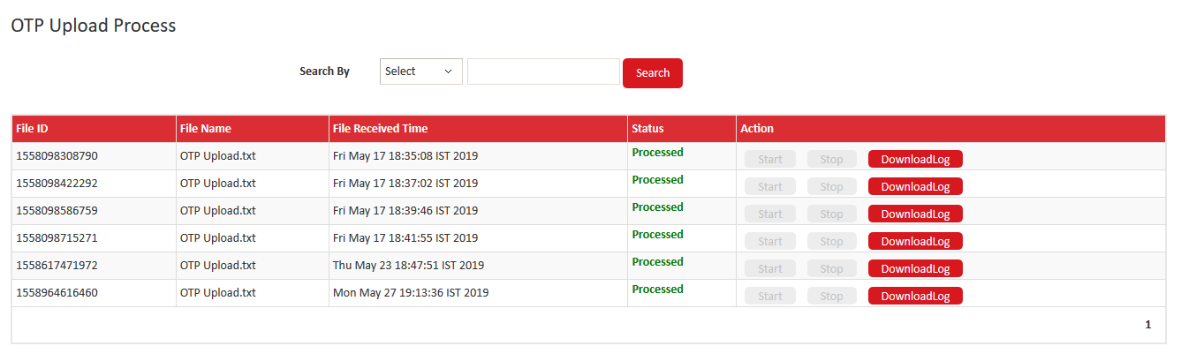
- Navigate to Configuration > OTP Upload Process.
- Select the batch file, click Start. Alternatively, to stop a batch file processing, click Stop.
- click DownloadLog to view the details of records that were processed successfully or the ones that were rejected.
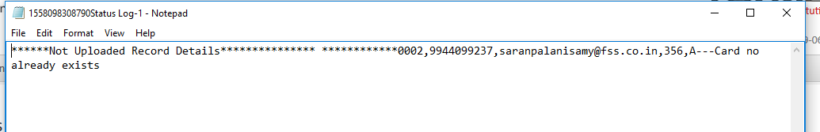
Rupay BIN Upload:
Rupay BIN as uploaded in bulk using the BIN upload. Rupay BIN upload supports .dat file extensions alone. Once the file is uploaded , the BIN are updated in Rupay bin Updated table. After Validation the BIN move from BIN updated table to Rupay BIN upload table.
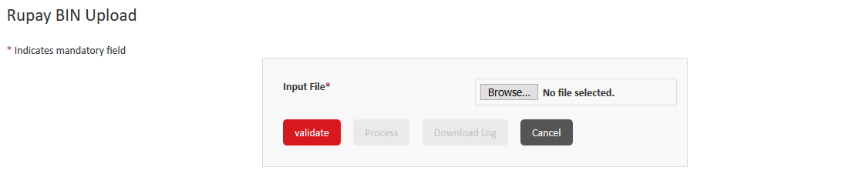
- Navigate to Uploads >> Rupay Bin Upload.
- Select the Rupay BIN .dat file, click Validate.
- Once the file is validated click on Process.
- If the uploaded file have any error , it displays error like “Validation failed”. You can dowload the logs for error.
- If no errors on Process, application displays successfull message.
Rupay BIN.dat file
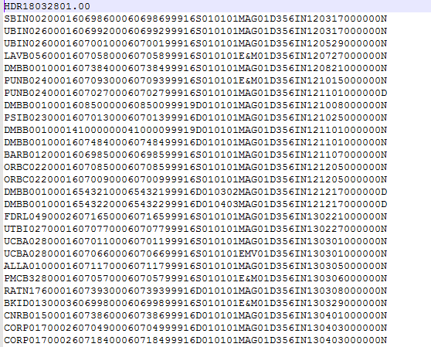
Merchant Upload:
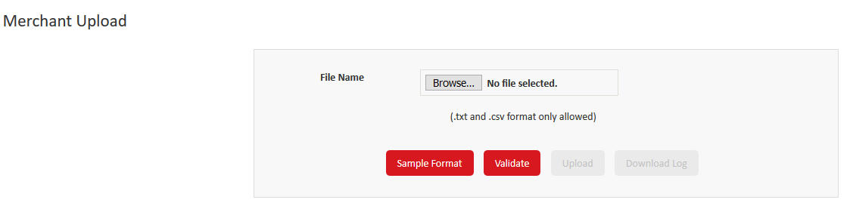
Merchant can be on-boarded with the upload category file.
- Navigate to Uploads >> Merchant Upload.
- Select the Merchant upload file, click Validate.
- Once the file is validated click on Process.
- If the uploaded file have any error , it displays error like “Validation failed”. You can dowload the logs for error.
- If no errors on Process, application displays successfull message.
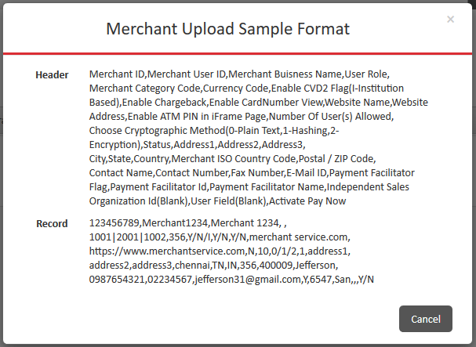
VPAS Merchant Upload :
You can upload the VPAS merchant file to add the details of multiple VPAS merchants in bulk. You can validate and upload a file in a specific format.
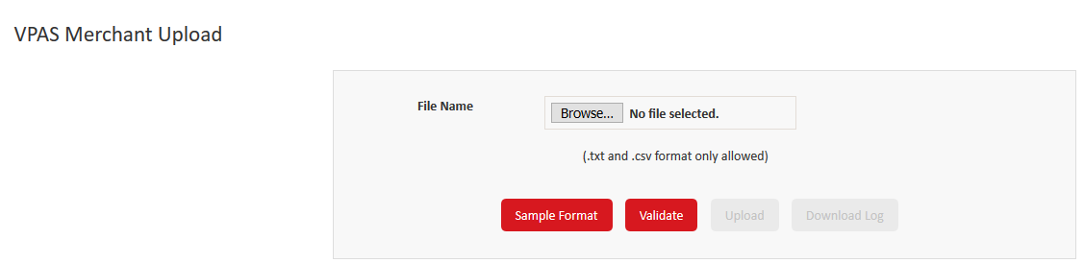
- Navigate to Uploads >> VPAS Merchant Upload.
- Select the VPAS Merchant upload file, click Validate.
- Once the file is validated click on Process.
- If the uploaded file have any error , it displays error like “Validation failed”. You can dowload the logs for error.
- If no errors on Process, application displays successfull message.
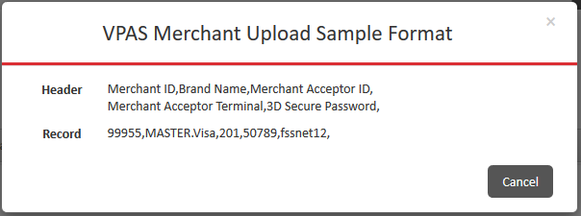
Merchant User Upload:
Multiple Merchant users can be created in bullk using Merchant User Upload process.
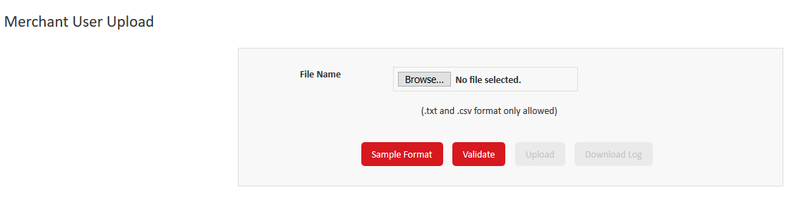
- Navigate to Uploads >> Merchant User Upload.
- Select the Merchant User upload file, click Validate.
- Once the file is validated click on Process.
- If the uploaded file have any error , it displays error like “Validation failed”. You can dowload the logs for error.
- If no errors on Process, application displays successfull message.
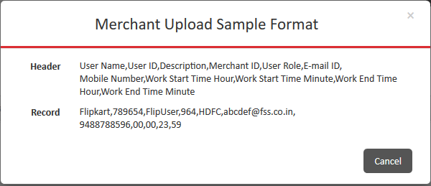
Terminal Upload:
You can upload the terminal file to add multiple terminals in FSS Payment Gateway. You can validate and upload files in a specific format.
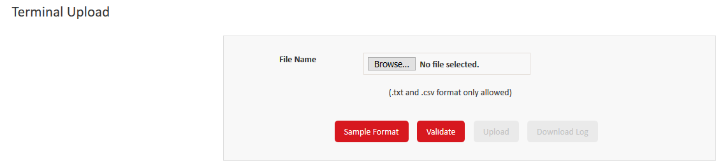
- Navigate to Uploads >> Terminal Upload.
- Select the Terminal upload file, click Validate.
- Once the file is validated click on Process.
- If the uploaded file have any error , it displays error like “Validation failed”. You can dowload the logs for error.

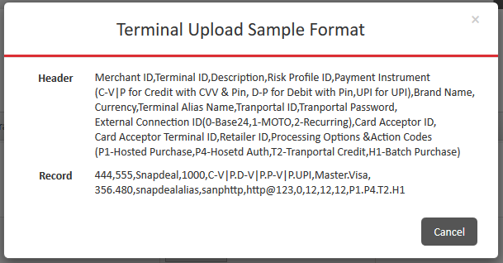

Reports:
BIN Activity Report – This report contains the count of all of the successful and failed transactions that have been initiated using a specific card BIN.
• IP Block Report – This report contains the details of all of the IP addresses that have been blocked during a specific period.
• Merchant Summary Report – This report contains the summary of transactions for a specific merchant.
• Merchant Threshold Report – This report contains the threshold transaction details that are associated with the risk profile for the merchant terminal.
• Merchant Velocity Report – This report contains the aggregated transaction count and transaction amount on a specific date for a merchant.
• Order Summary Report – This report contains the count of transactions for each processing status.
• Transaction Detail Report – This report contains the details of transactions initiated.
• Transaction Search Report – This report contains the details of a specific transaction ID.
• Transaction Summary Report – This report contains the number and amount of successful and failed transactions.
• Violated Terminals – This report contains the details of inactive terminals that violated the risk parameters for a merchant.
• Order Detail Report – This report contains the order details for a transaction based on the payment ID.
You can download the report in CSV, HTML, or TXT format depending on the report configuration.

Merchant Login :
All the functionality remains the same as per the Admin / Bank login for the below:
- User role
- Create User
- Password Security
- Security Questions
- Change passwords
- Resend password
Merchant Process:
Batch Upload:
Transactions with different actions codes can be uploaded from Merchant and gets processed by Bank User .
Batch Reports can also be generated to view the status of the Batch process. All success and failure transactions will be listed in the Batch report.
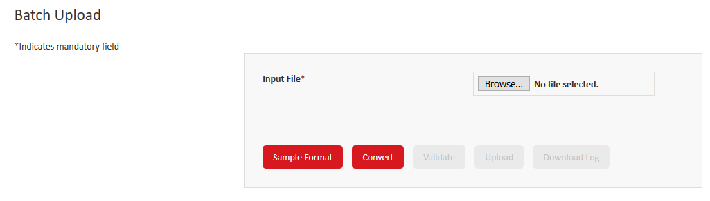
- Login to Merchant Login
- Navigate to Merchant Process>> Batch Upload.
- Select the Batch upload file from the Browse, click Convert.
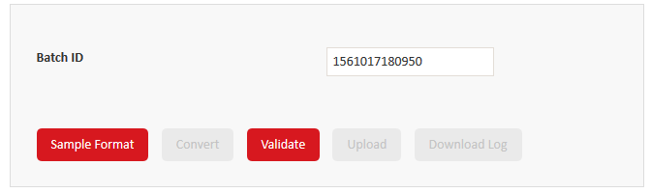
- A Unique Batch ID will be generated for the Batch file, then click Validate.
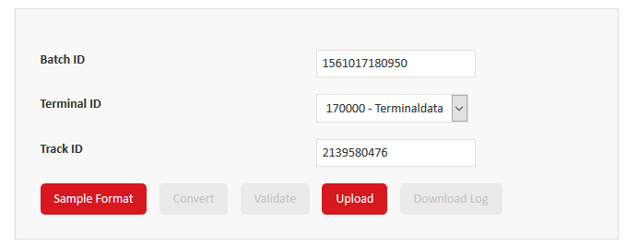
- Once the file is validated click on Upload.
- If the uploaded file have any error , it displays error like “Validation failed”. You can dowload the logs for error.
- If no errors on Process, application displays successfull message.
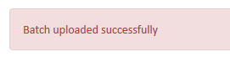
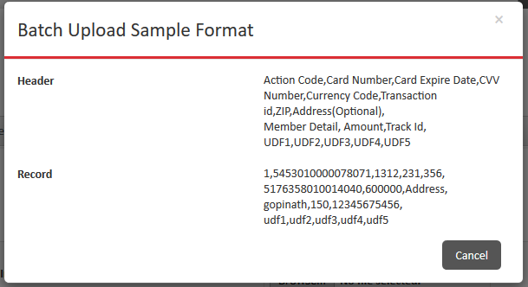
Remove Batches:
All the processed batches for this merchant will be listed under the remove batches. If any of the transactions failed under processed batch, user has to create a fresh batch to upload and process the transaction as it may create discrepency of an existing batch.
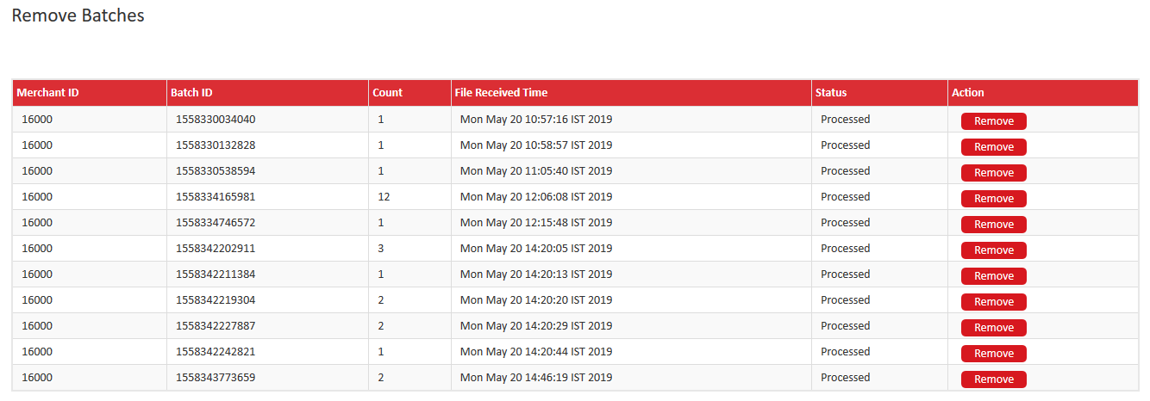
- Login to Merchant Login
- Navigate to Merchant Process>> Remove Batches.
- Choose the Processed Batch file , click Remove.
- Once removed , it displays a success message.
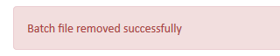
Plugin Download:
Merchant can download the plugin and integrate with the resource file. Plugin can be downloaded in the bleow formats.
- JSP/Perl/PHP
- ASP
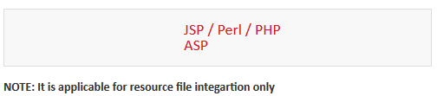
- Login to Merchant Login
- Navigate to Merchant Process>> Plugin Download.
- Select one of the plugin to download.
- Select the local path in your system to download the plugin.
Resource File Download:
The Data Encryption Key (DEK) is used to encrypt the sensitive data, such as card numbers. The Key Encryption Key (KEK) is used to encrypt the DEK. The DEK and KEK are stored in a protected KeyStore. You can download the KeyStore file from FSS Payment Gateway.
You can also download the resource file in the same path, Resource file contains tranportal ID, tranportal password, web address of FSS Payment Gateway, and the terminal resource keys of the terminal created in FSS Payment Gateway application. So whenever ther merchant tries to connect the payment gateway it checks the resource file and connects to the corresponding payment gateway terminal.

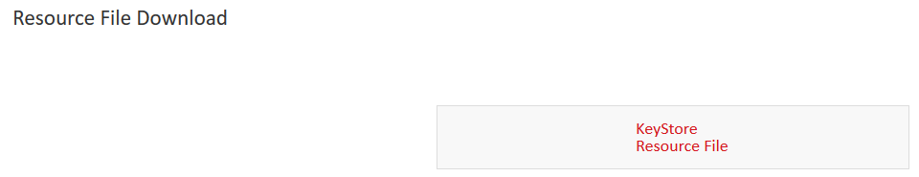

- Login to Merchant Login
- Navigate to Merchant Process>>Resource File Download.
- Select one of the Keystore and Resource file to download one after other.
- Select the local path in your system to download the Files.
- Integrate the Keystore file and resource file with the merchant server to connect to FSS Payment gateway.
Standing Instructions Upload:
Standing instructions are a way of making an automatic payment of a fixed amount to a loan, bill, or credit card at the same time every week or month. It can be made from your savings or checking account and is most commonly used to make payments to a mortgage, car loan, or to pay bills
It is a recurring payment that is processed with the help of batch category files. User can perform the following the SI Uploads
- Registration
- Deregistration
- Modification
- Payment
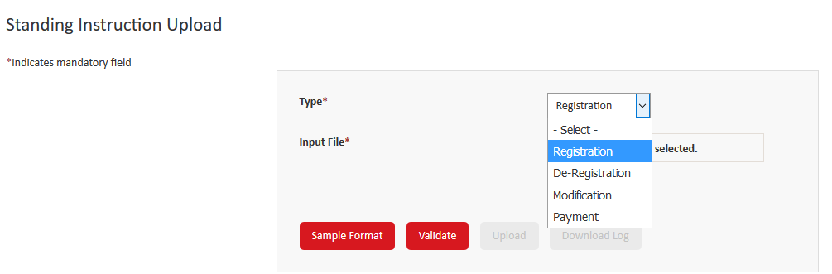
- Registration – Click this option to upload a file to register recurring transactions for customers.
- De-Registration – Click this to upload a file to deregister recurring transactions for customers.
- Modification – Click this option to upload a file to modify registration details for customers.
- Payment – Click this to upload a file to process recurring transactions for customers
Steps to Upload a SI File :
- Login to Merchant Login
- Navigate to Merchant Process>>Standing Instructions Upload
- Select the type from the dropdown ( Registration/ De-Registration/ Modification / Payment )
- Select the file from the local path by click on browse.
- Click on Validate.
- After success validation, click Upload.
- If the uploaded file have any error , it displays error like “Validation failed”. You can dowload the logs for error.
- If no errors on Process, application displays successfull message.

Registration Sample format :
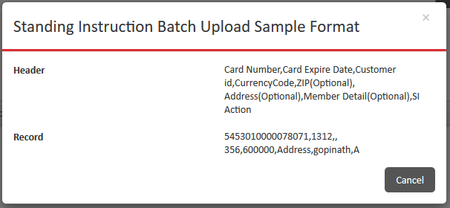
De-Registration Sample format:
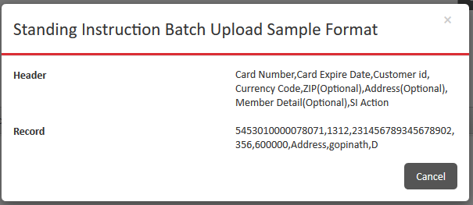
Modification Sample format:
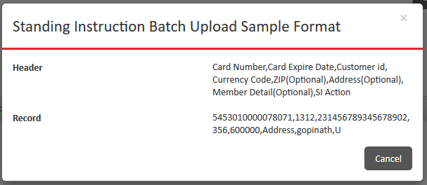
Payment Sample format:
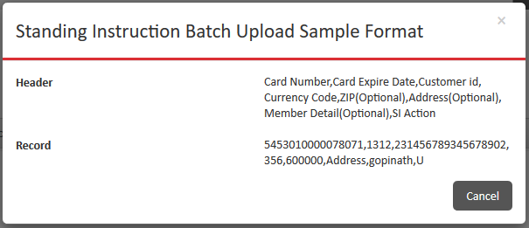
PayPage Preview:
Merchant can preview the payment page that is displayed to the customer for the particular terminal.
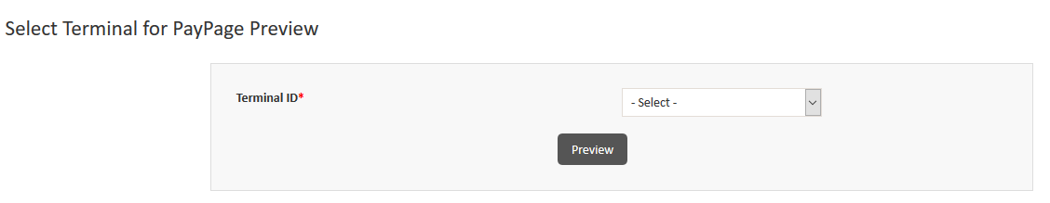
- Login to Merchant Login.
- Navigate to Merchant Process>> PayPage Preview.
- Select the Terminal ID from the dropdown.
- Click on Preview.

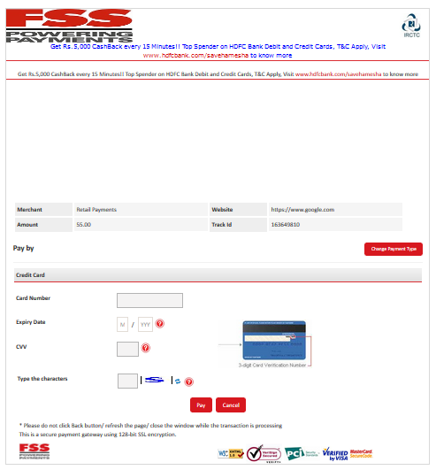
Transaction:
All the functionality remains the same as per the Bank login for the below:
- Authorization
- Posted Transaction
- Enter Transaction
- Order List

Accept Payments:
The product Pay Now will carter to multiple use cases that will enable Buyer to pay using intuitive ways. This
will result in larger transaction flows into the system which will mutually benefit Banks, Merchants and
Buyers. Merchants who already have a business and want to go online but can’t understand complexity of
setting up shopping cart can use our following solutions
- Email / SMS Invoice
- Web Front (Product Page)
- Web Store (Set of Product Pages)
- Pay on Social Media
- QR Code
Email/ SMS Invoice:
Transaction flow:
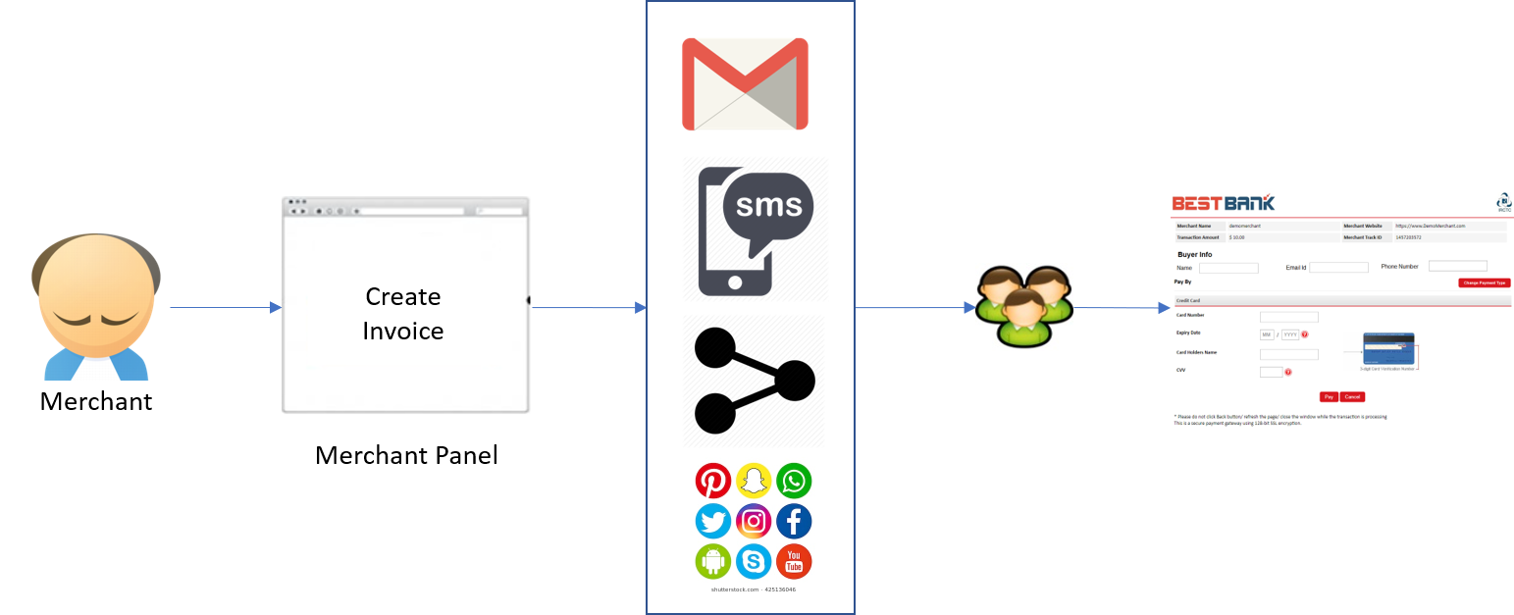

This feature provides customers with below links:
- Open Links – Multiple transactions can be processed with this link
- Dedicated Links – Transaction to be processed by an individual or for a product.
Steps to Create a Open Invoice:
- Login to Merchant Login
- Navigate to Accept Payments>>Email/SMS invoice >> Open Link Tab >> Create a Open Invoice.
- Enter the valid details.
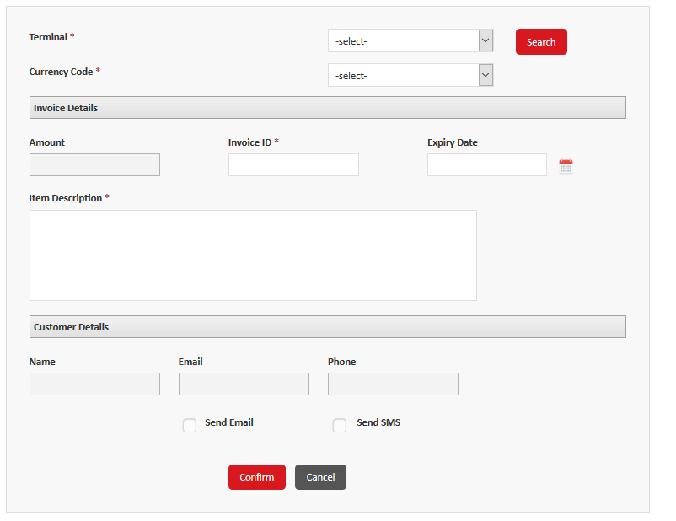
- Click on Confirm.
It generates a open source link that to be shared over email/ sms or web applications.
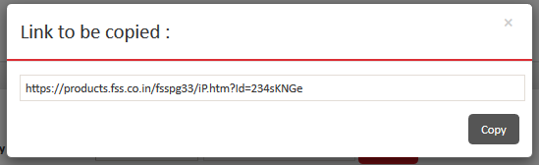
Transactions processed from this link will be logged in Child details as show below
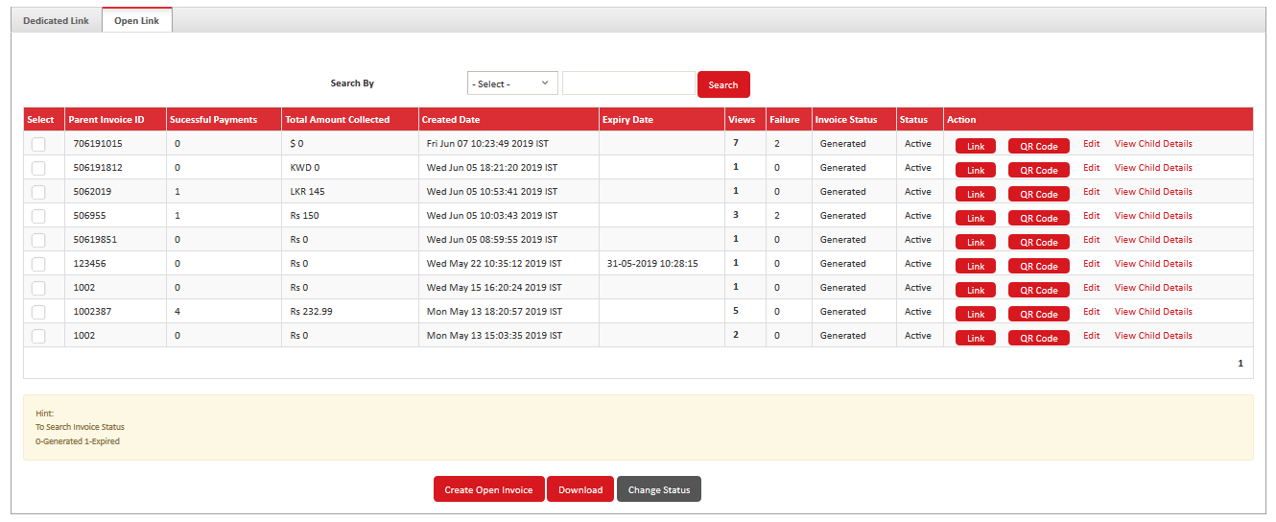
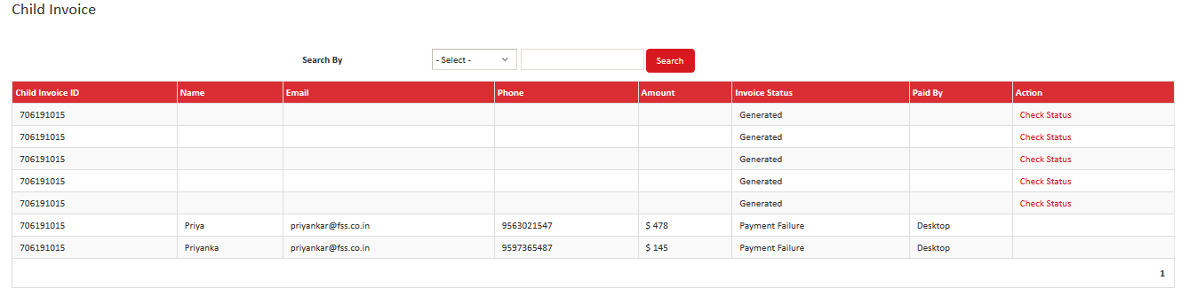
Open link also supports QR code for the online payments in different sizes.
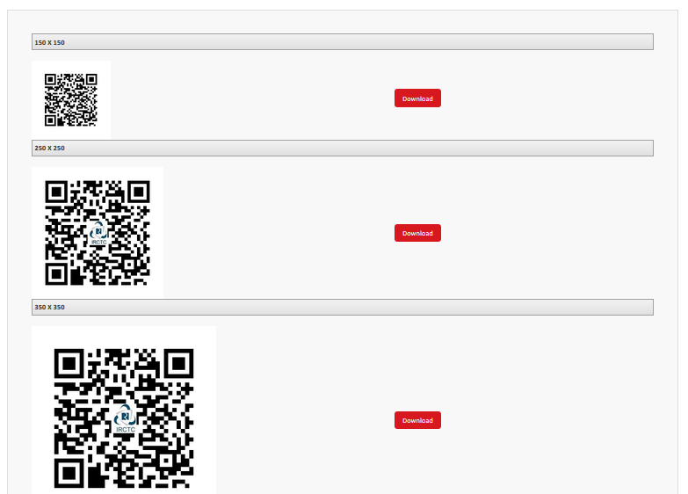
Dedicated Link :
Dedicated link also supports QR code and link. Merchant can share these links via Email /SMS to the customers to process the transaction.
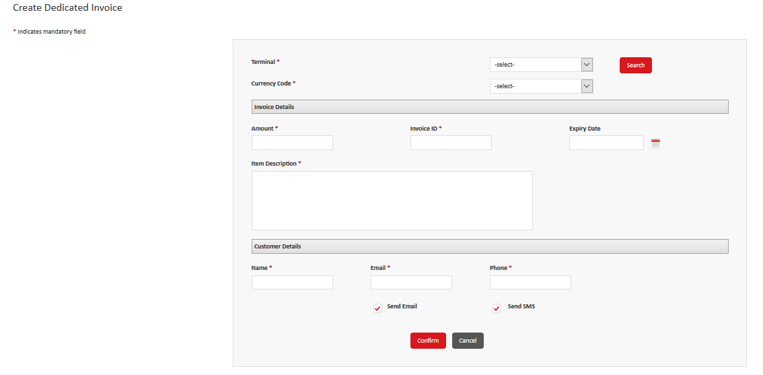
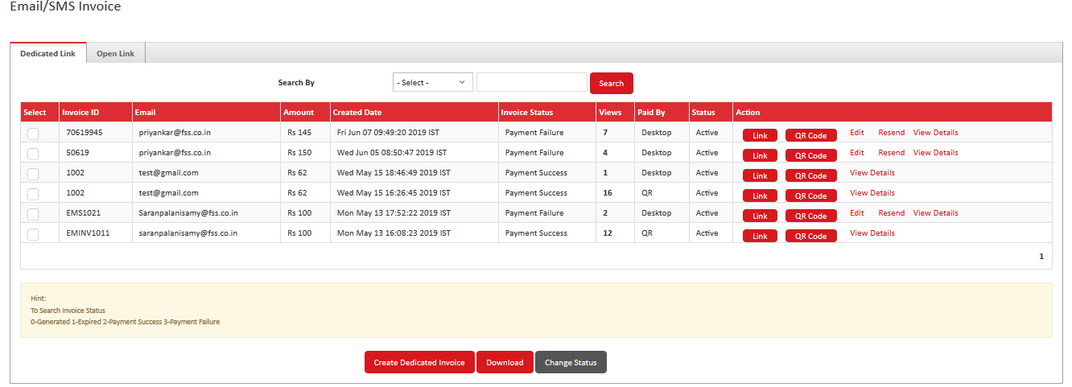

When customer copy and paste the link, it redirects to the payment gateway page to process the transaction for the merchant.
Buy Now Button:
Transaction Flow:
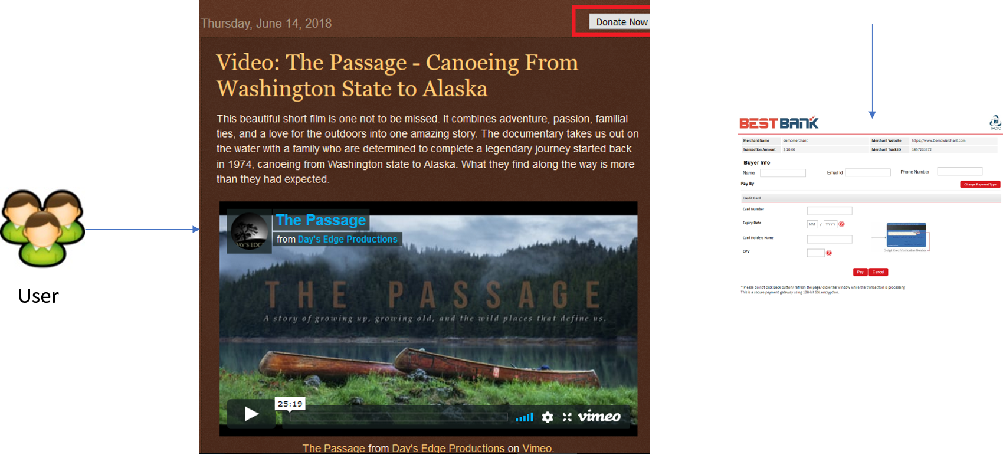

Steps to Create Buy Now button:
- Login to Merchant Portal
- Navigate to Accept payments >> Buy Now button >> Create Buy Now button
- Enter all the valid fields
- Click confirm.
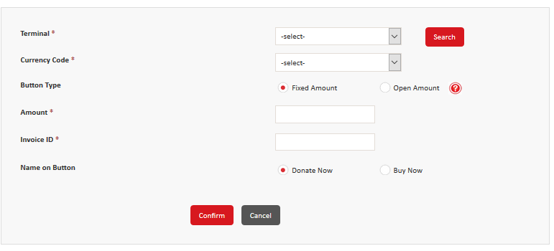
This should create a link like below when you click on copy code.

<div class='pm-button'><a href='https://www.BankName.com/paybypayButton/#/BE3F09EA2ADAED2C97B6276E039390D6'><img src='https://www. BankName.com/media/images/payby_Button/new_buttons/21.png'/></a></div>
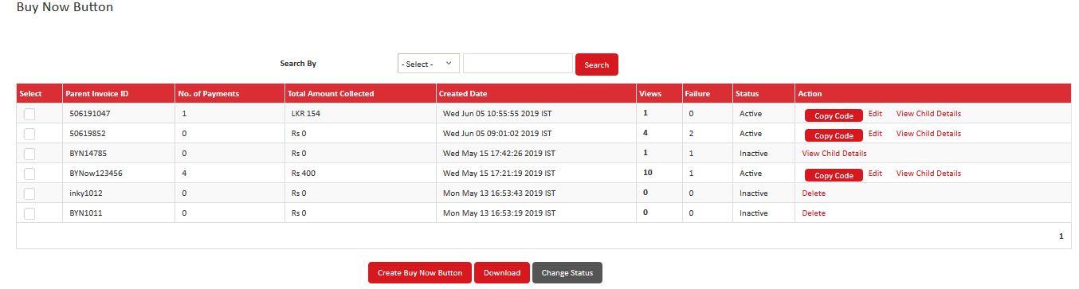

Merchant can paste it in HTML file and test. The button in the browser should look like



When Buyer clicks on the button, he should be redirected to Payment Page wherein he would be asked to enter his Name, Mail Id and Phone number (Amount in case of open field)

Merchant can place the button on his blog etc
Clicking on the link would open payment page
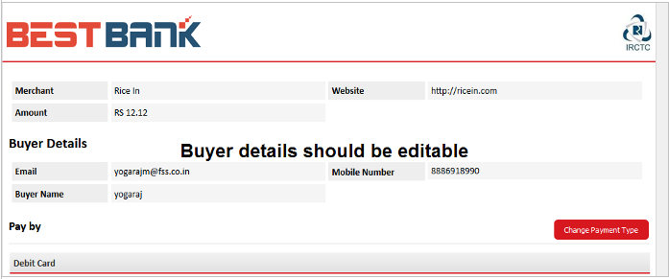

Similarly, Open amount feature would work. Only 2 differences being,
- While creating button, we should not be asking Amount from Merchant
- Buyer should be able to add Amount at the time of payment.
Web Front ( Single Product Page)
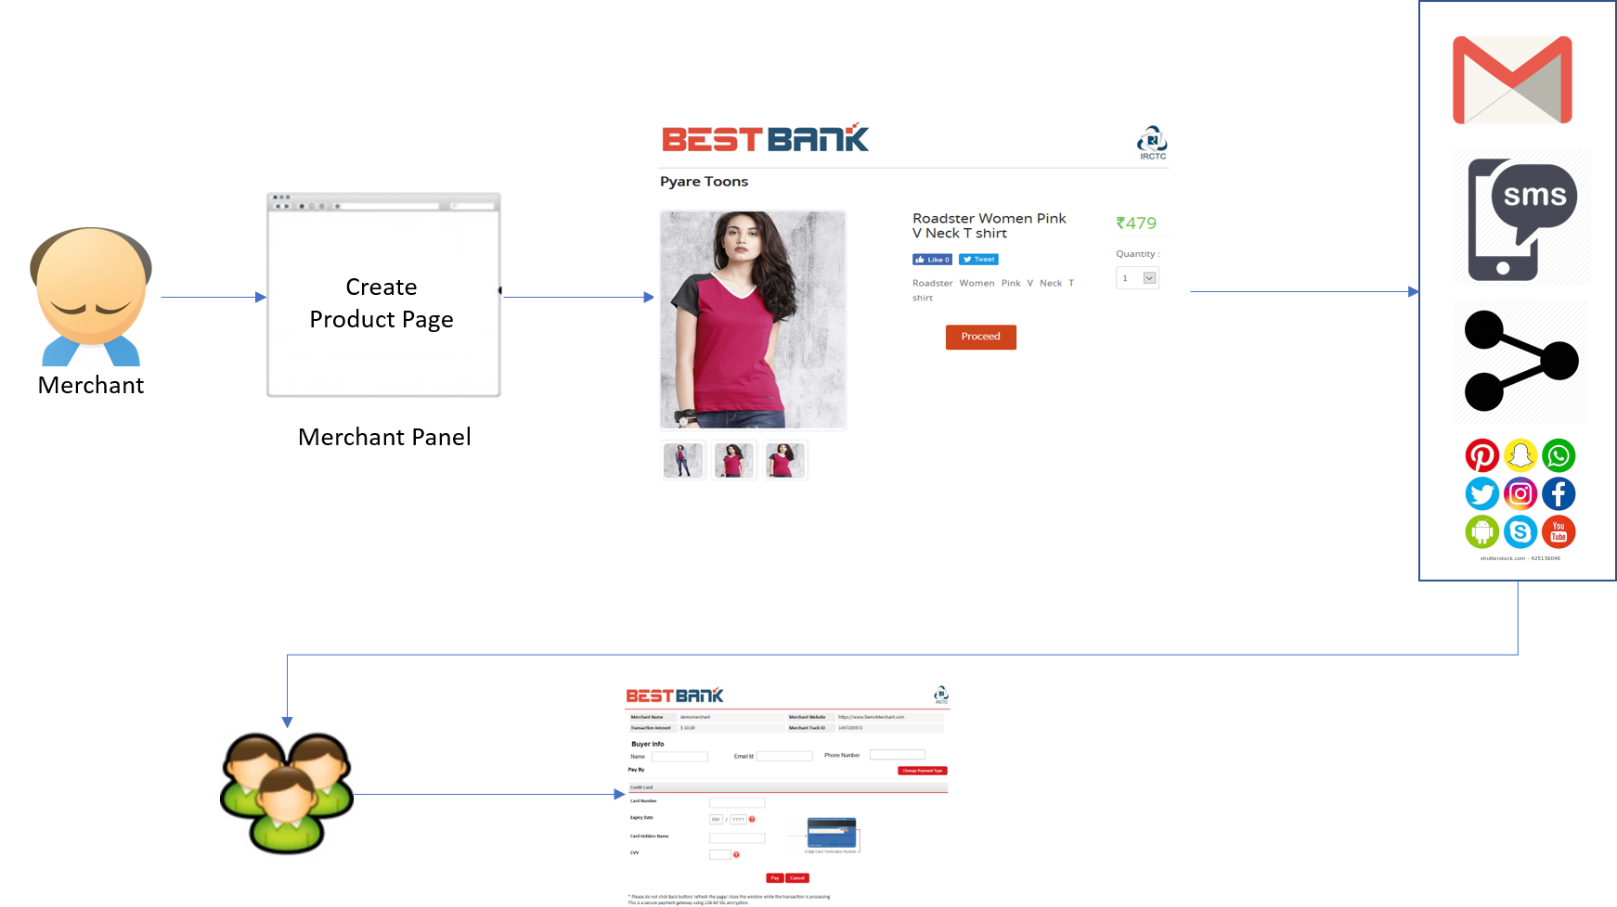
Transaction Flow:

Merchant can create a single product page with the web front feature. Merchant should be able to see all his product listings here with following details
- Product Name
- Link
- Views
- Units Sold
- Revenue Generated
- Edit
- Delete
- Publish/Unpublish

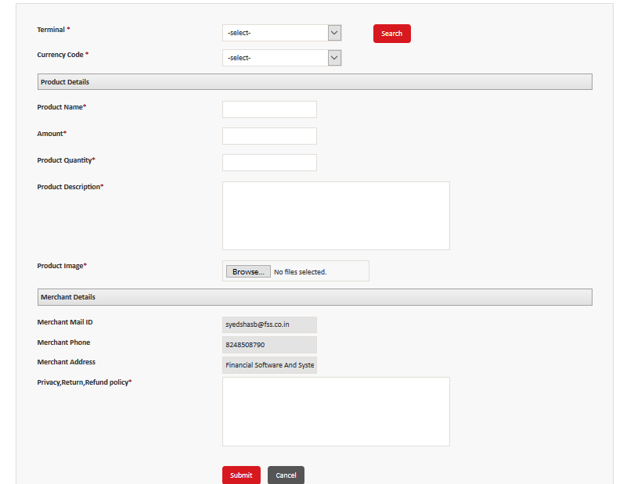
- Login to Merchant Portal
- Navigate to Accept payments >> Web Front >> Create Product Page
- Enter all the valid fields
- Click Submit.
- Once submit it will generate a link and QR code for Product page.
- Open the link and verify all the details displayed are correct.
- When shared to the customers, they can purchase the product and processed to process the transaction.

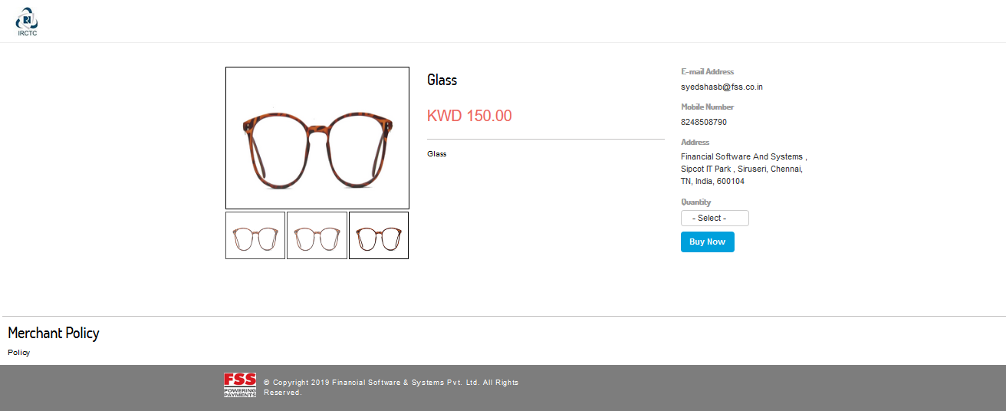
In the payment page listed, customer are prompted to enter the buyer details along with card details for processing.
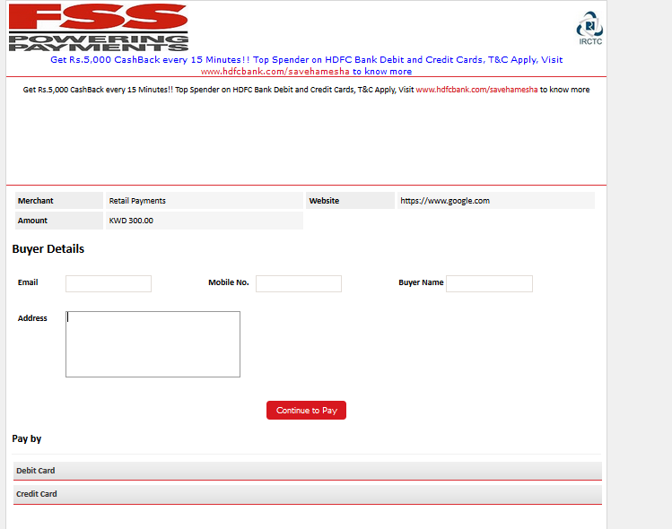
All the transactions made from the web front will be listed in the summary grid including the inventory left.
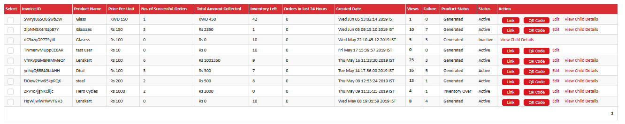
Web Store: (Set of Product Packages)
Transaction Flow:
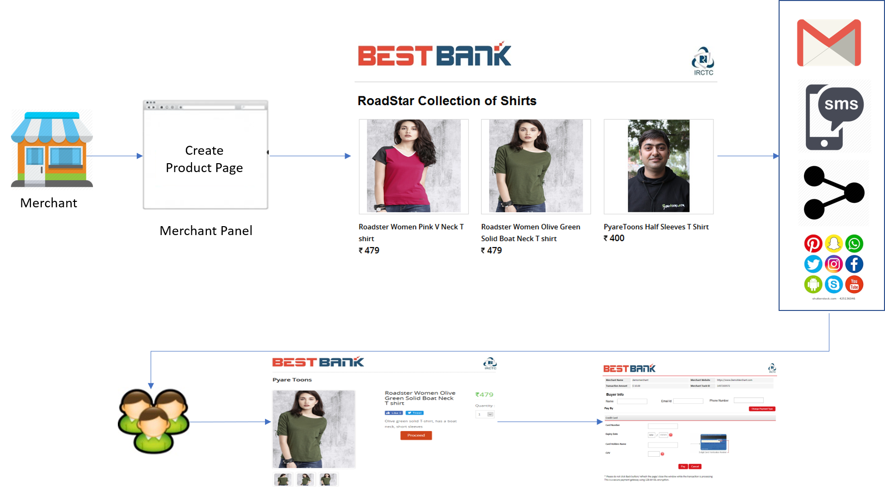

With the Webstore – Merchant can create a Max of 20 products (may vary in future)with the product packages. Also Merchant is allowed to create a Max of 5 store as of now (it may vary in future).
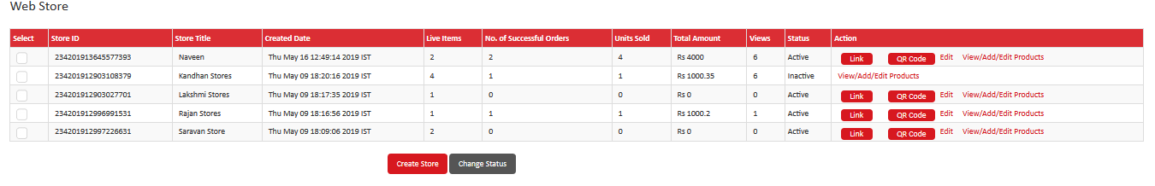
- Use the link to view the stores created with products.
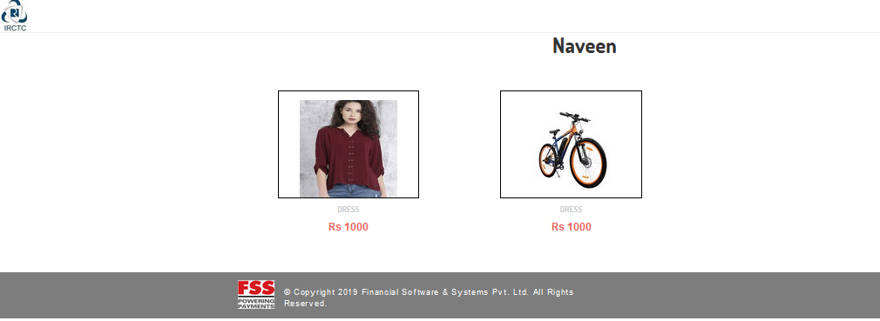
- When click on the Store it illustrates the products features as web front
- customer can view and select the number of items and proceed with transaction.
- Merchant can also share the QR code for the product package created.

Deployment Architecture:
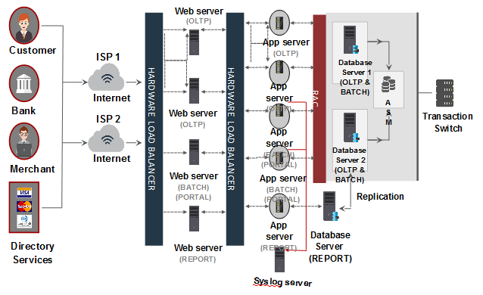
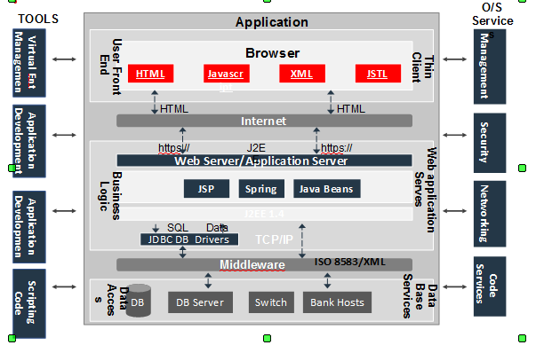
Technical Architecture:



